**MODULE 1**

**What Is Information Security?**

Information Security is the state of being protected against the unauthorized use of information, especially electronic data, or the measures taken to achieve this.

**What to Protect**

* Data
* Resource

**Resource**

• Prevention

• Detection

• Recovery

A fundamental understanding of the standard concepts of security is essential before people can start securing their environment.

**Risk**

A risk is generally defined as the probability that an event will occur.

* Disgruntled Former Employees
* Threat of Improper Access

Likelihood: Rare

Damage: Moderate

**Threats**

A threat is a possible danger that might exploit a vulnerability to breach security and therefore cause possible harm.

**Intentional or unintentional**

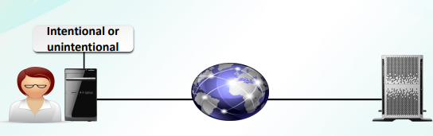

**Information Security Threats**

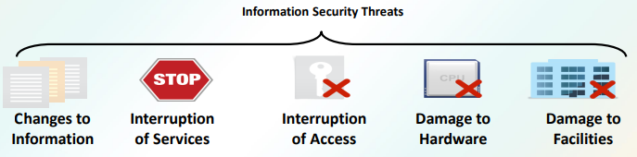

* Changes to Information
* Interruption of Services
* Interruption of Access
* Damage to Hardware
* Damage to Facilities

**Vulnerability**

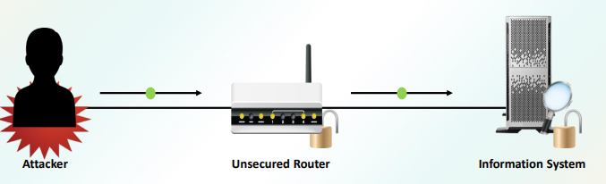

A vulnerability is a weakness which can be exploited by a threat actor, such as an attacker, to perform unauthorized actions within a computer system.

* Attacker
* Unsecured Router
* Information System

**Intrusion**

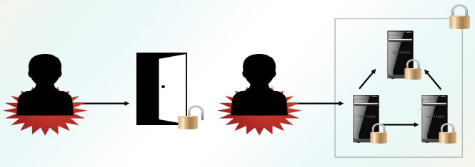

Intrusions often involves stealing valuable resources and almost always jeopardize the security of the systems and/or their data.

**Attacks**

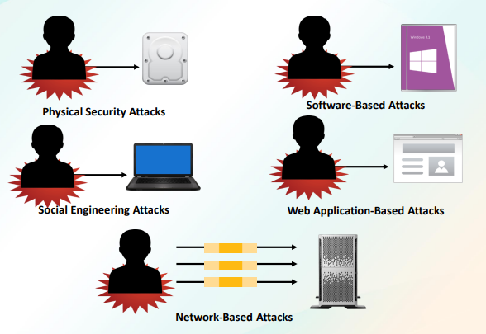

Attack is to set upon in a forceful, violent, hostile, or aggressive way, with or without a weapon.

* Physical Security Attacks
* Software-Based Attacks
* Social Engineering Attacks
* Web Application-Based Attacks
* Network-Based Attacks

**Security Controls**

• Controls are the countermeasures that you need to put in place to avoid, mitigate, or counteract security risks due to threats or attacks.

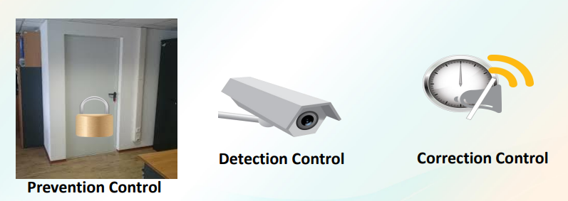

* Prevention Control
* Detection Control
* Correction Control

**Security Management Process**

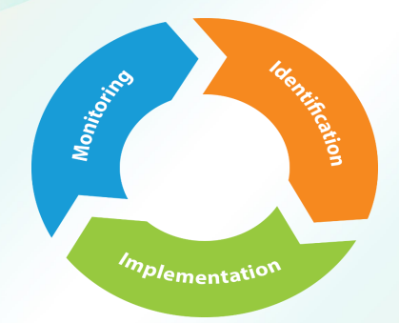

* Monitoring
* Implementation
* Identification

**CIA Triad**

* Confidentiality
* Availability
* Integrity

The CIA Triad is a well-known, venerable model for the development of security policies used in identifying problem areas, along with necessary solutions in the arena of information security.

**Confidentiality**

CONFIDENTIALITY is a concept we deal with frequently in real life. We expect our doctor to keep our medical records confidential.

There are several technologies that support confidentiality in an enterprise security implementation. These include the following:

* Strong encryption
* Strong authentication
* Stringent access controls

**Integrity**

We define INTEGRITY in the information security context as the consistency, accuracy, and validity of data or information.

**Availability**

AVAILABILITY is the third core security principle, and it is defined as a characteristic of a resource being accessible to a user, application, or computer system when required

**SUBTOPIC 2**

**AUTHENTICATION METHODS AND CRYPTOGRAPHY FUNDAMENTALS**

**Identification**

Identification is defined as the act of determining who someone or what something is.

**Authentication**

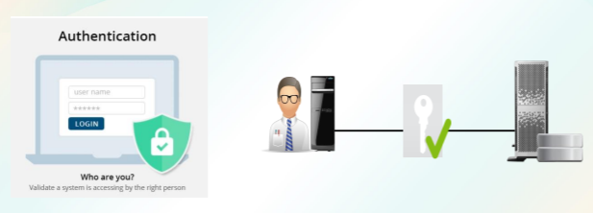

Authentication is the process of verifying the identity of a person or device.

Authentication Factors

1. Something you are

✓Fingerprints, handprints, or retinal patterns

1. Something you have

✓Key or ID card

1. Something you know

✓Password or PIN

1. Somewhere you are or are not

✓IP address or GPS

1. Something you do

✓Keystroke patterns

**Authorization**

AUTHORIZATION is the process of giving individuals access to system objects based on their identity.

**Non-repudiation**

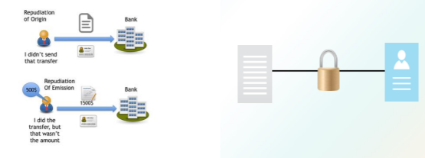

Non-repudiation is the assurance that someone cannot deny the validity of something.

**Access Control**

• Determining and assigning privileges to resources, objects, or data.

• Manages authorization.

**Access Control Models**

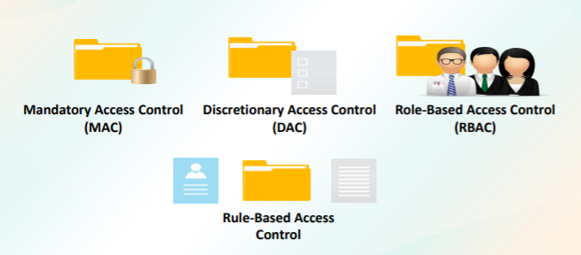

* Mandatory Access Control (MAC)
* Discretionary Access Control (DAC)
* Role-Based Access Control (RBAC)
* Rule-Based Access Control

**Accounting and Auditing**

• The process of tracking and recording system activities and resource access.

**Common Security Practices**

* Implicit deny
* Least privilege
* Separation of duties
* Job rotation
* Mandatory vacation
* Time of day restrictions
* Privilege management

**Implicit Deny**

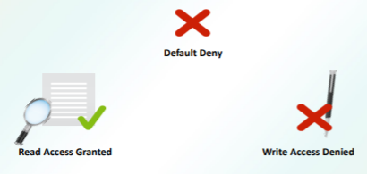

An implicit deny only denies a permission until the user or group is allowed to perform the permission

* Default Deny
* Read Access Granted
* Write Access Denied

**Least Privilege**

LEAST PRIVILEGE is a security discipline that requires that a user, system, or application be given no more privilege than necessary to perform its function or job.

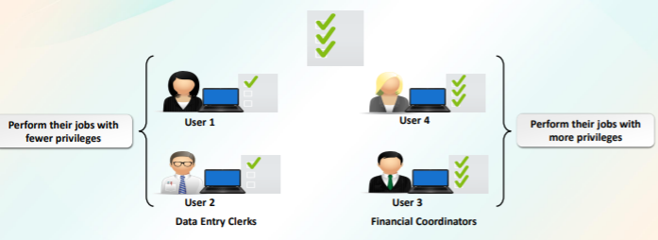

**Separation of Duties**

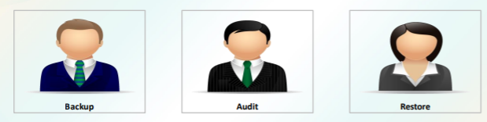

* Backup
* Audit
* Restore

SEPARATION OF DUTIES is a principle that prevents any single person or entity from being able to have full access or complete all the functions of a critical or sensitive process.

**Job Rotation**

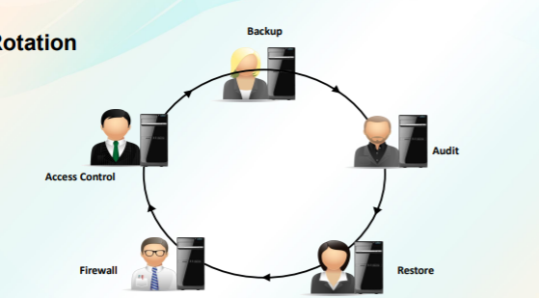

* Backup
* Audit
* Restore
* Firewall
* Access Control

JOB ROTATION is a concept that has employees rotate through different jobs to learn the procedures and processes in each.

**Mandatory Vacation**



MANDATORY VACATIONS policies require employees to take time away from their job.

**Time of Day Restrictions**

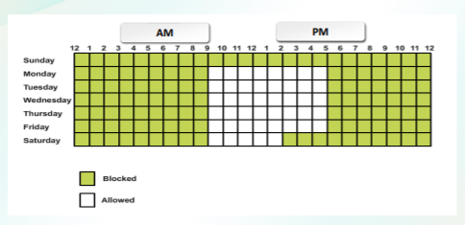

TIME OF DAY RESTRICTIONS limit when users can access specific systems based on the time of day or week.

**Security Tokens**

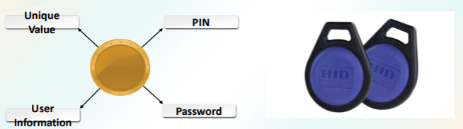

* Unique Value
* PIN
* User Information
* Password

A security token (or sometimes a hardware token, hard token, authentication token, USB token, cryptographic token, or key fob) is a physical device that an authorized user of computer services is given to ease authentication.

**Biometrics**

* Fingerprint scanner
* Retinal scanner
* Hand geometry scanner
* Voice-recognition software
* Facial-recognition software

Biometrics is an authentication method that identifies and recognizes people based on voice recognition or physical traits such as a fingerprint, face recognition, iris recognition, and retina scan.

**Keystroke Authentication  
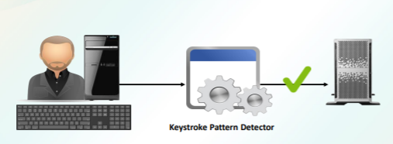**

Keystroke dynamics has been used to strengthen password-based user authentication systems by considering the typing characteristics of legitimate users.

**Multifactor Authentication**

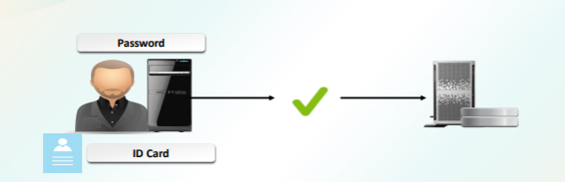

When two or more authentication methods are used to authenticate someone, a multifactor authentication system is being implemented.

**Cryptography**

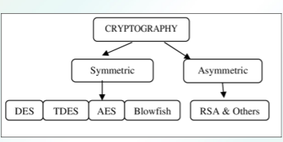

Cryptography is a method of protecting information and communications through the use of codes so that only those for whom the information is intended can read and process it.

**Encryption and Decryption**

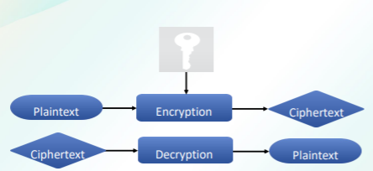

* Plaintext -> Encryption -> Ciphertext
* Ciphertext -> Decryption -> Plaintext

**Encryption** is a process which transforms the original information into an unrecognizable form.

**Decryption** is a process of converting encoded/encrypted data in a form that is readable and understood by a human or a computer.

**Ciphers**

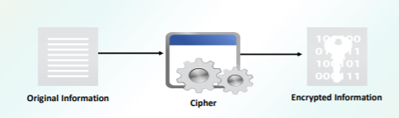

* Original Information
* Cipher
* Encrypted Information

Cipher is a system of writing that prevents most people from understanding the message

**Cipher Types**

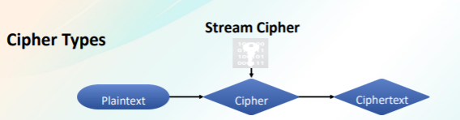

Plaintext -> Cipher -> Ciphertext

Stream ciphers create an arbitrarily long stream of key material, which is combined with plain text bit-by-bit or character-by-character.

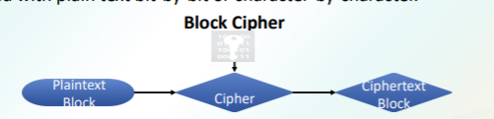

Plaintext Block -> Cipher -> Ciphertext Block

Block cipher takes a block of plain text and a key, and outputs a block of ciphertext of the same size.

**Steganography**

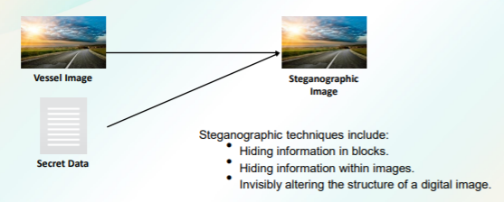

* Vessel Image
* Secret Data
* Steganographic Image

Steganographic techniques include:

• Hiding information in blocks.

• Hiding information within images.

• Invisibly altering the structure of a digital image.

The art and science of hiding information by embedding messages within other, seemingly harmless messages.

**Types of Encryption**

Encryption algorithms can be divided into three classes:

❑ Symmetric

❑ Asymmetric, and

❑ Hash function.

Symmetric and Asymmetric encryption can encrypt and decrypt data.

A Hash function can only encrypt data; that data cannot be decrypted

**Hashing Encryption**

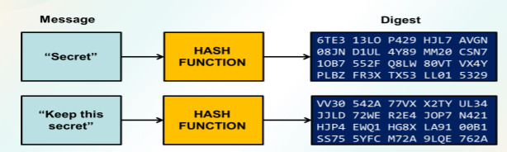

Hashing is one way to enable security during the process of message transmission when the message is intended for a particular recipient only.

**Hashing Encryption Algorithms**

❑MD5 – (Message Digest)

❑SHA – (Secure Hash Algorithms)

❑NTLM versions 1 and 2 – New Technology LAN Manager

❑RIPEMD - RACE Integrity Primitives Evaluation Message Digest

❑HMAC - Hash-based Message Authentication Code

**Key**

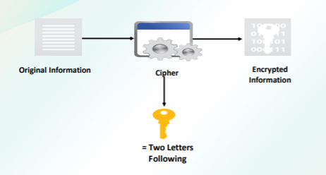

* Original Information
* Cipher
* Encrypted Information
* = Two Letters Following

An encryption key is a random string of bits created explicitly for scrambling and unscrambling data.

Symmetric Encryption

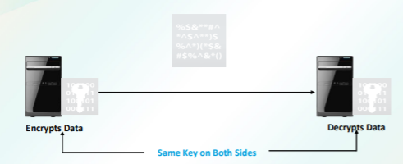

* Encrypts Data -> Same key on both sides -> Decrypts Data

Symmetric encryption uses a single key to encrypt and decrypt data. Therefore, it is also referred to as secret-key, single-key, shared-key, and private-key encryption.

**Symmetric Encryption Algorithms**

❑DES - Data Encryption Standard

❑3DES – Triple Data Encryption Standard

❑AES - Advanced Encryption Standard

❑Blowfish

❑Twofish

❑RC 4, 5, 6

**Asymmetric Encryption**

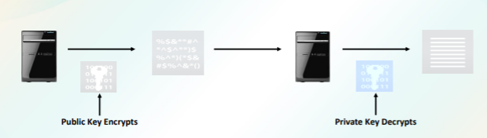

* Public Key Encrypts
* Private Key Decrypts

Asymmetric encryption, also known as public key cryptography, uses two mathematically related keys.

**Asymmetric Encryption Techniques**

❑RSA - Rivest–Shamir–Adleman

❑DH - Diffie–Hellman key exchange.

❑ECC - Elliptic curve cryptography

❑DHE - Diffie–Hellman key exchange

❑ECDHE - Elliptic curve Diffie-Hellman

**Key Exchange**

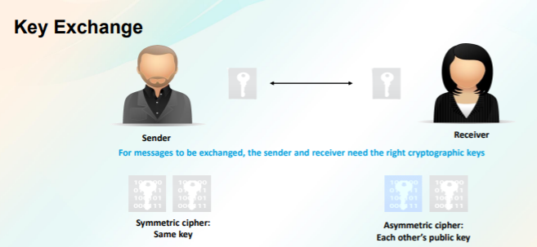

* Sender -> Receiver - For messages to be exchanged, the sender and receiver need the right cryptographic keys
* Symmetric cipher: Same key -> Asymmetric cipher: Each other’s public key

**Key exchange** (also key establishment) is a method in cryptography by which cryptographic keys are exchanged between two parties, allowing use of a cryptographic algorithm.

**Digital Signatures**

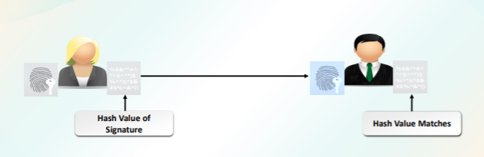

* Hash Value of Signature -> Hash Value Matches

DIGITAL SIGNATURE is a process that guarantees that the contents of a message have not been altered in transit.

**Session Keys**

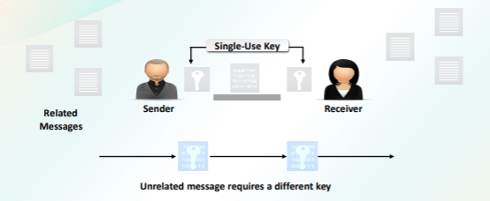

A SESSION KEY is an encryption and decryption key that is randomly generated to ensure the security of a communications session between a user and another computer or between two computers.

**Key Stretching**

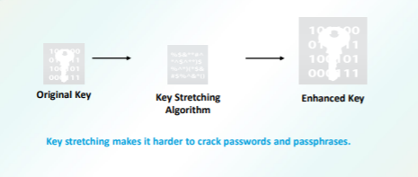

* Original Key -> Key Stretching Algorithm -> Enhanced Key

KEY STRETCHING is the practice of converting a password to a longer and more random key for cryptographic purposes such as encryption.

**Security Policy**

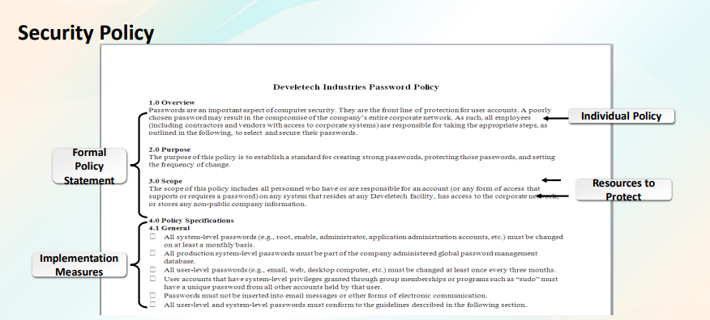

Formal Policy Statement – Overview, Purpose, Scope

Individual Policy – Overview

Resources to Protect – Purpose and Scope

Implementation Measures – Policy Specifications and General

**Security policy** is a definition of what it means to be secure for a system, organization or other entity.

**Security Policy Components**

**Policy statement** - Formal document outlining the ways in which an organization intends to conduct its affairs and act in specific circumstances.

**Standards** - a level of quality or attainment.

**Guidelines** - a general rule, principle, or piece of advice.

**Procedures** - an established or official way of doing something.

All security policies should include a well-defined security vision for the organization.

**Enforcement** – This section should clearly identify how the policy will be enforced and how security breaches and/or misconduct will be handled. User Access to

**Computer Resources** – This section should identify the roles and responsibilities of users accessing resources on the organization’s network.

**Security Profiles** – This section should include information that identifies how security profiles will be applied uniformly across common devices

**Sensitive data** — This section addresses any information that is protected against unwarranted disclosure.

**Passwords** – This section should state clearly the requirements imposed on users for passwords.

**E-Mail** – This section includes how to handle attachments, through filtering, personal use of the e-mail system, language restrictions, and archival requirements

**Internet** – This section is about usage and what content filtering is in place.

**Anti-Virus** – This section identifies the frequency of updating the file definitions as well as how removable media, e-mail attachments and other files are scanned.

**Back-up and Recovery** – A comprehensive back-up and recovery plan is included here.

**Intrusion Detection** – This section discusses what if any Network Security Intrusion Detection or Prevention System is used and how it is implemented.

**Remote Access** – This section should identify all the ways that the system can be remotely accessed and what is in place to ensure that access is from only authorized individuals

**Information Security Auditing** – How are all the security programs reviewed and how frequently

**Information Security Training** – Training occurs in many different flavors. One of the types of training required in an organization is Awareness Training

**Common Security Policy Types**

**AUP** – Acceptable User Policy - or fair use policy, is a set of rules applied by the owner, creator or administrator of a network, website, or service.

**Privacy policy** - is a statement or a legal document that discloses some or all of the ways a party gathers, uses, discloses, and manages a customer or client's data.

**Audit policy** defines account limits for a set of users of one or more resources.

**Extranet policy** - this document describes the policy under which third-party organizations connect to your networks for the purpose of transacting business related to your company

**Password policy** is a set of rules designed to enhance computer security by encouraging users to employ strong passwords and use them properly.

**Wireless standards policy -** provides guidelines regarding wireless access points and the management by ITS of 802.11X and related wireless standards access.

**Social media policy** is a living document that provides guidelines for your organization’s social media use.

**Group Policy**

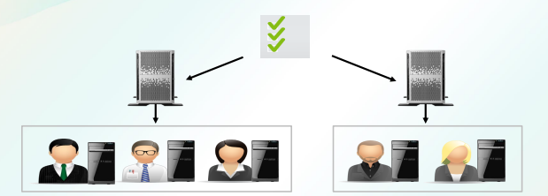

Group Policy is a feature of the Microsoft Windows NT family of operating systems that controls the working environment of user accounts and computer accounts.

**Security Document Categories**

**System architecture** - is the conceptual model that defines the structure, behavior, and more views of a system Change documentation should describe the requirements driving the change in sufficient detail to allow approvers and other officials to make an informed decision on the change request.

**Log** is an official record of events during the operation

**Inventories** is a complete list of items such as property, goods in stock, or the contents of a building.

**Change Management**

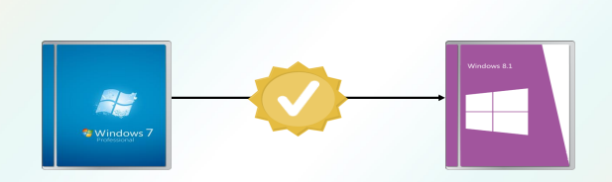

A CHANGE MANAGEMENT system will record what changes are made.

**Three Levels of Change Management**

❑ Individual Change Management

❑ Organizational/Initiative Change Management

❑ Enterprise Change Management Capability

**Documentation Handling Measures**

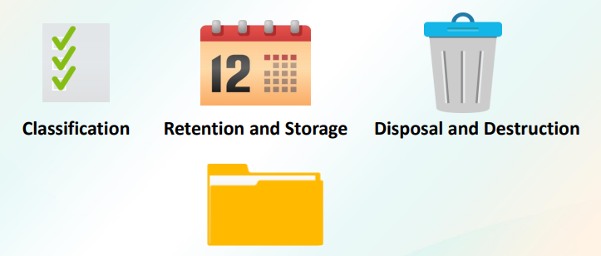

* Classification
* Retention and Storage
* Disposal and Destruction

**Classification**

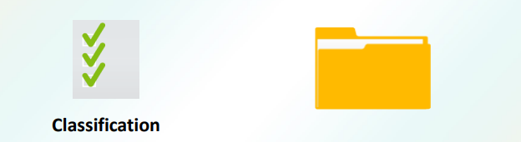

Classification is the action or process of classifying something according to shared qualities or characteristics.

**Disposal and Destruction**

Every paper or electronic record has a specific amount of time that it needs to be kept. This is called a retention period.

Once the retention period has ended, records are disposed according to their value and content:

▪ Shred

▪ Recycle

▪ Delete

▪ Transfer

**SUPPLEMENTARY**

**MODULE 1 SECURITY FUNDAMENTALS**

**SUBTOPIC 1 INFORMATION SECURITY CYCLE**

OBJECTIVES

Upon completion of this module, the student would be able to:

• Define Information Security and its goals;

• Demonstrate the abstract view of the components of a goal of security;

• Enumerate the types of risks, threats, vulnerability, intrusion and attacks;

• Explain the Information Security Controls;

• Discuss Security Management Process;

• Give different aspects of CIA Triad.

**What Is Information Security?**

Information Security is the state of being protected against the unauthorized use of information, especially electronic data, or the measures taken to achieve this. Protection of available information or information resources. Necessary for a responsible individual or organization to secure confidential information. Minimize business risks and other consequences of losing crucial data.

**What to Protect**

Data is the facts and statistics collected together for reference or analysis.

IT Resources means all the equipment, networks, hardware, software, technical knowledge, expertise and other resources, including all information technology resources and computer systems, held, owned or used by or on behalf of the Company.

**Goals of Security**

* Prevention
* Detection
* Recovery

A fundamental understanding of the standard concepts of security is essential before people can start securing their environment. It’s easy to start buying firewalls, but until you understand what needs to be protected, why it needs to be protected, and what it’s being protected from, you’re just throwing money away.

**Risk**

A risk is generally defined as the probability that an event will occur. Businesses are only concerned about risks that would negatively impact a computing environment. There is a risk that you’ll win the lottery on Friday—that’s not a risk to actively address, because it would be a positive.

**Threats**

A threat is a possible danger that might exploit a vulnerability to breach security and therefore cause possible harm. A threat is a very specific type of risk, and it is defined as an action or occurrence that could result in a breach in the security, outage, or corruption of a system by exploiting known or unknown vulnerabilities.

**Vulnerability**

A vulnerability is a weakness which can be exploited by a threat actor, such as an attacker, to perform unauthorized actions within a computer system. Vulnerability is the quality or state of being exposed to the possibility of being attacked or harmed, either physically or emotionally.

**Intrusion**

Intrusions often involves stealing valuable resources and almost always jeopardize the security of the systems and/or their data. Intrusion is an illegal act of entering, seizing, or taking possession of another's property.

**Attacks**

Attack is to set upon in a forceful, violent, hostile, or aggressive way, with or without a weapon. A computer attack may be defined as actions directed against computer systems to disrupt equipment operations, change process control, or corrupt stored data.

**Security Controls**

Controls are the countermeasures that you need to put in place to avoid, mitigate, or counteract security risks due to threats or attacks. Before the event, preventive controls are intended to prevent an incident from occurring e.g. by locking out unauthorized intruders; During the event, detective controls are intended to identify and characterize an incident in progress e.g. by sounding the intruder alarm and alerting the security guards or police; After the event, corrective controls are intended to limit the extent of any damage caused by the incident e.g. by recovering the organization to normal working status as efficiently as possible

**Security Management Process**

Identification is the action or process of identifying someone or something or the fact of being identified. Implementation is the process of putting a decision or plan into effect also known as execution. Monitoring is the act of observing and check the progress or quality of (something) over a period CIA Triad The CIA Triad is a well-known, venerable model for the development of security policies used in identifying problem areas, along with necessary solutions in the arena of information security. Confidentiality, integrity and availability, also known as the CIA triad, is a model designed to guide policies for information security within an organization. The model is also sometimes referred to as the AIC triad (availability, integrity and confidentiality) to avoid confusion with the Central Intelligence Agency.

**Confidentiality**

Confidentiality is a concept we deal with frequently in real life. We expect our doctor to keep our medical records confidential. We trust our friends to keep our secrets confidential. In the business world, we define confidentiality as the characteristic of a resource—ensuring access is restricted to only permitted users, applications, or computer systems.

There are several technologies that support confidentiality in an enterprise security implementation.

These include the following:

• Strong encryption

• Strong authentication

• Stringent access controls

**Integrity**

We define integrity in the information security context as the consistency, accuracy, and validity of data or information. integrity, also known as data integrity, is a term used to describe data that is intact. More specifically, data that may only be accessed, modified, or copied by those who are authorized to do so. Any data that has lost its integrity is said to have been compromised.

**Availability**

Availability is the third core security principle, and it is defined as a characteristic of a resource being accessible to a user, application, or computer system when required. In other words, when a user needs to get to information, it’s available to them. Availability, in the context of a computer system, refers to the ability of a user to access information or resources in a specified location and in the correct format.

**MODULE 1 SECURITY FUNDAMENTALS**

**SUBTOPIC 2 AUTHENTICATION METHODS AND CRYPTOGRAPHY FUNDAMENTALS**

OBJECTIVES Upon completion of this module, the student would be able to:

• Define cryptography;

• Discuss encryption and decryption;

• Discuss the concepts of steganography and digital signatures;

• Explain the process concept of authentication methods;

• Describe different states of authentication;

• Discuss common security practices

**Identification**

Identification is defined as the act of determining who someone or what something is. Identification is the ability to identify uniquely a user of a system or an application that is running in the system. A person choosing a suspect from a police lineup is an example of identification.

**Authentication**

Authentication is the process of verifying the identity of a person or device. Authentication is the process of identifying an individual, usually based on a username and password. After a user is authenticated, the user can access network resources based on the user’s authorization.

Authentication Factors

• Something you are Fingerprints, handprints, or retinal patterns

• Something you have Key or ID card

• Something you know Password or PIN

• Somewhere you are or are not IP address or GPS

• Something you do Keystroke patterns

**Authorization**

Authorization is the process of giving individuals access to system objects based on their identity. Determining the rights and privileges of a user or entity. Comes after identification and authentication. It is a security mechanism to determine access levels or user/client privileges related to system resources including files, services, computer programs, data and application features.

**Non-repudiation**

Non-repudiation is the assurance that someone cannot deny the validity of something. Nonrepudiation prevents one party from denying actions they carry out. If proper authentication, authorization, and accounting have been established, a person cannot deny their own actions. Non-repudiation is a legal concept that is widely used in information security and refers to a service, which provides proof of the origin of data and the integrity of the data.

**Access Control**

Determining and assigning privileges to resources, objects, or data. Manages authorization. Access Control (AC) is the selective restriction of access to a place or other resource while access management describes the process. The act of accessing may mean consuming, entering, or using.

**Access Control Models**

* Mandatory Access Control (MAC)
* Discretionary Access Control (DAC)
* Role-Based Access Control (RBAC)
* Rule-Based Access Control

**Mandatory Access Control (MAC)**

is a type of access control in which only the administrator manages the access controls. The administrator defines the usage and access policy, which cannot be modified or changed by users, and the policy will indicate who has access to which programs and files. MAC is most often used in systems where priority is placed on confidentiality.

**Discretionary Access Control (DAC)**

is a type of access control in which a user has complete control over all the programs it owns and executes, and also determines the permissions other users have those files and programs. Because DAC requires permissions to be assigned to those who need access, DAC is commonly called described as a "need-to-know" access model.

**Role-Based Access Control**

a system of controlling which users have access to resources based on the role of the user. Access rights are grouped by role name, and access to resources is restricted to users who have been authorized to assume the associated role. Rules Based Access Control (RBAC), access is allowed or denied to resource objects based on a set of rules defined by a system administrator.

**Accounting and Auditing**

The process of tracking and recording system activities and resource access.

**Common Security Practices**

* Implicit deny
* Least privilege
* Separation of duties
* Job rotation
* Mandatory vacation
* Time of day restrictions
* Privilege management

**Implicit Deny**

An implicit deny only denies a permission until the user or group can perform the permission. An implicit deny is when a user or group are not granted a specific permission in the security settings of an object, but they are not explicitly denied either.

**Least Privilege**

Least Privilege is a security discipline that requires that a user, system, or application be given no more privilege than necessary to perform its function or job.

**Separation of Duties**

Separation of duties is a principle that prevents any single person or entity from being able to have full access or complete all the functions of a critical or sensitive process. It is designed to prevent fraud, theft, and errors.

**Job Rotation**

Job rotation is a concept that has employees rotate through different jobs to learn the procedures and processes in each. From a security perspective, job rotation helps to prevent or expose dangerous shortcuts or even fraudulent activity.

**Mandatory Vacation**

Mandatory vacations policies require employees to take time away from their job. These policies help to reduce fraud and discover malicious activities by employees.

**Time of Day Restrictions**

Time of day restrictions limit when users can access specific systems based on the time of day or week.

**Security Tokens**

A security token (or sometimes a hardware token, hard token, authentication token, USB token, cryptographic token, or key fob) is a physical device that an authorized user of computer services is given to ease authentication. Hardware tokens are typically small enough to be carried in a pocket and are often designed to attach to a user’s keychain. Some of these security tokens include a USB connector, RFID functions, or Bluetooth wireless interface to enable transfer of a generated key number sequence to a client system.

**Biometrics**

* Fingerprint scanner
* Retinal scanner
* Hand geometry scanner
* Voice-recognition software
* Facial-recognition software

Biometrics is an authentication method that identifies and recognizes people based on voice recognition or physical traits such as a fingerprint, face recognition, iris recognition, and retina scan.

**Keystroke Authentication**

Keystroke dynamics has been used to strengthen password-based user authentication systems by considering the typing characteristics of legitimate users.

**Multifactor Authentication**

When two or more authentication methods are used to authenticate someone, a multifactor authentication system is being implemented. A system that uses two authentication methods such as smart cards and a password can be referred to as a two-factor authentication.

**Cryptography**

Cryptography is a method of protecting information and communications using codes so that only those for whom the information is intended can read and process it.

**Encryption and Decryption**

Encryption is a process which transforms the original information into an unrecognizable form.

Decryption is a process of converting encoded/encrypted data in a form that is readable and understood by a human or a computer.

**Ciphers**

Cipher is a system of writing that prevents most people from understanding the message Cipher Types Stream ciphers create an arbitrarily long stream of key material, which is combined with plain text bit-bybit or character-by-character.

**Block cipher**

takes a block of plain text and a key, and outputs a block of ciphertext of the same size.

**Steganography**

The art and science of hiding information by embedding messages within other, seemingly harmless messages.

**Types of Encryption**

Encryption algorithms can be divided into three classes:

* Symmetric
* Asymmetric,
* and Hash function.

Symmetric and Asymmetric encryption can encrypt and decrypt data.

A Hash function can only encrypt data; that data cannot be decrypted

**Hashing Encryption**

Hashing is one way to enable security during the process of message transmission when the message is intended for a recipient only. A formula generates the hash, which helps to protect the security of the transmission against tampering. Hashing is also a method of sorting key values in a database table in an efficient manner.

**Hashing Encryption Algorithms**

* MD5 – (Message Digest)
* SHA – (Secure Hash Algorithms)
* NTLM versions 1 and 2 – New Technology LAN Manager
* RIPEMD - RACE Integrity Primitives Evaluation Message Digest
* HMAC - Hash-based Message Authentication Code

**Key**

An encryption key is a random string of bits created explicitly for scrambling and unscrambling data.

**Symmetric Encryption**

Symmetric encryption uses a single key to encrypt and decrypt data. Therefore, it is also referred to as secret-key, single-key, shared-key, and private-key encryption.

**Symmetric Encryption Algorithms**

* DES - Data Encryption Standard
* 3DES – Triple Data Encryption Standard
* AES - Advanced Encryption Standard
* Blowfish
* Twofish
* RC 4, 5, 6

**Asymmetric Encryption**

Asymmetric encryption, also known as public key cryptography, uses two mathematically related keys. One key is used to encrypt the data, while the second key is used to decrypt the data.

**Asymmetric Encryption Techniques**

* RSA - Rivest–Shamir–Adleman
* DH - Diffie–Hellman key exchange.
* ECC - Elliptic curve cryptography
* DHE - Diffie–Hellman key exchange
* ECDHE - Elliptic curve Diffie-Hellman

**Key Exchange**

Key exchange (also key establishment) is a method in cryptography by which cryptographic keys are exchanged between two parties, allowing use of a cryptographic algorithm.

**Digital Signatures**

Digital Signature is a process that guarantees that the contents of a message have not been altered in transit.

**Session Keys**

A session key is an encryption and decryption key that is randomly generated to ensure the security of a communications session between a user and another computer or between two computers.

**Key Stretching**

Key stretching is the practice of converting a password to a longer and more random key for cryptographic purposes such as encryption.

MODULE 1 SECURITY FUNDAMENTALS

SUBTOPIC 3 SECURITY POLICY FUNDAMENTALS

OBJECTIVES Upon completion of this module, the student would be able to:

• Explain security policy;

• Discuss the concept of common security policy and group policy;

**Security Policy**

Security policy is a definition of what it means to be secure for a system, organization or other entity. A security policy is a written document in an organization outlining how to protect the organization from threats, including computer security threats, and how to handle situations when they do occur.

**Security Policy Components**

* **Policy statement -** Formal document outlining the ways in which an organization intends to conduct its affairs and act in specific circumstances. A policy statement is an organization-level document that prescribes acceptable methods or behaviors. Essentially, a policy is simply the way things are done within an organization. Policies are different from procedures and standard operating procedures because they are applicable to an entire organization and are primarily intended to set direction.
* **Standards** - a level of quality or attainment. Standards exist for programming languages, operating systems, data formats, communications protocols, and electrical interfaces
* **Guidelines** - a general rule, principle, or piece of advice. A guideline aims to streamline processes according to a set routine or sound practice.
* **Procedures** - an established or official way of doing something. A procedure is a set of coded instructions that tell a computer how to run a program or calculation.

All security policies should include a well-defined security vision for the organization.

* **Enforcement –** This section should clearly identify how the policy will be enforced and how security breaches and/or misconduct will be handled. Whatever enforcement actions you enact should be cohesive with the enforcement actions that you already have in place for any enterprise security breaches.
* **User Access to Computer Resources** – This section should identify the roles and responsibilities of users accessing resources on the organization’s network.
* **Security policies -** The security vision should be clear and concise and convey to readers the intent of the policy. security policy defines the goals and elements of an organization's computer systems. The definition can be highly formal or informal. Security policies are enforced by organizational policies or security mechanisms. A technical implementation defines whether a computer system is secure or insecure. These formal policy models can be categorized into the core security principles of: Confidentiality, Integrity and Availability.
* **Security Profiles** – This section should include information that identifies how security profiles will be applied uniformly across common devices
* **Sensitive data** — This section addresses any information that is protected against unwarranted disclosure.
* **Passwords** – This section should state clearly the requirements imposed on users for passwords. Length, character set, # of times the password can be entered prior to it being disabled, # of days the password is good for, and # of unique passwords required prior to reuse.

**Common Security Policy Types**

* **AUP** – Acceptable User Policy - or fair use policy, is a set of rules applied by the owner, creator or administrator of a network, website, or service, that restrict the ways in which the network, website or system may be used and sets guidelines as to how it should be used.
* **Privacy policy** - is a statement or a legal document that discloses some or all of the ways a party gathers, uses, discloses, and manages a customer or client's data.
* **Audit policy defines account limits for a set of users of one or more resources.** It comprises rules that define the limits of a policy and workflows to process violations after they occur.
* **Extranet policy** - this document describes the policy under which third-party organizations connect to your networks for the purpose of transacting business related to your company
* **Password policy** is a set of rules designed to enhance computer security by encouraging users to employ strong passwords and use them properly. A password policy is often part of an organization's official regulations and may be taught as part of security awareness training. Either the password policy is merely advisory, or the computer systems force users to comply with it. Some governments have national authentication frameworks that define requirements for user authentication to government services, including requirements for passwords.
* **Wireless standards policy** - provides guidelines regarding wireless access points and the management by ITS of 802.11X and related wireless standards access.
* **Social media policy** is a living document that provides guidelines for your organization’s social media use. It covers your brand’s official channels, as well as how employees use social media, both personally and professionally.

**Group Policy**

* **Group Policy** is a feature of the Microsoft Windows NT family of operating systems that controls the working environment of user accounts and computer accounts. Group Policy provides centralized management and configuration of operating systems, applications, and users' settings in an Active Directory environment.

**Security Document Categories**

* **System architecture -** is the conceptual model that defines the structure, behavior, and more views of a system
* **Change documentation** should describe the requirements driving the change in enough detail to allow approvers and other officials to make an informed decision on the change request.
* **Log** is an official record of events during the operation Inventories is a complete list of items such as property, goods in stock, or the contents of a building. Although change documentation will be different for each organization, there are some elements that all change documentation should have in common. Inventory is commonly thought of as the finished goods a company accumulates before selling them to end users. But inventory can also describe the raw materials used to produce the finished goods, goods as they go through the production process
* **Change Management**

A change management system will record what changes are made. Change management is the discipline that guides how we prepare, equip and support individuals to successfully adopt change in order to drive organizational success and outcomes. It gives the IT department a method to review the changes before they are implemented, so that if the change could cause problems with a system, it can be raised as a concern. The ticket system will provide a record of all problems and requests by users. A ticket system helps to determine the most common problems and identify trends. The objective of change management in this context is to ensure that standardized methods and procedures are used for efficient and prompt handling of all changes to control IT infrastructure, in order to minimize the number and impact of any related incidents upon service.

**Three Levels of Change Management**

• Individual Change Management

• Organizational/Initiative Change Management

• Enterprise Change Management Capability

**Individual change** management requires understanding how people experience change and what they need to change successfully.

**Organizational change management** involves first identifying the groups and people who will need to change as the result of the project, and in what ways they will need to change. Organizational change management then involves creating a customized plan for ensuring impacted employees receive the awareness, leadership, coaching, and training they need in order to change successfully.

**Enterprise change management** is an organizational core competency that provides competitive differentiation and the ability to effectively adapt to the ever-changing world. An enterprise change management capability means effective change management is embedded into your organization’s roles, structures, processes, projects and leadership competencies.

**Documentation Handling Measures**

**Classification** is the action or process of classifying something according to shared qualities or characteristics. Official information that has been determined to require, in the interests of national security, protection against unauthorized disclosure and which has been so designated.

**Document classification** or document categorization is a problem in library science, information science and computer science. The task is to assign a document to one or more classes or categories.

**Paper documents** are typically stored in folders, which are kept in filing cabinets. Large drawings and other documents need commensurately large storage media, like spacious table drawers. Easily damaged documents like photographs need special protective storage.

You also must arrange for protecting all these documents against fire, floods, and other natural disasters. The systems should also ensure continued readability of the documents. If humidity or other factors make the documents undecipherable, it’s equivalent to losing them.

**Identification**

Identification is defined as the act of determining who someone or what something is. Identification is the ability to identify uniquely a user of a system or an application that is running in the system. A person choosing a suspect from a police lineup is an example of identification.

**Authentication**

Authentication is the process of verifying the identity of a person or device. Authentication is the process of identifying an individual, usually based on a username and password. After a user is authenticated, the user can access network resources based on the user’s authorization.

**Authentication Factors**

* Something you are Fingerprints, handprints, or retinal patterns
* Something you have Key or ID card
* Something you know Password or PIN
* Somewhere you are or are not IP address or GPS
* Something you do Keystroke patterns

**Authorization**

Authorization is the process of giving individuals access to system objects based on their identity. Determining the rights and privileges of a user or entity. Comes after identification and authentication. It is a security mechanism to determine access levels or user/client privileges related to system resources including files, services, computer programs, data and application features.

**Non-repudiation**

Non-repudiation is the assurance that someone cannot deny the validity of something. Nonrepudiation prevents one party from denying actions they carry out. If proper authentication, authorization, and accounting have been established, a person cannot deny their own actions. Non-repudiation is a legal concept that is widely used in information security and refers to a service, which provides proof of the origin of data and the integrity of the data.

**Access Control**

Determining and assigning privileges to resources, objects, or data. Manages authorization.

**Access Control Models**

* Mandatory Access Control (MAC)
* Discretionary Access Control (DAC)
* Role-Based Access Control (RBAC)
* Rule-Based Access Control

**Accounting and Auditing**

The process of tracking and recording system activities and resource access.

**Common Security Practices**

* Implicit deny
* Least privilege
* Separation of duties
* Job rotation
* Mandatory vacation
* Time of day restrictions
* Privilege management

**Implicit Deny**

An implicit deny only denies a permission until the user or group can perform the permission. An implicit deny is when a user or group are not granted a specific permission in the security settings of an object, but they are not explicitly denied either.

**Least Privilege**

Least Privilege is a security discipline that requires that a user, system, or application be given no more privilege than necessary to perform its function or job.

**Separation of Duties**

Separation of duties is a principle that prevents any single person or entity from being able to have full access or complete all the functions of a critical or sensitive process. It is designed to prevent fraud, theft, and errors.

**Job Rotation**

Job rotation is a concept that has employees rotate through different jobs to learn the procedures and processes in each. From a security perspective, job rotation helps to prevent or expose dangerous shortcuts or even fraudulent activity.

**Mandatory Vacation**

Mandatory vacations policies require employees to take time away from their job. These policies help to reduce fraud and discover malicious activities by employees.

**Time of Day Restrictions**

Time of day restrictions limit when users can access specific systems based on the time of day or week.

**Security Tokens**

A security token (or sometimes a hardware token, hard token, authentication token, USB token, cryptographic token, or key fob) is a physical device that an authorized user of computer services is given to ease authentication. Hardware tokens are typically small enough to be carried in a pocket and are often designed to attach to a user’s keychain. Some of these security tokens include a USB connector, RFID functions, or Bluetooth wireless interface to enable transfer of a generated key number sequence to a client system.

**Biometrics**

* Fingerprint scanner
* Retinal scanner
* Hand geometry scanner
* Voice-recognition software
* Facial-recognition software

**Biometrics** is an authentication method that identifies and recognizes people based on voice recognition or physical traits such as a fingerprint, face recognition, iris recognition, and retina scan.

**Keystroke Authentication**

Keystroke dynamics has been used to strengthen password-based user authentication systems by considering the typing characteristics of legitimate users.

**Multifactor Authentication**

When two or more authentication methods are used to authenticate someone, a multifactor authentication system is being implemented. A system that uses two authentication methods such as smart cards and a password can be referred to as a two-factor authentication.

**Cryptography**

Cryptography is a method of protecting information and communications using codes so that only those for whom the information is intended can read and process it.

**Encryption and Decryption**

**Encryption** is a process which transforms the original information into an unrecognizable form.

**Decryption** is a process of converting encoded/encrypted data in a form that is readable and understood by a human or a computer.

**Ciphers**

**Cipher** is a system of writing that prevents most people from understanding the message Cipher Types

**Stream ciphers** create an arbitrarily long stream of key material, which is combined with plain text bit-bybit or character-by-character.

**Block cipher** takes a block of plain text and a key, and outputs a block of ciphertext of the same size.

**Steganography**

The art and science of hiding information by embedding messages within other, seemingly harmless messages.

**Types of Encryption**

Encryption algorithms can be divided into three classes:

* Symmetric
* Asymmetric, and
* Hash function.

Symmetric and Asymmetric encryption can encrypt and decrypt data.

A Hash function can only encrypt data; that data cannot be decrypted

**Hashing Encryption**

Hashing is one way to enable security during the process of message transmission when the message is intended for a recipient only. A formula generates the hash, which helps to protect the security of the transmission against tampering. Hashing is also a method of sorting key values in a database table in an efficient manner.

**Hashing Encryption Algorithms**

* MD5 – (Message Digest)
* SHA – (Secure Hash Algorithms)
* NTLM versions 1 and 2 – New Technology LAN Manager
* RIPEMD - RACE Integrity Primitives Evaluation Message Digest
* HMAC - Hash-based Message Authentication Code

**Key**

An encryption key is a random string of bits created explicitly for scrambling and unscrambling data.

**Symmetric Encryption**

Symmetric encryption uses a single key to encrypt and decrypt data. Therefore, it is also referred to as secret-key, single-key, shared-key, and private-key encryption.

**Symmetric Encryption Algorithms**

* DES - Data Encryption Standard
* 3DES – Triple Data Encryption Standard
* AES - Advanced Encryption Standard
* Blowfish
* Twofish
* RC 4, 5, 6

**Asymmetric Encryption**

Asymmetric encryption, also known as public key cryptography, uses two mathematically related keys. One key is used to encrypt the data, while the second key is used to decrypt the data.

**Asymmetric Encryption Techniques**

* RSA - Rivest–Shamir–Adleman
* DH - Diffie–Hellman key exchange.
* ECC - Elliptic curve cryptography
* DHE - Diffie–Hellman key exchange
* ECDHE - Elliptic curve Diffie-Hellman

**Key Exchange**

Key exchange (also key establishment) is a method in cryptography by which cryptographic keys are exchanged between two parties, allowing use of a cryptographic algorithm.

**Digital Signatures**

Digital Signature is a process that guarantees that the contents of a message have not been altered in transit. A digital signature guarantees the authenticity of an electronic document or message in digital communication and uses encryption techniques to provide proof of original and unmodified documentation. Digital signatures are used in e-commerce, software distribution, financial transactions and other situations that rely on forgery or tampering detection techniques. A digital signature is also known as an electronic signature.

**Session Keys**

A session key is an encryption and decryption key that is randomly generated to ensure the security of a communications session between a user and another computer or between two computers. A session key is an encryption and decryption key that is randomly generated to ensure the security of a communications session between a user and another computer or between two computers. Session keys are sometimes called symmetric keys, because the same key is used for both encryption and decryption.

**Key Stretching**

Key stretching is the practice of converting a password to a longer and more random key for cryptographic purposes such as encryption. key stretching techniques are used to make a possibly weak key, typically a But if key stretching was used, the attacker must compute a strengthened key for each key they test, meaning there are 65,000 hashes to compute per test.

**MODULE 2**

**IDENTIFYING SECURITY THREATS AND VULNERABILITIES**

**SOCIAL ENGINEERING**

**Social Engineering Attacks**

* “This is the help desk. Please provide your user name and password so that we can update our records.”
* SOCIAL ENGINEERING is a method used to gain access to data, systems, or networks, primarily through misrepresentation.

Some techniques for avoiding social engineering attacks include the following:

❑Be suspicious

❑Verify identity

❑Be cautious

❑Don’t use email

**Types of Social Engineering**

❑Spoofing/Impersonation

❑Hoax

❑Phishing

❑Vishing

❑Whaling

❑URL hijacking/typo squatting

❑Spam and spim

❑Shoulder surfing

❑Dumpster diving

❑Tailgating

**Spoofing imitate** (something) while exaggerating its characteristic features for comic effect.

**Impersonation** is an act of pretending to be another person for the purpose of entertainment or fraud.



**Hoax** is a humorous or malicious deception.

Phishing is the fraudulent practice of sending emails purporting to be from reputable companies in order to induce individuals to reveal personal information, such as passwords and credit card numbers.

**Vishing** is the fraudulent practice of making phone calls or leaving voice messages purporting to be from reputable companies in order to induce individuals to reveal personal information, such as bank details and credit card numbers.

A **whaling** attack is a method used by cybercriminals to masquerade as a senior player at an organization and directly target senior or other important individuals at an organization, with the aim of stealing money or sensitive information or gaining access to their computer systems for criminal purposes.

**URL hijacking** also known as **typo squatting** is the process by which a URL is wrongly removed from the search engine index and replaced by another URL.

**Spam** is unsolicited usually commercial messages sent to a large number of recipients or posted in a large number of places

**Spim** is perpetuated by bots that harvest IM screen names off of the Internet and simulate a human user by sending spam to the screen names via an instant message.

**Shoulder** surfing is a form of credit-card fraud in which the perpetrator stands behind and looks over the shoulder of the victim as he or she withdraws money from an automated teller machine, memorizes the card details, and later steals the card

**Dumpster diving** is a technique used to retrieve information that could be used to carry out an attack on a computer network.

**Tailgating** - In these types of attacks, someone without the proper authentication follows an authenticated employee into a restricted area.

**Social Engineering Recommendations**

Here are a few tips that organizations can incorporate into their security awareness training programs that will help users to avoid social engineering schemes:

• Do not open any emails from untrusted sources.

• Do not give offers from strangers the benefit of the doubt.

• Lock your laptop whenever you are away from your workstation.

• Purchase anti-virus software.

**Hackers and Attackers**

▪ Hacker was originally a neutral term.

▪ Attacker always refers to malicious hackers.

Categories of Attackers

❑Malicious insiders

❑Hacktivists

❑Data thefts

❑Script kiddies

❑Electronic vandals

❑Cyberterrorists

**Malicious insiders**

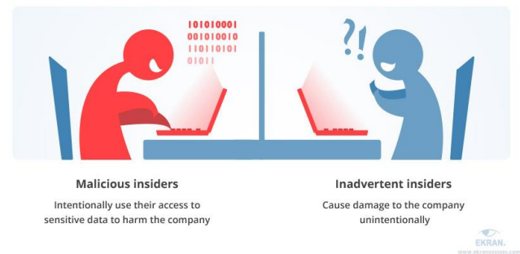

* **Malicious insiders –** Intentionally user their access to sensitive data to harm the company
* **Inadvertent insiders –** Cause damage to the company unintentionally

**Hacktivists** - a person who gains unauthorized access to computer files or networks in order to further social or political ends.

**Data theft** is the act of stealing information stored on computers, servers, or other devices from an unknowing victim with the intent to compromise privacy or obtain confidential information.

**Script kiddie**, skiddie, or skid is an unskilled individual who uses scripts or programs, such as a web shell, developed by others to attack computer systems and networks and deface websites.

**Electronic vandalism** entails the determined and intentional malicious attempt to destroy or manipulate the electronic media and data through viruses, malevolent codes and other similar means

**Cyberterrorism** is the use of the Internet to conduct violent acts that result in, or threaten, loss of life or significant bodily harm, in order to achieve political or ideological gains through threat or intimidation

**MALWARE & SOFTWARE-BASED THREATS**

**Software Attacks**

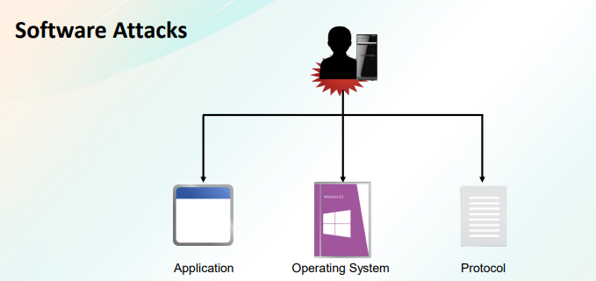

* Application
* Operating System
* Protocol

Software attacks means attack by Viruses, Worms, Trojan Horses etc. Many users believe that malware, virus, worms, bots are all same things.

**TYPES OF MALWARE**

Common for a computer to be connected to the internet, there are more opportunities than ever for a computer to be infected by malware.

Malware can be identified as one or more of the following:

❑Virus

❑Worm

❑Adware

❑Spyware and dishonest adware

❑Trojan horse

❑Rootkit

❑Backdoor

❑Polymorphic virus

❑Logic Bomb

❑Botnets

❑Zero-day attack

❑Ransomware

❑Armored Virus

**Viruses**

A computer virus is a malicious software program loaded onto a user’s computer without the user’s knowledge and performs malicious actions.

**Worms**

A computer worm is a malicious, self-replicating software program which affects the functions of software and hardware programs.

**Adware**

Adware software that automatically displays or downloads advertising material (often unwanted) when a user is online.

**Spyware**

Spyware is unwanted software that infiltrates your computing device, stealing your internet usage data and sensitive information.

**Ex:** Spyware is unwanted software that infiltrates your computing device, stealing your internet usage data and sensitive information

**Trojan Horses**

A Trojan horse is an executable program that appears as a desirable or useful program.

**Rootkits**

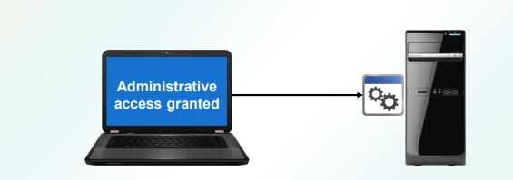

A rootkit is a software program designed to provide a user with administrator access to a computer without being detected.

**Backdoor Attacks**

A backdoor refers to any method by which authorized and unauthorized users are able to get around normal security measures and gain high level user access (aka root access) on a computer system, network, or software application.

**Polymorphic Malware**

Polymorphic malware is a type of malware that constantly changes its identifiable features in order to evade detection.

**Logic Bombs**

A logic bomb is commonly defined as an attribute or a portion of code running within a program that remains inactive until a specific event or time occurs.

**Botnets**

A botnet is a distributed network of computers that have been compromised by malicious software and are under the control of an attacker.

**Ransomware**

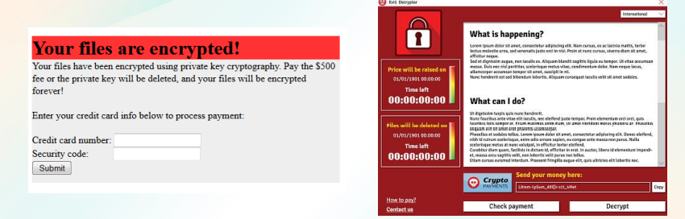

Ransomware is a type of malware from cryptology that threatens to publish the victim's data or perpetually block access to it unless a ransom is paid

**Armored Viruses**

An armored virus is a computer virus that contains a variety of mechanisms specifically coded to make its detection and decryption very difficult.

**Password Attacks**

Password attacks are a critical segment of a pentest in which preparation can make a major impact on the success (or failure) of a pentest.

**Types of Password Attacks**

✓ Dictionary attack

✓ Brute force attack

✓ Man In the Middle

✓ Birthday attack

✓ Rainbow Table Attack

**Types of Password Attacks**

**Dictionary attack** - An attack that takes advantage of the fact people tend to use common words and short passwords.

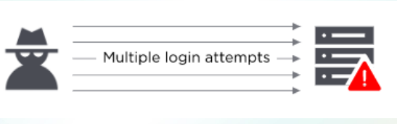

**Brute force** - Using a program to generate likely passwords or even random character sets.

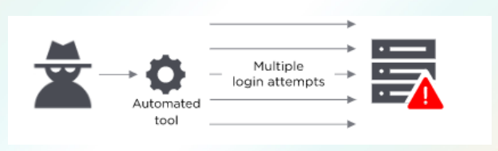

**Man In the Middle** - the hacker’s program doesn’t just monitor information being passed but actively inserts itself in the middle of the interaction, usually by impersonating a website or app.

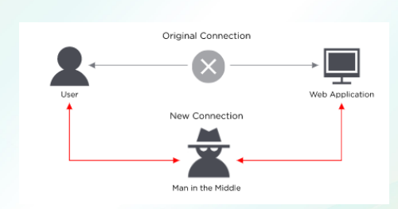

**Rainbow Table Attack** - a rainbow table compiles a list of pre-computed hashes.

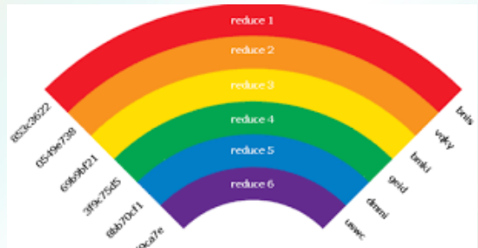

**Application Attacks**

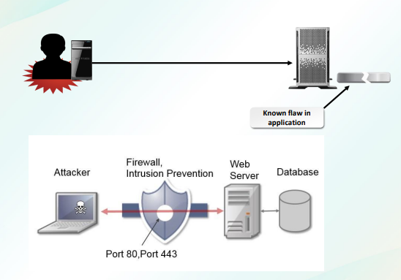

**Types of Application Attacks**

|  |  |
| --- | --- |
| Types of Application Attacks | Description |
| Cross-site scripting (XSS) | An attack that injects malicious scripts into trusted websites to be run when a user visits the site. |
| Command injection attacks | Command injection attacks include several types:  • SQL injection  • LDAP injection  • XML injection  • Directory traversal |
| Zero day exploit | An attack that occurs when the security level of a system is at its lowest, immediately after the discovery of a vulnerability. |
| Cookies manipulation | An attack where an attacker injects a meta tag in an HTTP header, making it possible to modify a cookie stored in a browser. |
| LSO attack | An attack where a website running Flash stores data objects (Flash cookies) on a user’s computer that are difficult to detect and remove, and may threaten the user’s privacy. |
| Attachment attack | An attack where a website running Flash stores data objects (Flash cookies) on a user’s computer that are difficult to detect and remove, and may threaten the user’s privacy. |
| Malicious add-ons | An add-on that is meant to look like a normal add-on, except that when a user installs it, malicious content will be injected to target the security loopholes that are present in a web browser |
| Header manipulation | An attack where the attacker manipulates the header information passed between the web servers and clients in HTTP requests. |
| Buffer overflow | An attack in which data goes past the boundary of the destination buffer and begins to corrupt adjacent memory, which may cause an app to crash or rogue code to execute on a system |
| Integer overflow | An attack in which a computed result is too large to fit in its assigned storage space, which may lead to crashing or data corruption, and may trigger a buffer overflow. |
| Arbitrary code execution | An attack that exploits application vulnerabilities by allowing an attacker to execute any command on a victim's machine, potentially taking complete control over a system |

**Cross-site scripting** - This attack is the type of an injection in which there are some malicious scripts inserted into the websites which are pretty trusted ones by the users.

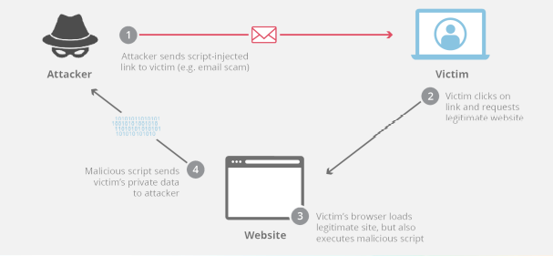

**Attacker** – Sends script-injected link to victim (email scam) -> **Victim** – victim clicks on link and request legitimate website -> **Website** -> Victim’s browser loads legitimate site, but also executes malicious script, -> Malicious script sends victim’s private data to attacker

**SQL injection** - This attack is the technique in which some code injection method is used.

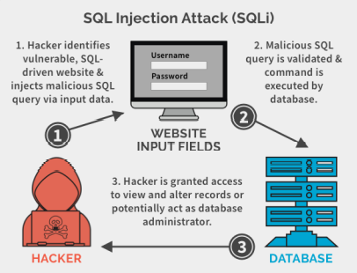

**LDAP injection** - This attack falls into the category of the applications attacks as well since it is also associated to some applications.

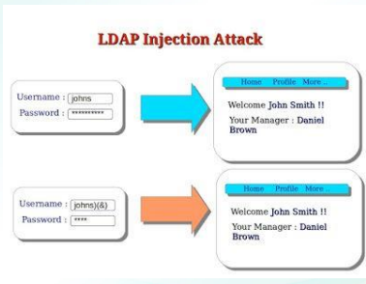

**XML injection** - When this attack is taken place, the attack mainly makes some efforts and has an aim to inject some XML tags into the SOAP message and hence he wants to modify the source of XML

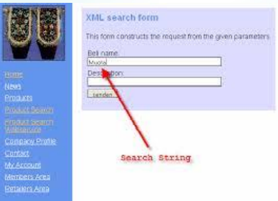

**Buffer overflow** - This term is seed very basically and widely in the computer programming and security.

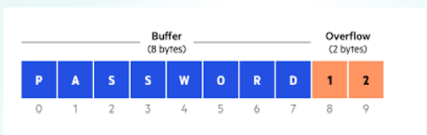

**Integer overflow** - There is some overflow of integer condition when there is an integer which is used in the determination of some memory allocation, concatenation, allocation and something like this.

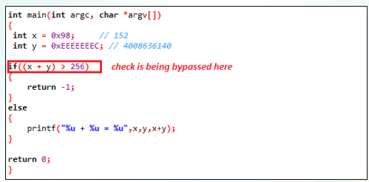

**Zero-day** - It is also known s the zero hour or the day zero attacks.



**Cookies and attachments** - There is a possibility that the cookies which are downloaded are infected ones and the attachments which are downloaded are also the victim of them.

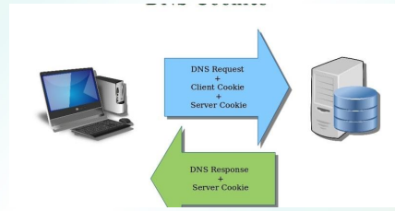

**LSO (Locally Shared Objects)**- Local shared objectives are the pieces of the data which belong to some website and they are happened when the adobe flash is stored on the user's computer.

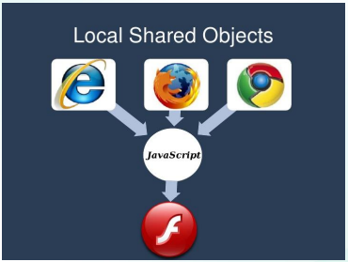

**Malicious add-ons** - Sometimes the ads on which are available to get can get injected and they can turn the computers into botnets, it happened once in the past when the Firefox got some ad on which created this problem.

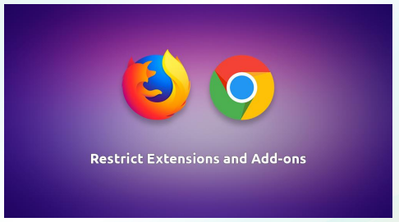

**Session hijacking** - This is also known as the cookie hijack. In this case, the computer session or the key session is simply exploited and hence the access to some unauthorized area is gained to get some information or the service in a computer.

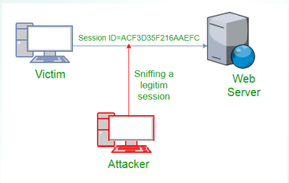

**NETWORK-BASED THREATS, WIRELESS THREATS, PHYSICAL THREATS AND VULNERABILITIES**

TCP/IP Basics

❑Standard network protocol used today.

❑A layered suite of many protocols.

❑The logical endpoints of a connection between hosts are called ports.

❑Ports can be open to allow communication or closed to prevent it.

❑Layers:

▪ Network interface/data link

▪ Internet

▪ Transport

▪ Application

**Port Scanning Attacks**

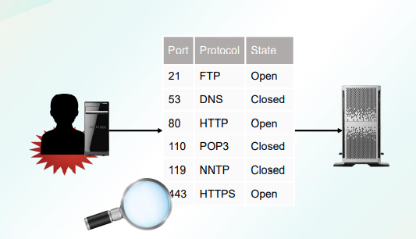

**Eavesdropping Attacks**

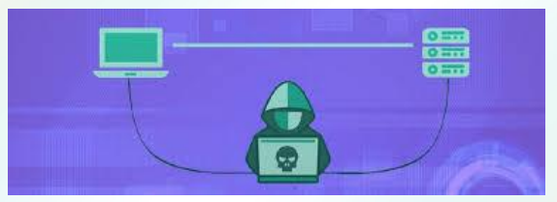

An eavesdropping attack can be difficult to detect because the network transmissions will appear to be operating normally.

**Man-in-the-Middle Attacks**

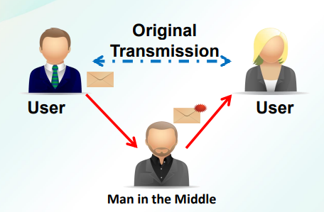

Man-in-the-Middle Attacks is an attack where the attacker secretly relays and possibly alters the communications between two parties who believe that they are directly communicating with each other.

**Replay Attacks**

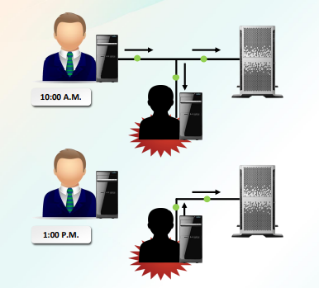

It is a form of network attack in which a valid data transmission is maliciously or fraudulently repeated or delayed.

**Social Network Attacks**

**▪ Evil twin attack** - is a fraudulent Wi-Fi access point that appears to be legitimate but is set up to eavesdrop on wireless communications.

**▪ Account phishing** - the act of sending an email to a user falsely claiming to be an established legitimate enterprise in an attempt to scam the user into surrendering private information that will be used for identity theft.

**▪ Drive-by download** - refers to potentially harmful software code that is installed on a person's computer without the user needing to first accept or even be made aware of the software installation.

**▪ Clickjacking** - is a malicious technique of tricking a user into clicking on something different from what the user perceives

**▪ Password stealer** - is a Trojan that is designed to gather information from a system.

**▪ Spamming** - the activity of sending advertisements by email to people who do not want to receive them

**DoS Attacks**

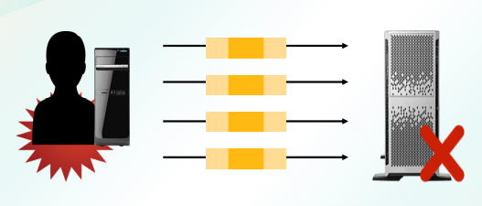

**Denial-of-service attack (DoS attack)** is a cyber-attack in which the perpetrator seeks to make a machine or network resource unavailable to its intended users by temporarily or indefinitely disrupting services of a host connected to the Internet.

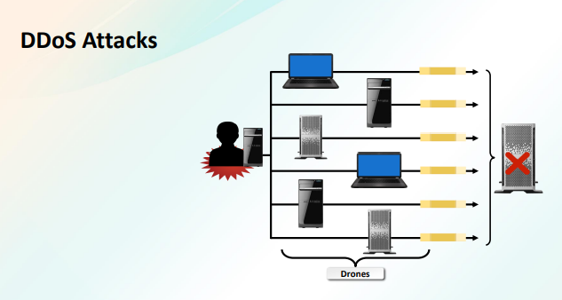

**Distributed denial of service (DDoS)** attacks are a subclass of denial of service (DoS) attacks.

**Types of DoS Attacks (1 of 2)**

**❑ ICMP flood** - also known as a Ping flood attack, is a common Denial-ofService (DoS) attack in which an attacker attempts to overwhelm a targeted device with ICMP echo-requests (pings)

**❑ UDP flood** - attack in which the attacker overwhelms random ports on the targeted host with IP packets containing UDP datagrams.

**❑ SYN flood** - an attacker sends a succession of SYN requests to a target's system in an attempt to consume enough server resources to make the system unresponsive to legitimate traffic.

**Types of DoS Attacks (2 of 2)**

**❑Buffer overflow**- is an anomaly where a program, while writing data to a buffer, overruns the buffer's boundary and overwrites adjacent memory locations.

**❑Reflected DoS attack** - makes use of a potentially legitimate third party component to send the attack traffic to a victim, ultimately hiding the attackers’ own identity.

**❑Permanent DoS attack** - is denial of service via hardware sabotage. During such an attack, an attacker bricks a device or destroys firmware, rendering the device or an entire system useless.

**Session Hijacking**

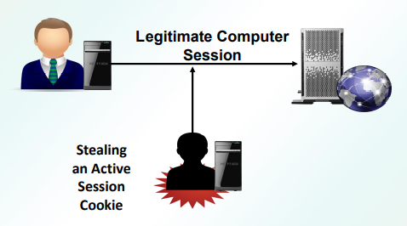

**Session hijacking** is an attack where a user session is taken over by an attacker.

**ARP Poisoning**

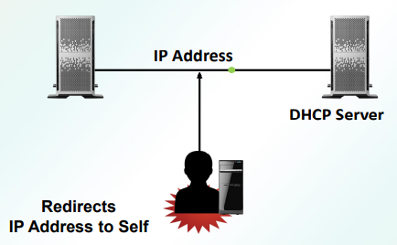

ARP poisoning is an attack on the protocol used to determine a device’s hardware address (MAC address) on the network when the IP address is known.

**Transitive Access Attacks**

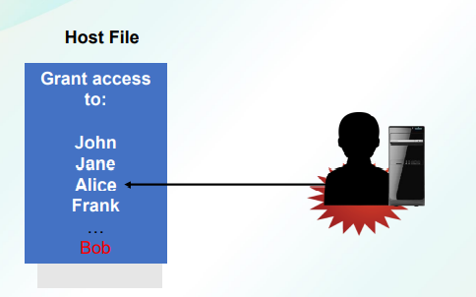

Transitive access is a misuse of trust that causes issues with securing information or control.

DNS Vulnerabilities

|  |  |
| --- | --- |
| Vulnerability | Description |
| DNS poisoning | An attacker exploits the traditionally open nature of the DNS system to redirect a domain name to an IP address of the attacker's choosing. |
| DNS hijacking | An attacker sets up a rogue DNS server. This rogue DNS server responds to legitimate requests with IP addresses for malicious or non-existent websites. |

**Wireless Security**

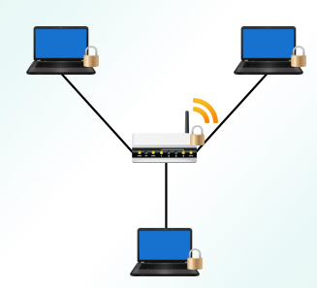

**Wireless security** is the prevention of unauthorized access or damage to computers or data using wireless networks, which include Wi-Fi networks.

**Rogue Access Points**

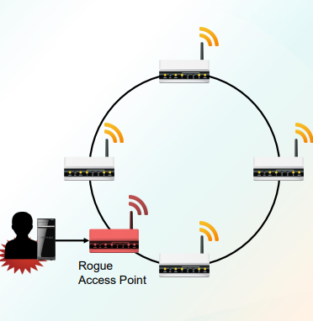

**Rogue access points** often do not conform to wireless LAN (WLAN) security policies, and additionally can allow anyone with a Wi-Fi device to connect to your network.

**Evil Twins**

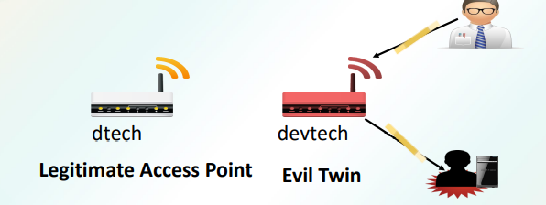

A rogue wireless access point installed near a legitimate one for purposes of eavesdropping or phishing.

**Jamming**

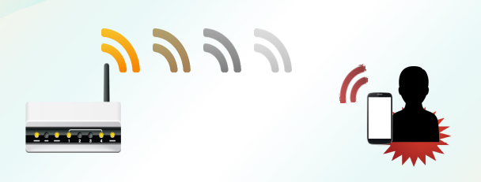

Jamming is a simple, yet highly effective method of causing a DoS on a wireless LAN.

**Bluejacking**

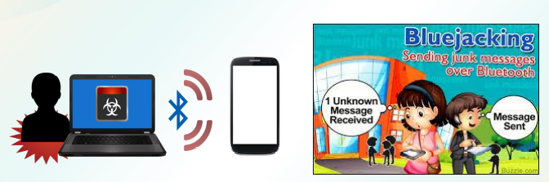

Bluejacking is a hacking method that allows an individual to send anonymous messages to Bluetooth-enabled devices within a certain radius.

**Bluesnarfing**

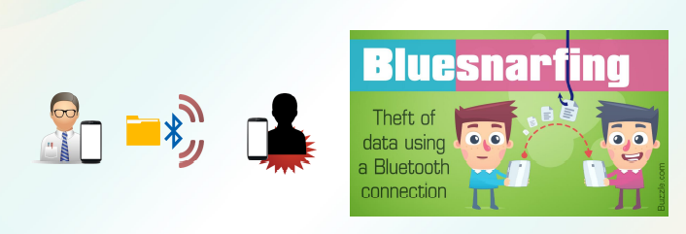

Bluesnarfing is a device hack performed when a wireless, Bluetoothenabled device is in discoverable mode.

**War Driving and War Chalking**

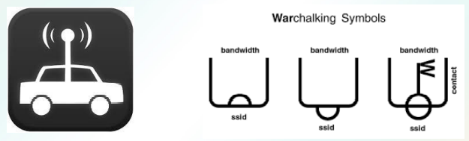

War driving also called access point mapping

Warchalking is the drawing of symbols in public places to advertise an open WiFi network.

**Wireless Replay Attacks**

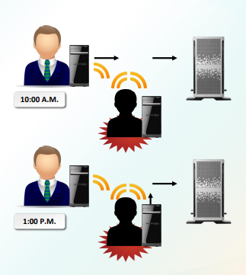

The delay or repeat of the data transmission is carried out by the sender or by the malicious entity, who intercepts the data and retransmits it.

**Sinkhole Attacks**

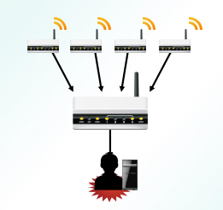

Sinkhole attacks are carried out by either hacking a node in the network or introducing a fabricated node in the network

**WEP and WPA Attacks**

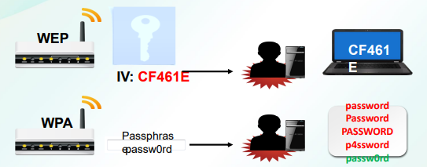

Wired Equivalent Privacy (**WEP**) is used in home / personal as well as enterprise environments to protect the connection between a wireless device and Wifi network with a secret key.

A Wi-Fi Protected Access **(WPA) cracking attack** captures traffic and then performs an offline brute force attack to discover the encryption key.

**WPS Attacks**

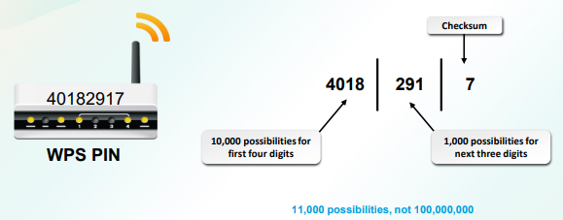

The WPS attack is relatively straightforward using an open source tool called **Reaver.**

**Physical Security**

❑ The implementation and practice of various control mechanisms that are intended to restrict physical access to facilities.

❑ Assuring the reliability of certain critical infrastructure elements such as electrical power, data networks, and fire suppression systems.

**Physical Security, Threats and Vulnerabilities**

• Physical security

• Physical threat

• Physical Vulnerability

❑ Internal

❑ External

❑ Natural

❑ Man-made

**Environmental Threats and Vulnerabilities**

❑ Fire

❑ Hurricanes and tornadoes

❑ Flood

❑ Extreme temperature

❑ Extreme humidity

**SUPPLEMENTARY**

**MODULE 2 IDENTIFYING SECURITY THREATS AND VULNERABILITIES**

**SUBTOPIC 1 Social Engineering Attacks**

OBJECTIVES Upon completion of this module, the student would be able to:

• Upon completion of this module, the student would be able to:

• Define the social engineering and its goals;

• Demonstrate the abstract view of the social engineering;

• Enumerate the types of social engineering;

**Social engineering** is a method used to gain access to data, systems, or networks, primarily through misrepresentation. This technique typically relies on the trusting nature of the person being attacked.

**Some techniques for avoiding social engineering attacks include the following:**

**Be suspicious:** Phone calls, emails, or visitors who ask questions about the company, its employees, or other internal information, should be treated with extreme suspicion, and if appropriate, reported to the security organization.

**Verify identity**: When receiving inquiries that you are unsure of, verify the identity of the requestor.

**Be cautious:** Do not provide sensitive information unless certain not only of the person’s identity, but also of the person’s right to have the information.

**Don’t use email:** Email is inherently insecure, and prone to a variety of address spoofing techniques. Don’t reveal personal or financial information in email.

**Types of Social Engineering**

* Spoofing/Impersonation
* Hoax
* Phishing
* Vishing
* Whaling
* URL hijacking/typo squatting
* Spam and spim
* Shoulder surfing
* Dumpster diving
* Tailgating

**Spoofing imitate** (something) while exaggerating its characteristic features for comic effect.

**Impersonation** is an act of pretending to be another person for the purpose of entertainment or fraud.

**Spoofing** is the act of disguising a communication from an unknown source as being from a known, trusted source. Spoofing can apply to emails, phone calls, and websites, or can be more technical, such as a computer spoofing an IP address.

**An impersonation attack** is an attack in which an adversary successfully assumes the identity of one of the legitimate parties in a system or in a communications protocol.

**Hoax** is a humorous or malicious deception. This is often a chain message telling recipients to forward the mail to all their contacts. The aim is simply to cause alarm and confusion among users.

**Phishing** is the fraudulent practice of sending emails purporting to be from reputable companies in order to induce individuals to reveal personal information, such as passwords and credit card numbers.

**Phishing** is a cyber-attack that uses disguised email as a weapon. The goal is to trick the email recipient into believing that the message is something they want or need — a request from their bank, for instance, or a note from someone in their company — and to click a link or download an attachment.

**Vishing** is the fraudulent practice of making phone calls or leaving voice messages purporting to be from reputable companies in order to induce individuals to reveal personal information, such as bank details and credit card numbers. Vishing is type of phishing attacks that try to lure victims via voice calls.

**A whaling attack** is a method used by cybercriminals to masquerade as a senior player at an organization and directly target senior or other important individuals at an organization, with the aim of stealing money or sensitive information or gaining access to their computer systems for criminal purposes. A whaling attack is a targeted attempt to steal sensitive information from a company such as financial information or personal details about employees, typically for malicious reasons. A whaling attack specifically targets senior management that hold power in companies, such as the CEO, CFO, or other executives who have complete access to sensitive data.

**URL hijacking** also known as typo squatting is the process by which a URL is wrongly removed from the search engine index and replaced by another URL. The new, false URL still links to the actual target page, not directly, but via a redirect. Since the incorrect URL also takes over the ranking of the original site, URL hijacking can lead to a huge drop in visitors.

**Spam** is unsolicited usually commercial messages sent to many recipients or posted in many places. Spam is the use of messaging systems to send an unsolicited message

**Spim** is perpetuated by bots that harvest IM screen names off the Internet and simulate a human user by sending spam to the screen names via an instant message. The spim typically contains a link to a Web site that the spimmer is trying to market. Spam over instant messaging (IM).

**Shoulder surfing** is a form of credit-card fraud in which the perpetrator stands behind and looks over the shoulder of the victim as he or she withdraws money from an automated teller machine, memorizes the card details, and later steals the card. Shoulder surfing is a type of social engineering technique used to obtain information such as personal identification numbers (PINs), passwords and other confidential data by looking over the victim's shoulder, either from keystrokes on a device or sensitive information being spoken and heard, also known as eavesdropping.

**Dumpster diving** is a technique used to retrieve information that could be used to carry out an attack on a computer network. Dumpster diving isn't limited to searching through the trash for obvious treasures like access codes or passwords written down on sticky notes.

**Tailgating** - In these types of attacks, someone without the proper authentication follows an authenticated employee into a restricted area. The attacker might impersonate a delivery driver and wait outside a building to get things started. When an employee gains security’s approval and opens the door, the attacker asks the employee to hold the door, thereby gaining access to the building. Tailgating does not work in all corporate settings such as large companies whose entrances require the use of a keycard. However, in mid-size enterprises, attackers can strike up conversations with employees and use this show of familiarity to get past the front desk.

**Social Engineering Recommendations**

**Here are a few tips that organizations can incorporate into their security awareness training programs that will help users to avoid social engineering schemes:**

• Do not open any emails from untrusted sources.

• Do not give offers from strangers the benefit of the doubt.

• Lock your laptop whenever you are away from your workstation.

• Purchase anti-virus software.

• Malicious actors who engage in social engineering attacks prey off human psychology and curiosity in order to compromise their targets’ information. With this human-centric focus in mind, it is up to organizations to help their employees counter these types of attacks.

**Contact a friend or family member in person or by phone if you receive a suspicious email message from them.**

If they seem too good to be true, they probably are. To avoid stolen laptops. Read your company’s privacy policy to understand under what circumstances you can or should let a stranger into the building.

No AV solution can defend against every threat that seeks to jeopardize users’ information, but they can help protect against some.

**Hacker** was originally a neutral term.

**Attacker** always refers to malicious hackers.

**Categories of Attackers**

**Malicious insiders** can be current or former employees, contractors or business partners that gains access to an organizations network, system or data and release this information without permission by the organization.

**Hacktivism** is the act of misusing a computer system or network for a socially or politically motivated reason. ... Most hacktivists work anonymously. A hacktivist uses the same tools and techniques as a hacker but does so in order to disrupt services and bring attention to a political or social cause.

**Data theft** is a growing problem for individual computer users as well as large corporations and organizations. Data theft occurs both outside and inside companies and reducing the risk of insider data theft at the corporate level is anything but easy. This is especially true because system administrators and employees have access to technology such as database servers, desktop computers, and external devices including USBs, smart phones, and other removable and mobile devices.

**Script kiddie, skiddie, or skid** is an unskilled individual who uses scripts or programs, such as a web shell, developed by others to attack computer systems and networks and deface websites. It is generally assumed that most script kiddies are juveniles who lack the ability to write sophisticated programs or exploits on their own and that their objective is to try to impress their friends or gain credit in computerenthusiast communities. However, the term does not relate to the actual age of the participant. The term is derogatory.

**Electronic vandalism** entails the determined and intentional malicious attempt to destroy or manipulate the electronic media and data through viruses, malevolent codes and other similar means vandalism can be defined as defacing the digital assets of a company or individual to cause nuisance or permanent damage.

**Cyberterrorism** is the use of the Internet to conduct violent acts that result in, or threaten, loss of life or significant bodily harm, in order to achieve political or ideological gains through threat or intimidation. It is also sometimes considered an act of Internet terrorism where terrorist activities, including acts of deliberate, large-scale disruption of computer networks, especially of personal computers attached to the Internet by means of tools such as computer viruses, computer worms, phishing, and other malicious software and hardware methods and programming scripts. Cyberterrorism is a controversial term. Some authors opt for a very narrow definition, relating to deployment by known terrorist organizations of disruption attacks against information systems for the primary purpose of creating alarm, panic, or physical disruption.

**MODULE 2 IDENTIFYING SECURITY THREATS AND VULNERABILITIES**

**SUBTOPIC 2 MALWARE AND SOFTWARE-BASED THREATS**

OBJECTIVES

Upon completion of this module, the student would be able to:

• Explain the types of malware;

• Discuss the different types of malware;

• Give different malware attacks.

• Identify the different types of software-based threats;

• Define the different types of software-based threats;

• Discuss the types of application attacks

**Software Attacks**

Software attacks means attack by Viruses, Worms, Trojan Horses etc. Many users believe that malware, virus, worms, bots are all same things. But they are not same, only similarity is that they all are malicious software that behave differently. These are programs written deliberately to vandalize someone’s computer or to use that computer in an unauthorized way. There are many forms of malicious software; sometimes the media refers to all malicious software as viruses.

**TYPES OF MALWARE**

Common for a computer to be connected to the internet, there are more opportunities than ever for a computer to be infected by malware. In addition, over the last couple of years, the number of malware attacks perpetrated over the internet is staggering. Most of the time, these were intended to be harmless or merely annoying. However, as time goes by, malware has turned more toward vandalism, extortion, and even terrorism, as a tool used to compromise private information, encrypt data for ransom, and generally damage confidence in economic and political systems.

**Malware can be identified as one or more of the following:**

* Virus
* Worm
* Adware
* Spyware and dishonest adware
* Trojan horse
* Rootkit
* Backdoor
* Polymorphic virus
* Logic Bomb
* Botnets Zero-day attack
* Ransomware
* Armored Virus

**Viruses**

A computer virus is a malicious software program loaded onto a user’s computer without the user’s knowledge and performs malicious actions. A computer virus is a program that can copy itself and infect a computer without the user’s consent or knowledge. Early viruses were usually some form of executable code that was hidden in the boot sector of a disk or as an executable file (a file name with an .exe or .com extension).

**Worms**

A computer worm is a malicious, self-replicating software program which affects the functions of software and hardware programs. A worm is a self-replicating program that copies itself to other computers over the network without the need for any user intervention. Different from a virus, a worm does not corrupt or modify files on a target computer. Instead, it consumes bandwidth and ties up processor and memory resources, slowing the system down, and causing the system to become unusable.

**Adware**

Adware software that automatically displays or downloads advertising material (often unwanted) when a user is online. Adware is any software package that automatically plays, displays, or downloads advertisements to a computer after the software is installed on it or while the application is being used. While adware may not necessarily be bad, it is often used with ill intent.

**Spyware**

Spyware is unwanted software that infiltrates your computing device, stealing your internet usage data and sensitive information. Spyware is a type of malware that is installed on computers and collects personal information and browsing habits, often without the user’s knowledge. Spyware can also install additional software, which can redirect your web browser to other sites or change your home page. Spyware gathers your personal information and relays it to advertisers, data firms, or external users.

**Spyware (Example)** A keylogger is a program that records the keystrokes on a computer. It does this by monitoring a user's input and keeping a log of all keys that are pressed. A keylogger is a physical or logical device used to capture keystrokes. An attacker will either place a device between the keyboard and the computer or install a software program to record each keystroke taken, and then use software to replay the data to capture critical information like user IDs and passwords, credit card numbers, Social Security Numbers, or even confidential emails or other data.

**Trojan Horses**

A Trojan horse is an executable program that appears as a desirable or useful program. A Trojan horse is a program named after the Trojan horse story in Greek mythology. In Greek mythology, there is a story about the Trojan War. This war lasted many years, as the Greeks could not penetrate the heavily barricaded city of Troy. So, one day, a few of the Greek soldiers brought the people of Troy a large wooden horse, which they accepted as a peace offering. The horse was moved inside the city walls, where it sat until the night. After the people of the city had fallen asleep, Greek soldiers jumped out of the wooden horse, opened the gates to let their fellow soldiers in, and took over the city.

**Rootkits**

A rootkit is a software program designed to provide a user with administrator access to a computer without being detected. A rootkit is a software or hardware device designed to gain administrator-level control over a computer system without being detected. Rootkits can target the BIOS, hypervisor, boot loader, kernel or, less commonly, libraries or applications. Rootkits are considered one of the most serious types of malware since they may be used to gain unauthorized access to remote systems and perform malicious operations. The name "rootkit" includes the word "root," because the goal of a rootkit is to gain root access to a computer.

**Backdoor Attacks**

A backdoor refers to any method by which authorized and unauthorized users can get around normal security measures and gain high level user access (aka root access) on a computer system, network, or software application. Backdoor attacks are attacks against an opening left in a functional piece of software that allows access into a system or software application without the owner’s knowledge. Many times, these backdoors were left by the application developers, but current code testing has dramatically reduced the number of these found in commercial software.

Polymorphic Malware

Polymorphic malware is a type of malware that constantly changes its identifiable features in order to evade detection. Polymorphic malware is a type of malware that constantly changes its identifiable features in order to evade detection. Many of the common forms of malware can be polymorphic, including viruses, worms, bots, trojans, or keyloggers. Polymorphic techniques involve frequently changing identifiable characteristics like file names and types or encryption keys to make the malware unrecognizable to many detection techniques. A polymorphic virus will continue to spread and infect devices even if its signature changes to avoid detection

**Logic Bombs**

A logic bomb is commonly defined as an attribute or a portion of code running within a program that remains inactive until a specific event or time occurs. A logic bomb is a piece of code intentionally inserted into a software system that will set off a malicious function when specified conditions are met. For example, a programmer may hide a piece of code that starts deleting files (such as a salary database trigger), should they ever be terminated from the company.

**Botnets**

A botnet is a distributed network of computers that have been compromised by malicious software and are under the control of an attacker. A botnet is a number of Internet-connected devices, each of which is running one or more bots. Botnets can be used to perform Distributed Denial-of-Service (DDoS) attacks, steal data, send spam, and allows the attacker to access the device and its connection.

**Ransomware**

Ransomware is a type of malware from cryptology that threatens to publish the victim's data or perpetually block access to it unless a ransom is paid. Ransomware is one of the fastest growing forms of malware; it encrypts data files and then demands a ransom to decrypt the files. As the user tries to access the files, the files are unreadable until they are decrypted

**Armored Viruses**

An armored virus is a computer virus that contains a variety of mechanisms specifically coded to make its detection and decryption very difficult. One of these methods involves fooling anti-virus software into believing that the virus is resides somewhere other than its real location, which makes it difficult to detect and remove. A type of virus that has been designed to thwart attempts by analysts from examining its code by using various methods to make tracing, disassembling and reverse engineering more difficult. An Armored Virus may also protect itself from antivirus programs, making it more difficult to trace.

**Password Attacks**

Password attacks are a critical segment of a pentest in which preparation can make a major impact on the success (or failure) of a pentest. A password attack is exactly what it sounds like: a third party trying to gain access to your systems by cracking a user's password.

**Types of Password Attacks**

* Dictionary attack
* Brute force attack
* Man In the Middle
* Birthday attack
* Rainbow Table Attack

**Dictionary attack** - An attack that takes advantage of the fact people tend to use common words and short passwords. The hacker uses a list of common words, the dictionary, and tries them, often with numbers before and/or after the words, against accounts in a company for each username. (Usernames are generally pretty easy to determine as they are almost universally based on the names of the employees.) A dictionary attack allows hackers to employ a program which cycles through common words.

**Brute force -** Using a program to generate likely passwords or even random character sets. These attacks start with commonly used, weak passwords like Password123 and move on from there. The programs running these attacks usually try variations on upper and lowercase characters, as well. In a brute force attack, a hacker uses a computer program to login to a user’s account with all possible password combinations. Moreover, brute force accounts don’t start at random; instead, they start with the easiestto-guess passwords. A hacker uses a computer program to login to a user’s account with all possible password combinations.

**Man In the Middle -** the hacker’s program doesn’t just monitor information being passed but actively inserts itself in the middle of the interaction, usually by impersonating a website or app. In this attack, This allows the program to capture the user’s credentials and other sensitive information, such as account numbers, social security numbers, etc. Man in the middle (MITM) attacks are often facilitated by social engineering attacks which lure the user to a fake site.

**Rainbow Table Attack** - a rainbow table compiles a list of pre-computed hashes. It already has the mathematical answers for all possible password combinations for common hash algorithms. Like many identity managements threats, this one uses time to its advantage. A rainbow table is a precomputed table for reversing cryptographic hash functions, usually for cracking password hashes. Tables are usually used in recovering a password (or credit card numbers, etc.) up to a certain length consisting of a limited set of characters. It is a practical example of a space–time tradeoff, using less computer processing time and more storage than a brute-force attack which calculates a hash on every attempt, but more processing time and less storage than a simple lookup table with one entry per hash.

**Application Attacks**

**Types of Application Attacks**

**Cross-site scripting -** This attack is the type of an injection in which there are some malicious scripts inserted into the websites which are trusted ones by the users.

**SQL injection -** This attack is the technique in which some code injection method is used. This is used to make some attacks on the applications which are data driven. There the SQL statements which are malicious are inserted into the fields for some executions. This injection of SQP also exploits the security vulnerability in some application software. User might put some input which is not correct and is not filtered or there is some string character which has been embedded in the SQL statements. It might also happen that the input given by the user is not types so strongly and is handled badly.

**LDAP injection -** This attack falls into the category of the applications attacks as well since it is also associated to some applications. This injection is used there to exploit some of the website-based applications which can construct the LDAP statements. The statements constructed are based on some input which is given by user. When there is an application which fails to sanitize the input, then it becomes possible for the LDAP statements to use the local proxy.

**XML injection -** When this attack is taken place, the attack mainly makes some efforts and has an aim to inject some XML tags into the SOAP message and hence he wants to modify the source of XML. If the injection of XML is successful, then the result is the execution of the operation which is restricted. Also, it depends on the operation that the security objectives done might get violated as well

**Buffer overflow -** This term is seed very basically and widely in the computer programming and security. There is a thing where some problem, over burns the boundaries of the user and overwrite that's adjunct memory. It happens when the data is being written to the buffer. This is some case which is special and belongs to the memory safety violation. These overflows can be initiated by some inputs which are specially made for the execution of codes. They can be used for targeting any other programs as well.

**Integer overflow -** There is some overflow of integer condition when there is an integer which is used in the determination of some memory allocation, concatenation, allocation and something like this. That integer is not checked properly and hence it causes some damages. That integer might be wrapped up into something very tiny and the negative number as well and hence it can provide some really in accurate value. There are some consequences too which are associated to it, like the availability of the integer can lead someone to the overflowing of some identifying behavior. It can also result into some crashes.

**Zero-day -** It is also known as the zero hour or the day zero attacks. It is a threat which can exploit smooth vulnerability which has been known in the past as well. They can exist in any of the computer applications. It may happen that the developer who developed that application couldn't find time to overcome it or could create some security patch.

**Cookies and attachments -** There is a possibility that the cookies which are downloaded are infected ones and the attachments which are downloaded are also the victim of them. When this thing happens, if someone has got some anti-viruses or any other denting program installed, it will automatically detect the cookies which are lying there and hence it would become so easy for someone to remove them and he can secure his computer.

**LSO (Locally Shared Objects)-** Local shared objectives are the pieces of the data which belong to some website and they are happened when the adobe flash is stored on the user's computer. These LSO are mostly used by the adobe flash's all versions and the non-obsolete flash player's versions as well. There is some important usage of these flashes when the user likes to play some flash games. Here the websites might become the victim of it for the purpose of having some strong user's preferences. Then there are some privacy concerns which can go on regarding the LSO and it might result into the breaching of browser securities.

**Malicious add-ons -** Sometimes the ads on which are available to get can get injected and they can turn the computers into botnets, it happened once in the past when the Firefox got some ad on which created this problem.

**Session hijacking -** This is also known as the cookie hijack. In this case, the computer session or the key session is simply exploited and hence the access to some unauthorized area is gained to get some information or the service in a computer. Specially, this thing is used for the theft of some magic cookie which is used for the authentication of user to some remote access.

**MODULE 2 IDENTIFYING SECURITY THREATS AND VULNERABILITIES**

**SUBTOPIC 3 NETWORK-BASED THREATS, WIRELESS THREATS, PHYSICAL THREATS AND VULNERABILITIES OBJECTIVES**

Upon completion of this module, the student would be able to:

• Define TCP/IP;

• Discuss the concept of network-based attacks;

• Differentiate the types of network-based attacks;

• Define wireless threats and vulnerability;

• Discuss the concept of wireless security;

• Differentiate the types of wireless attacks;

**TCP/IP Basics**

Standard network protocol used today.

A layered suite of many protocols. The logical endpoints of a connection between hosts are called ports. Ports can be open to allow communication or closed to prevent it.

**Layers:**

* Network interface/data link
* Internet
* Transport
* Application

**Port Scanning Attacks**

A port scan is an attack that sends client requests to a range of server port addresses on a host, with the goal of finding an active port and exploiting a known vulnerability of that service. Scanning, as a method for discovering exploitable communication channels, has been around for ages.

**Eavesdropping Attacks**

An eavesdropping attack can be difficult to detect because the network transmissions will appear to be operating normally. An eavesdropping attack, which are also known as a sniffing or snooping attack, is an incursion where someone tries to steal information that computers, smartphones, or other devices transmit over a network.

**Man-in-the-Middle Attacks**

Man-in-the-Middle Attacks is an attack where the attacker secretly relays and possibly alters the communications between two parties who believe that they are directly communicating with each other. A man-in-the-middle attack is a type of attack where the attacker breaks into the communication between the endpoints of a network connection. Once the attacker has broken into the communication stream, they can intercept data being transferred, or even inject false information into the data stream.

**Replay Attacks**

It is a form of network attack in which a valid data transmission is maliciously or fraudulently repeated or delayed. A replay attack occurs when a cybercriminal eavesdrops on a secure network communication, intercepts it, and then fraudulently delays or resends it to misdirect the receiver into doing what the hacker wants. The added danger of replay attacks is that a hacker doesn't even need advanced skills to decrypt a message after capturing it from the network. The attack could be successful simply by resending the whole thing.

**Social Network Attacks**

**Evil twin attack** - is a fraudulent Wi-Fi access point that appears to be legitimate but is set up to eavesdrop on wireless communications.

**Account phishing** - the act of sending an email to a user falsely claiming to be an established legitimate enterprise in an attempt to scam the user into surrendering private information that will be used for identity theft.

**Drive-by download -** refers to potentially harmful software code that is installed on a person's computer without the user needing to first accept or even be made aware of the software installation. Drive-by downloads may happen when visiting a website, opening an e-mail attachment or clicking a link, or clicking on a deceptive pop-up window: by clicking on the window in the mistaken belief that, for example, an error report from the computer's operating system itself is being acknowledged or a seemingly innocuous advertisement pop-up is being dismissed.

**Clickjacking -** is a malicious technique of tricking a user into clicking on something different from what the user perceives

**Password stealer -** is a Trojan that is designed to gather information from a system. Spamming - the activity of sending advertisements by email to people who do not want to receive them

**DoS Attacks**

Denial-of-service attack (DoS attack) is a cyber-attack in which the perpetrator seeks to make a machine or network resource unavailable to its intended users by temporarily or indefinitely disrupting services of a host connected to the Internet. A denial-of-service (DoS) attack is an attack whereby the attacker renders a machine or network resource unavailable. It is usually done by flooding the targeted machine or resources with superfluous requests in an attempt to overload the system.

**DDoS Attacks**

Distributed denial of service (DDoS) attacks are a subclass of denial of service (DoS) attacks. A DDoS attack involves multiple connected online devices, collectively known as a botnet, which are used to overwhelm a target website with fake traffic. This type of attack takes advantage of the specific capacity limits that apply to any network resources – such as the infrastructure that enables a company’s website. The DDoS attack will send multiple requests to the attacked web resource – with the aim of exceeding the website’s capacity to handle multiple requests… and prevent the website from functioning correctly.

**Types of DoS Attacks**

**ICMP flood** - also known as a Ping flood attack, is a common Denial-of-Service (DoS) attack in which an attacker attempts to overwhelm a targeted device with ICMP echo-requests (pings)

**UDP flood** - attack in which the attacker overwhelms random ports on the targeted host with IP packets containing UDP datagrams.

**SYN flood** - an attacker sends a succession of SYN requests to a target's system in an attempt to consume enough server resources to make the system unresponsive to legitimate traffic.

**Buffer overflow-** is an anomaly where a program, while writing data to a buffer, overruns the buffer's boundary and overwrites adjacent memory locations.

**Reflected DoS attack** - makes use of a potentially legitimate third party component to send the attack traffic to a victim, ultimately hiding the attackers’ own identity.

**Permanent DoS attack -** is denial of service via hardware sabotage. During such an attack, an attacker bricks a device or destroys firmware, rendering the device or an entire system useless.

**Session Hijacking**

Session hijacking is an attack where a user session is taken over by an attacker. A session starts when you log into a service, for example your banking application, and ends when you log out. The attack relies on the attacker’s knowledge of your session cookie, so it is also called cookie hijacking or cookie side-jacking.

**ARP Poisoning**

ARP poisoning is an attack on the protocol used to determine a device’s hardware address (MAC address) on the network when the IP address is known. It is a technique by which an attacker sends (spoofed) Address Resolution Protocol (ARP) messages onto a local area network.

**Transitive Access Attacks**

Transitive access is a misuse of trust that causes issues with securing information or control. Transitive access might be thought of as a kind of inheritance. If a user has rights to one system, and that system has rights to another system, it follows that the user has rights to the second system. If system A trusts B and system B trusts C, then it is possible for system A to inadvertently trust system C, which might lead to exploitation by a nefarious operator on system C.

**DNS Vulnerabilities**

DNS poisoning - An attacker exploits the traditionally open nature of the DNS system to redirect a domain name to an IP address of the attacker's choosing.

**DNS hijacking** - An attacker sets up a rogue DNS server. This rogue DNS server responds to legitimate requests with IP addresses for malicious or non-existent websites.

**Wireless Security**

Wireless security is the prevention of unauthorized access or damage to computers or data using wireless networks, which include Wi-Fi networks. Wireless security is the prevention of unauthorized users from accessing your wireless network and stealing the data using your Wi-Fi network. To be precise, wireless security ensures protection to a Wi-Fi network from unauthorized access.

**Rogue access points** often do not conform to wireless LAN (WLAN) security policies, and additionally can allow anyone with a Wi-Fi device to connect to your network. A rogue access point, also called rogue AP, is any Wi-Fi access point that is installed on a network but is not authorized for operation on that network, and is not under the management of the network administrator. Rogue access points often do not conform to wireless LAN (WLAN) security policies, and additionally can allow anyone with a Wi-Fi device to connect to your network. A rogue access point is a wireless access point that has been installed on a secure network without explicit authorization from a local network administrator, whether added by a well-meaning employee or by a malicious attacker.

**Evil Twins** A rogue wireless access point installed near a legitimate one for purposes of eavesdropping or phishing. A rogue access point is a wireless access point that has been installed on a secure network without explicit authorization from a local network administrator, whether added by a well-meaning employee or by a malicious attacker.

**Jamming**

Jamming is a simple, yet highly effective method of causing a DoS on a wireless LAN. Jamming, as the name suggests, involves the use of a device to intentionally create interfering radio signals to effectively “jam” the airwaves, resulting in the AP and any client devices being unable to transmit.

**Bluejacking**

Bluejacking is a hacking method that allows an individual to send anonymous messages to Bluetooth-enabled devices within a certain radius. Bluejacking is the sending of unsolicited messages over Bluetooth to Bluetooth-enabled devices such as mobile phones, PDAs or laptop computers, sending a vCard which typically contains a message in the name field (i.e., for bluedating or bluechat) to another Bluetoothenabled device via the OBEX protocol. Bluejacking is also known as bluehacking.

**Bluesnarfing**

Bluesnarfing is a device hack performed when a wireless, Bluetooth-enabled device is in discoverable mode. Bluesnarfing allows hackers to remotely access Bluetooth device data, such as a user's calendar, contact list, emails and text messages. This attack is perpetrated without the victim's knowledge. Bluesnarfing is the unauthorized access of information from a wireless device through a Bluetooth connection, often between phones, desktops, laptops, and PDAs (personal digital assistant).

**War driving** also called access point mapping. War driving is the act of locating and possibly exploiting connections to wireless local area networks while driving around a city or elsewhere.

**Warchalking** is the drawing of symbols in public places to advertise an open Wi-Fi network. Inspired by hobo symbols, the warchalking marks were conceived by a group of friends in June 2002 and publicized by Matt Jones who designed the set of icons and produced a downloadable document containing them.

**Wireless Replay Attacks**

The delay or repeat of the data transmission is carried out by the sender or by the malicious entity, who intercepts the data and retransmits it.

**Sinkhole Attacks**

Sinkhole attacks are carried out by either hacking a node in the network or introducing a fabricated node in the network. The malicious node promotes itself as the shortest path to the base station and tries to guide the traffic from other nodes towards itself. DNS sinkhole or black hole DNS is used to spoof DNS servers to prevent resolving host names of specified URLs. This can be achieved by configuring the DNS forwarder to return a false IP address to a specific URL. DNS sink holing can be used to prevent access of malicious URLs in an enterprise level.

**WEP and WPA Attacks**

Wired Equivalent Privacy (WEP) is used in home / personal as well as enterprise environments to protect the connection between a wireless device and Wifi network with a secret key. A Wi-Fi Protected Access (WPA) cracking attack captures traffic and then performs an offline brute force attack to discover the encryption key. This attack uses aircrack-ng suite of commands to gain access to the WEP protected network. Wi-Fi Protected Setup (WPS) attacks also use a brute force attack, but do not need to wait for an authorized client to connect.

**WPS Attacks**

The WPS attack is relatively straightforward using an open source tool called Reaver.

**Physical Security**

The implementation and practice of various control mechanisms that are intended to restrict physical access to facilities. Assuring the reliability of certain critical infrastructure elements such as electrical power, data networks, and fire suppression systems.

**Physical Security, Threats and Vulnerabilities** Physical security describes security measures that are designed to deny unauthorized access to facilities, equipment and resources and to protect personnel and property from damage or harm. Physical threat means having a dangerous weapon in one’s possession and either threatening with or using the weapon or committing assault.

A Physical Vulnerability is defined as any flaw or weakness in a data system or its hosting environment that can enable a physical attack on the system.

**Physical Security, Threats and Vulnerabilities**

* Internal
* External
* Natural
* Man-made

**Environmental Threats and Vulnerabilities**

* Fire
* Hurricanes and tornadoes
* Flood
* Extreme temperature
* Extreme humidity

**MODULE 3 - MANAGING DATA, APPLICATION, AND HOST SECURITY**

**Application security** - is the process of making apps more secure by finding, fixing, and enhancing the security of apps.

* Proper development, deployment, and maintenance of applications.
* Protects applications from threats and vulnerabilities.

**Patch Management** – A solid patch management practice is the best defense against this type of attack, especially if coupled with a vulnerability management program.

Evaluate -> Test -> Implement

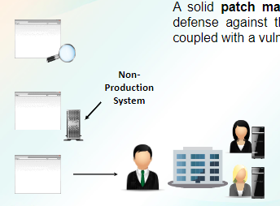

**Application Security Methods**

* Configuration
* Application hardening
* Patch management

**Input Validation –** Input validation, also known as data validation, is the proper testing of any input supplied by a user or application.

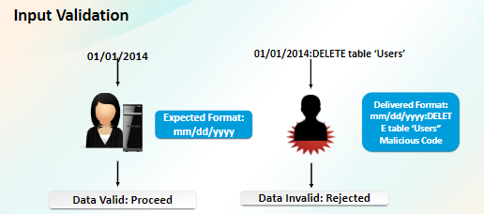

**Input Validation Vulnerabilities**

* Any type of software.
* Websites and applications are popular targets
* Requires careful coding to avoid.

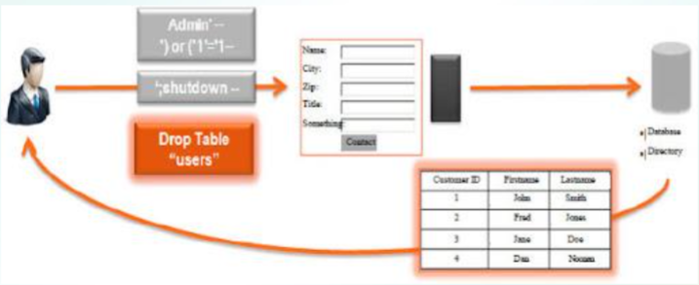

**Client-Side and Server-Side Validation**

* **Client-side validation:**
* Input validation and error recovery at the browser
* JavaScript, AJAX, VBScript, and HTML 5 attributes
* **Server-side validation:**
* Input validation and error recover at the server
* Perl, PHP, ASP, and other scripting languages
* **For enhanced user experience, use client-side validation.**
* **For enhanced security, use server-side validation.**

**Error and Exception Handling**

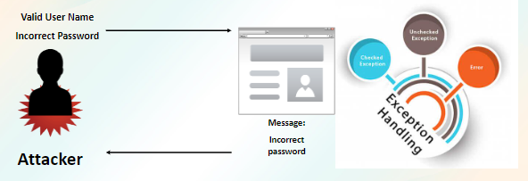

**XSS -Cross-site scripting**

**Cross-site scripting (XSS)** is a type of computer security vulnerability typically found in web applications.

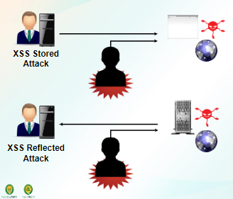

**Stored cross-site scripting** arises when an application receives data from an untrusted source and includes that data within its later HTTP responses in an unsafe way.

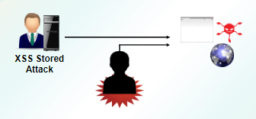

**Reflected cross-site scripting** arises when an application receives data in an HTTP request and includes that data within the immediate response in an unsafe way

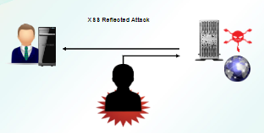

**Cross-site request forgery,** also known as one-click attack or session riding and abbreviated as CSRF (sometimes pronounced sea-surf) or XSRF

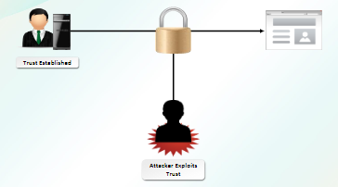

**Cross-Site Attack Prevention Methods**

* Restrict HTML formatting in form fields.
* Use input validation.
* Restrict cookie information.
* Encrypt data communications.
* Advise on the Remember Me options.

**Fuzzing** – Fuzz testing (fuzzing) is a quality assurance technique used to discover coding errors and security loopholes in software, operating systems or networks

**Web Browser Security**

* Pop-up blocker
* Parental controls
* Automated updating
* Encryption
* Proxy support
* Web content
* Advanced security
* **Pop-up blocker** - is software that prevents pop-up windows from appearing on a website.
* **Parental controls** - give guardians the ability to set parameters for what can show up on a browser
* **Automated updating**
* **Encryption** – is a process through which some or all of the Internet activity initiated from a Web browser is natively encrypted.
* **Proxy server** - is a server application or appliance that acts as an intermediary for requests from clients seeking resources from servers that provide those resources.
* **Web content** – is the textual, visual, or aural content that is encountered as part of the user experience on websites.

**Guidelines for Establishing Web Browser Security**

* Disable auto-complete and password saving.
* Harden the host machine.
* Install the latest software.
* Configure security settings.
* Disable scripting.
* Install anti-malware software

**Layered Security**

**Defense in depth** is a concept in which multiple layers of security are used to defend assets.

**Site security** deals with securing the physical premises.

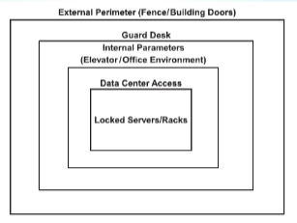

**Defense in Depth** – This multi-layered approach to physical security is known as defense-in-depth or a layered security approach.

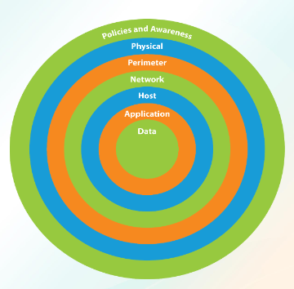

What Is Data Security?

**Data Security** is a process of protecting files, databases, and accounts on a network

* Security controls and measures implemented to secure an organization’s data.
* Protect data storage systems and devices that access them.
* Incorporated into security policies.

**Data Security Vulnerabilities**

* Increased cloud computing
* Lack of restricted access to data systems
* Lack of user awareness

**Data Storage Methods**

**Data storage** is a general term for archiving data in electromagnetic or other forms for use by a computer or device.

* DAS - Direct-Attached Storage
* NAS -Network-Attached Storage
* SAN -Storage Area Network
* Cloud

**Direct-attached storage (DAS)** is computer storage that is connected to one computer and not accessible to other computers.

**Network-Attached Storage** - NAS is usually attached to your computer through ethernet port via router or a network switch and allow multiple computers to connect to your NAS device at the same time.

**Cloud storage** is a model of computer data storage in which the digital data is stored in logical pools.

**Hardware-Based Encryption Devices**

* Enforces encryption, decryption, and access control using an HSM.
* Denies execution of external programs.
* Benefits
* Prevents unauthenticated storage mapping.
* Prevents copying data without the assigned HSM.
* Self-governed; not affected by malicious code or other OS issues.
* Proves that all computers are encrypted and that data is secure.

**Types of Hardware-Based Encryption Devices**

* TPM - Trusted Platform Module
* HSM - Hardware security module
* USB - Universal Serial Bus

**TPM** is a hardware-based encryption solution that is embedded in the system's motherboard and is enabled or disable in BIOS.

**Hardware Security Module (HSM)** is a crypto processor that can be used to enhance security. It provides a fast solution for the for large asymmetrical encryption calculations and is much faster than software-based cryptographic solutions

**Data States**

* Data at rest
* Data in transit
* Data in use

**Permissions and Access Control Lists**

**Permissions**

* Who can read or change data in a file or folder.
* Implemented at individual file and folder level.

**ACLs**

* Who can access files and folders.
* Implemented as MAC address filters on wireless routers and wireless APs.

**MANAGE DEVICE, MANAGE MOBILE SECURITYAND HOST SECURITY**

**Guidelines for Managing Application Security**

* Consider implementing a combination of client-side validation and server-side validation.
* Implement error and exception handling for applications developed in-house.
* Establish security configuration baselines.
* Harden applications, especially web browsers.
* Implement patch management for applications.
* Implement input validation.
* Protect against XSS and XSRF attacks.
* Protect databases and associated applications.

**Hardening** is a collection of tools, techniques, and best practices to reduce vulnerability in technology applications, systems, infrastructure, firmware, and other areas.

* Operating System Security
* Unique vulnerabilities for:
* Different operating systems
* Different vendors
* Client and server systems
* Vendors try to correct; attackers try to exploit.
* Security professionals must stay current.
* Manage services
* Configure firewall
* Configure Internet security
* Manage automatic updates
* Enable auditing and logging

**TCB -Trusted Computing**

**A trusted computing base** (TCB) refers to all of a computer system's hardware, firmware and software components that combine to provide the system with a secure environment.

**Security Baselines** - A "Security Baseline" defines a set of basic security objectives which must be met by any given service or system.

**Patches** - Supplemental code

**Hotfixes** - Address specific security flaws

**Rollups** - Collection of patches and hotfixes

**Service Packs** - Comprehensive updates with new features

**Application Blacklisting and Whitelisting**

**Black listing**: preventing identified programs from running.

**White listing**: allowing only identified programs to run.

**Logging** - A log file is a file that records either events that occur in an operating system or other software runs, or messages between different users of a communication software.

**Auditing** – Site security also provides the ability to audit activities within the facility. This can be done through reviewing camera footage, badge reader logs, visitor registration logs, or other mechanisms.

**Anti-malware** is a type of software program designed to prevent, detect and remove malicious software (malware) on IT systems, as well as individual computing devices.

**Types of Anti-malware Software**

* Antivirus
* Anti-spam
* Anti-spyware
* Pop-up blockers
* Host-based firewalls

**Virtualization Security Techniques**

* Establish a patch management system.
* Apply the least privilege concept.
* Establish log requirements.
* Establish secure design for virtual components.
* Take consistent snapshots of virtual environments.
* Ensure that virtual hosts are consistently available and elastic.
* Leverage virtual sandboxes for security testing.

**Hardware Security Controls**

* Logoff and shutdown procedures
* Wireless device approval
* Properly secured mobile devices
* Cable locks
* Strong password policies

**Non-standard Hosts**

Hosts and devices with static environments:

* SCADA
* Embedded-software systems
* Mainframe computers
* Some mobile devices

**Security Controls for Non-standard Hosts**

* Layered security:
* Network segmentation
* Application firewalls
* Manual updates
* Android
* iOS
* Firmware version control:
* SCADA systems
* Embedded systems
* Wrappers
* Controlling redundancy and diversity

**Strong Passwords** – A basic component of an information security program is ensuring that employees select and use strong passwords. The strength of a password can be determined by examining the length, complexity, and randomness of the password.

**Mobile Device Types**

* Smartphones
* Wi-Fi enabled devices

**Mobile Device Vulnerabilities**

* Viruses
* Spam
* Lost or stolen devices

**Mobile Device Security Controls**

* Use device management.
* Enable screen lock.
* Require strong passwords.
* Use device encryption if available.
* Require remote wipe/sanitization/lockout.
* Enable GPS tracking if available.
* Enforce access control.
* Enforce application control.
* Track assets and keep inventory.
* Limit removable storage use.
* Implement storage segmentation.
* Disable unused features.

**Mobile Application Security Controls**

* Encryption and key management
* Credential management
* Authentication and transitive trust
* Restricted geo-tagging
* Application white listing

**BYOD Controls**

* Corporate and acceptable use policies
* On-boarding and off-boarding
* Data/support ownership
* Patch and antivirus management
* Architecture and infrastructure needs
* Forensics
* Privacy
* Control for on-board camera, microphone, and video use

**MODULE 3 SUPPLEMENTARY**

# What Is Application Security?

Application security is the process of making apps more secure by finding, fixing, and enhancing the security of apps. Proper development, deployment, and maintenance of applications. Protects applications from threats and vulnerabilities. Much of this happens during the development phase, but it includes tools and methods to protect apps once they are deployed

# Patch Management

A solid patch management practice is the best defense against this type of attack, especially if coupled with a vulnerability management program. Software patches are often necessary in order to fix existing problems with software that are noticed after the initial release. Many of these patches have to do with security. Others may have to do with specific functionality for programs

# Application Security Methods

**Configuration baseline** - is a fixed reference in the development cycle or an agreed-upon specification of a product at a point in time.

**Application hardening** - is a process of taking a finished application and making it more difficult to reverse engineer and tamper.

**Patch management** - is an area of systems management that involves acquiring, testing and installing multiple patches, or code changes, to an administered computer system

**Input Validation -** Input validation is performed to ensure only properly formed data is entering the workflow in an information system, preventing malformed data from persisting in the database and triggering malfunction of various downstream components. Input validation should happen as early as possible in the data flow, preferably as soon as the data is received from the external party. Input Validation should not be used as the primary method of preventing XSS, SQL Injection and other attacks which are covered in respective cheat sheets but can significantly contribute to reducing their impact if implemented properly. Input validation vulnerability is characterized by the ability to decide at each step of the execution whether or not the program is in a safe state.

# Input Validation Vulnerabilities

Any type of software.

Websites and applications are popular targets.

Requires careful coding to avoid.

# Client-Side and Server-Side Validation

Client-side validation:

Input validation and error recovery at the browser

JavaScript, AJAX, VBScript, and HTML 5 attributes

# Server-side validation:

Input validation and error recover at the server

Perl, PHP, ASP, and other scripting languages

For enhanced user experience, use client-side validation.

For enhanced security, use server-side validation.

Before submitting data to the server, it is important to ensure all required form controls are filled out, in the correct format. This is called client-side form validation, and helps ensure data submitted matches the requirements set forth in the various form controls.

In the server-side validation, information is being sent to the server and validated using one of server-side languages. If the validation fails, the response is then sent back to the client, page that contains the web form is refreshed and a feedback is shown.

# Error and Exception Handling

An Error “indicates serious problems that a reasonable application should not try to catch.”

Both Errors and Exceptions are the subclasses of java.lang.Throwable class. Errors are the conditions which cannot get recovered by any handling techniques. It surely cause termination of the program abnormally. Errors belong to unchecked type and mostly occur at runtime. Some of the examples of errors are Out of memory error or a System crash error.

An Exception “indicates conditions that a reasonable application might want to catch.”

Exceptions are the conditions that occur at runtime and may cause the termination of program. But they are recoverable using try, catch and throw keywords. Exceptions are divided into two catagories : checked and unchecked exceptions. Checked exceptions like IOException known to the compiler at compile time while unchecked exceptions like ArrayIndexOutOfBoundException known to the compiler at runtime. It is mostly caused by the program written by the programmer.

# XSS - Cross-site scripting

**Cross-site scripting (XSS)** is a type of computer security vulnerability typically found in web applications. XSS enables attackers to inject client-side scripts into web pages viewed by other users. A cross-site scripting vulnerability may be used by attackers to bypass access controls such as the same-origin policy.

# XSS - Cross-site scripting

**Stored cross-site scripting** arises when an application receives data from an untrusted source and includes that data within its later HTTP responses in an unsafe way. Stored cross-site scripting also known as second-order or persistent XSS

Stored XSS, where the malicious script comes from the website's database. Stored XSS (also known as persistent or second-order XSS) arises when an application receives data from an untrusted source and includes that data within its later HTTP responses in an unsafe way.

Reflected cross-site scripting arises when an application receives data in an HTTP request and includes that data within the immediate response in an unsafe way. Reflected XSS arises when an application takes some input from an HTTP request and embeds that input into the immediate response in an unsafe way. With stored XSS, the application instead stores the input and embeds it into a later response in an unsafe way. Reflected XSS, where the malicious script comes from the current HTTP request. Reflected XSS is the simplest variety of cross-site scripting.

# XSRF - Cross-Site Request Forgery

Cross-site request forgery, also known as one-click attack or session riding and abbreviated as CSRF (sometimes pronounced sea-surf) or XSRF. Cross-site request forgery is a type of malicious exploit of a website where unauthorized commands are transmitted from a user that the web application trusts. Cross-Site Request Forgery (CSRF) is an attack that forces an end user to execute unwanted actions on a web application in which they’re currently authenticated. CSRF attacks specifically target state-changing requests, not theft of data, since the attacker has no way to see the response to the forged request. CSRF is an attack that tricks the victim into submitting a malicious request. It inherits the identity and privileges of the victim to perform an undesired function on the victim’s behalf. CSRF attacks are also known by a number of other names, including XSRF, “Sea Surf”, Session Riding, Cross-Site Reference Forgery, and Hostile Linking.

**Cross-Site Attack Prevention Methods**

Restrict HTML formatting in form fields.

Use input validation.

Restrict cookie information.

Encrypt data communications.

Advise on the Remember Me options.

# Fuzzing

Fuzz testing (fuzzing) is a quality assurance technique used to discover coding errors and security loopholes in software, operating systems or networks. It involves inputting massive amounts of random data, called fuzz, to the test subject in an attempt to make it crash. Fuzz testing or Fuzzing is a Black Box software testing technique, which basically consists in finding implementation bugs using malformed/semi-malformed data injection in an automated fashion. Fuzzing can add another point of view to classical software testing techniques (hand code review, debugging) because of it’s non-human approach.

# Web Browser Security

Browser security is the application of Internet security to web browsers in order to protect networked data and computer systems from breaches of privacy or malware.

Pop-up blocker

Parental controls

Automated updating

Encryption

Proxy support

Web content

Advanced security

# Web Browser Security

**Pop-up blocker -** is software that prevents pop-up windows from appearing on a website.

**Parental controls** - give guardians the ability to set parameters for what can show up on a browser

# Automated updating

**Encryption** - is a process through which some or all of the Internet activity initiated from a Web browser is natively encrypted.

**Proxy server** - is a server application or appliance that acts as an intermediary for requests from clients seeking resources from servers that provide those resources.

**Web content** - is the textual, visual, or aural content that is encountered as part of the user experience on websites.

**Guidelines for Establishing Web Browser Security**

Disable auto-complete and password saving.

Harden the host machine.

Install the latest software.

Configure security settings.

Disable scripting.

Install anti-malware software.

Defense in depth is a concept in which multiple layers of security are used to defend assets.

Site security deals with securing the physical premises.

This ensures that if an attacker breaches one layer of defenses, there are additional layers of defense to keep them out of the critical areas of an environment.

One of the fundamental concepts used when designing a security environment is the concept of defense in depth.

# Defense in Depth

This multi-layered approach to physical security is known as defense-in-depth or a layered security approach.

# What Is Data Security?

Data Security is a process of protecting files, databases, and accounts on a network. Data Security is a process of protecting files, databases, and accounts on a network by adopting a set of controls, applications, and techniques that identify the relative importance of different datasets, their sensitivity, regulatory compliance requirements and then applying appropriate protections to secure those resources.

Security controls and measures implemented to secure an organization’s data.

Protect data storage systems and devices that access them.

Incorporated into security policies.

**Data Security Vulnerabilities**

Increased cloud computing

Lack of restricted access to data systems

Lack of user awareness

# Data Storage Methods

Data storage is a general term for archiving data in electromagnetic or other forms for use by a computer or device.

DAS - Direct-Attached Storage

NAS - Network-Attached Storage

SAN - Storage Area Network

Cloud

**Direct-attached storage (DAS)** is computer storage that is connected to one computer and not accessible to other computers. Direct attached storage (DAS), also called direct attach storage, is digital storage that is attached directly to a computer or a server. In other words, DAS isn't part of a storage network. The most familiar example of DAS is the internal hard drive in a laptop or desktop PC.

**Network-Attached Storage** - NAS is usually attached to your computer through ethernet port via router or a network switch and allow multiple computers to connect to your NAS device at the same time. Network-attached storage (NAS) is a file-level (as opposed to block-level) computer data storage server connected to a computer network providing data access to a heterogeneous group of clients. Network Attached Storage is a dedicated file storage system which can be connected to many different devices at the same time and allows access to the same disk. NAS devices has its own file server capabilities to store and managed access to files but does not have any keyboard or display interface and are managed from the connected machine/computers.

**Storage area network (SAN) or storage network** is a Computer network which provides access to consolidated, block-level data storage. SANs are primarily used to enhance accessibility of storage devices, such as disk arrays and tape libraries, to servers so that the devices appear to the operating system as locally-attached devices.

**Storage Area Network (SAN)** is a specialized, high-speed network that provides block-level network access to storage. SANs are typically composed of hosts, switches, storage elements, and storage devices that are interconnected using a variety of technologies, topologies, and protocols.

**Cloud storage** is a model of computer data storage in which the digital data is stored in logical pools. The physical storage spans multiple servers (sometimes in multiple locations), and the physical environment is typically owned and managed by a hosting company. These cloud storage providers are responsible for keeping the data available and accessible, and the physical environment protected and running.

# Hardware-Based Encryption Devices

Enforces encryption, decryption, and access control using an HSM.

Denies execution of external programs.

# Benefits:

Prevents unauthenticated storage mapping.

Prevents copying data without the assigned HSM.

Self-governed; not affected by malicious code or other OS issues.

Proves that all computers are encrypted and that data is secure.

**Types of Hardware-Based Encryption Devices**

TPM - Trusted Platform Module

HSM - Hardware security module

USB - Universal Serial Bus

TPM is a hardware-based encryption solution that is embedded in the system's motherboard and is enabled or disable in BIOS. It helps with hash key generation and stores cryptographic keys, passwords, or certificates.

Hardware Security Module (HSM) is a crypto processor that can be used to enhance security. It provides a fast solution for the for large asymmetrical encryption calculations and is much faster than software- based cryptographic solutions

# Types of Hardware-Based Encryption Devices

TPM is a hardware-based encryption solution that is embedded in the system's motherboard and is enabled or disable in BIOS. It helps with hash key generation and stores cryptographic keys, passwords, or certificates.

**Trusted Platform Module (TPM)** is a specialized chip on an endpoint device that stores RSA encryption keys specific to the host system for hardware authentication. Each TPM chip contains an RSA key pair called the Endorsement Key (EK). The pair is maintained inside the chip and cannot be accessed by software.

**Hardware Security Module (HSM)** is a crypto processor that can be used to enhance security. It provides a fast solution for the for large asymmetrical encryption calculations and is much faster than software- based cryptographic solutions

A hardware security module (HSM) is a physical computing device that safeguards and manages digital keys, performs encryption and decryption functions for digital signatures, strong authentication and other cryptographic functions. These modules traditionally come in the form of a plug-in card or an external device that attaches directly to a computer or network server. A hardware security module contains one or more secure cryptoprocessor chips.

**Data States**

Data at rest

Data in transit

Data in use

Permissions and Access Control Lists

Permissions:

Who can read or change data in a file or folder.

Implemented at individual file and folder level.

# ACLs:

Who can access files and folders.

Implemented as MAC address filters on wireless routers and wireless APs.

# Hardening

Hardening is a collection of tools, techniques, and best practices to reduce vulnerability in technology applications, systems, infrastructure, firmware, and other areas. The next step in securing a server is to harden the server by reducing its surface of attack and thereby reducing the server’s vulnerabilities. To harden a server, look for security guides/guidelines and best practices for Windows servers and for the specific network services that are being installed, such as Microsoft Exchange or Microsoft SQL Server.

The goal of systems hardening is to reduce security risk by eliminating potential attack vectors and condensing the system’s attack surface. By removing superfluous programs, accounts functions, applications, ports, permissions, access, etc. attackers and malware have fewer opportunities to gain a foothold within your IT ecosystem.

# Operating System Security

Unique vulnerabilities for:

Different operating systems

Different vendors

Client and server systems

Vendors try to correct; attackers try to exploit.

Security professionals must stay current.

Operating System Security Settings

Manage services

Configure firewall

Configure Internet security

Manage automatic updates

Enable auditing and logging

# TCB - Trusted Computing Base

A trusted computing base (TCB) refers to all of a computer system's hardware, firmware and software components that combine to provide the system with a secure environment. The trusted computing base (TCB) of a computer system is the set of all hardware, firmware, and/or software components that are critical to its security, in the sense that bugs or vulnerabilities occurring inside the TCB might jeopardize the security properties of the entire system. By contrast, parts of a computer system outside the TCB must not be able to misbehave in a way that would leak any more privileges than are granted to them in accordance to the security policy. It enforces security policies to ensure security of the system and its information.

# Security Baselines

A "Security Baseline" defines a set of basic security objectives which must be met by any given service or system. A security baseline is a collection of security settings. Security baselines should include Microsoft’s recommendations for configuring those settings. To help with faster deployments, and to ease the managing of Windows, Microsoft provides customers with security baselines that can be used with Group Policy Objects (GPOs).

# Software Updates

**Patches:** Supplemental code. A patch is a set of changes to a computer program or its supporting data designed to update, fix, or improve it.

**Hotfixes:** Address specific security flaws. A hotfix or Quick Fix Engineering update (QFE update) is a single, cumulative package that includes information (often in the form of one or more files) that is used to address a problem in a software product.

**Rollups:** Collection of patches and hotfixes

**Service Packs:** Comprehensive updates with new features. A service pack is a collection of updates and fixes, called patches, for an operating system or a software program. Many of these patches are often released before a larger service pack, but the service pack allows for an easy, single installation.

**Application Blacklisting and Whitelisting**

**Blacklisting:** preventing identified programs from running. A blacklist or blocklist is a basic access control mechanism that allows through all elements (email addresses, users, passwords, URLs, IP addresses, domain names, file hashes, etc.), except those explicitly mentioned. Those items on the list are denied access.

**White listing:** allowing only identified programs to run. Whitelists are used frequently with e-mail applications to allow users to compile lists of senders they wish to receive e-mail from. This list overrides any blacklists and spam filters, and allows the e-mails to be delivered to the users inbox instead of filtered out as spam.

# Logging

A log file is a file that records either events that occur in an operating system or other software runs, or messages between different users of a communication software. Logging is the process of collecting and storing data over a period of time in order to analyze specific trends or record the data-based events/actions of a system, network or IT environment. Logging is the process of collecting and storing data over a period of time in order to analyze specific trends or record the data-based events/actions of a system, network or IT environment. It enables the tracking of all interactions through which data, files or applications are stored, accessed or modified on a storage device or application.

# Auditing

Site security also provides the ability to audit activities within the facility. This can be done through reviewing camera footage, badge reader logs, visitor registration logs, or other mechanisms.

# Anti-malware Software

Anti-malware is software tools and programs designed to identify and prevent malicious software, or malware, from infecting computer systems or electronic devices. Anti-malware tools can also include malware removal capabilities.

# Types of Anti-Malware Software

Antivirus

Anti-spam

Anti-spyware

Pop-up blockers

Host-based firewalls

**Antivirus software**, or anti-virus software (abbreviated to AV software), also known as anti-malware, is a computer program used to prevent, detect, and remove malware. Antivirus software was originally developed to detect and remove computer viruses, hence the name.

**Anti spam** refers to any software, hardware or process that is used to combat the proliferation of spam or to keep spam from entering a system. Anti-spam techniques are used to prevent email spam. Anti- spam refers to services and solutions that focus on blocking and mitigating the effects of illegal emails – or spam – on email users. To achieve this objective, different types of anti-spam systems have been integrated with the email systems of many email and Internet service providers (ISP).

**Anti-spyware** is a type of software that is designed to detect and remove unwanted spyware programs. Spyware is a type of malware that is installed on a computer without the user's knowledge in order to collect information about them. Anti-spyware software detects spyware through rules-based methods or based on downloaded definition files that identify common spyware programs. Anti-spyware software can be used to find and remove spyware that has already been installed on the user's computer, or it can act much like an anti-virus program by providing real-time protection and preventing spyware from being downloaded in the first place.

A **pop-up blocker** refers to any software or application that disables any pop-up, pop-over or pop-under advertisement window that you would see while using a Web browser. Some pop-up blockers may try to close all pop-up windows, some may remove all advertising from a publisher's Web site, and still others may help you choose which pop-up windows you want to be closed with block list feature.

Host-based firewalls run on host computers and control network traffic in and out of those machines.

**Virtualization Security Techniques**

Establish a patch management system.

Apply the least privilege concept.

Establish log requirements.

Establish secure design for virtual components.

Take consistent snapshots of virtual environments.

Ensure that virtual hosts are consistently available and elastic.

Leverage virtual sandboxes for security testing.

**Hardware Security Controls**

Logoff and shutdown procedures

Wireless device approval

Properly secured mobile devices

Cable locks

Strong password policies

Non-standard Hosts

**Hosts and devices with static environments:**

SCADA

Embedded-software systems

Mainframe computers

Some mobile devices

# Security Controls for Non-standard Hosts

Layered security:

Network segmentation

Application firewalls

# Manual updates:

Android

iOS

**Firmware version control:**

SCADA systems

Embedded systems

Wrappers

Controlling redundancy and diversity

# Strong Passwords

A basic component of an information security program is ensuring that employees select and use strong passwords. The strength of a password can be determined by examining the length, complexity, and randomness of the password. A strong password describes a password that is difficult to detect by both humans and computer programs, effectively protecting data from unauthorized access. A strong password consists of at least six characters (and the more characters, the stronger the password) that are a combination of letters, numbers and symbols (@, #, $, %, etc.) if allowed.

# Mobile Device Security Controls

Use device management.

Enable screen lock.

Require strong passwords.

Use device encryption if available.

Require remote wipe/sanitization/lockout.

Enable GPS tracking if available.

Enforce access control.

Enforce application control.

Track assets and keep inventory.

Limit removable storage use.

Implement storage segmentation.

Disable unused features.

**Mobile Application Security Controls**

Encryption and key management

Credential management

Authentication and transitive trust

Restricted geo-tagging

Application white listing

# BYOD Controls

Corporate and acceptable use policies

On-boarding and off-boarding

Data/support ownership

Patch and antivirus management

Architecture and infrastructure needs

Forensics

Privacy

Control for on-board camera, microphone, and video use

**MODULE 4 IMPLEMENTING NETWORK SECURITY**

**CONFIGURE SECURITY PARAMETERS ON NETWORK DEVICES AND TECHNOLOGIES**

**Network Components**

**There are several common components that make up a network:**

* Device
* Media
* Network adapter
* Network operating system
* Protocol

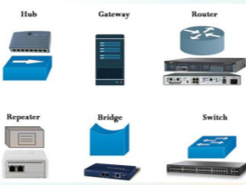

**Network Devices**

* Router
* Switch
* Firewall
* Load balancer
* All-in-one security appliance

**Using Dedicated Firewalls to Protect a Network**

A firewall is a system that is designed to protect a computer or a computer network from network-based attacks. A firewall does this by filtering the data packets traversing the network.

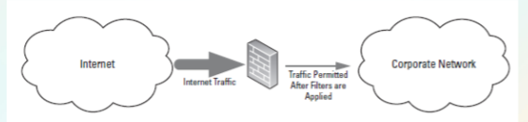

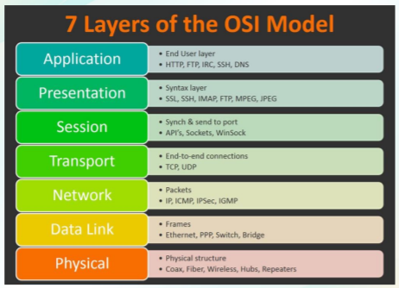

**OSI Model and Security**

* Identify threats and targets.
* Identify how threats will impact your network
* Secure your network by layers.

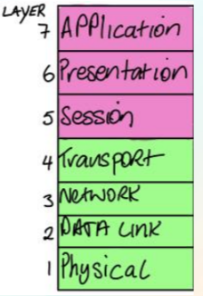

**When to Use a Hardware Firewall Instead of a Software Firewall**

There are two basic types of software firewall:

* Host firewall
* Network firewall

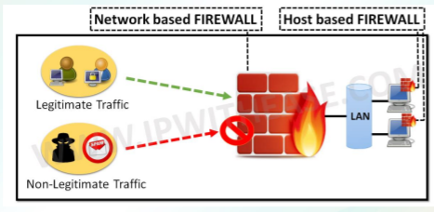

**Network Analysis Tools**

* Sniffers
* Protocol analyzers

With an understanding of the network infrastructure, the next step is to analyze the logs to see which traffic is allowed and which traffic is blocked.

* Ingress traffic
* Egress traffic

**VLAN** - Virtual Local Area Network

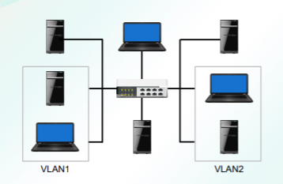

A virtual LAN (VLAN) is any broadcast domain that is partitioned and isolated in a computer network at the data link layer

**Subnet**

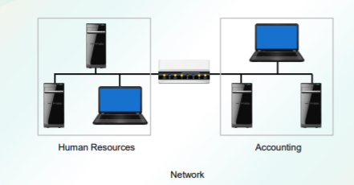

It is any broadcast domain that is partitioned and isolated in a computer network at the data link layer

**IDS - Intrusion Detection Systems**

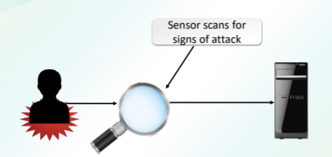

**INTRUSION DETECTION SYSTEMS (IDS)** are designed to detect unauthorized user activities, attacks, and network compromises.

**IPS - Intrusion Prevention System**

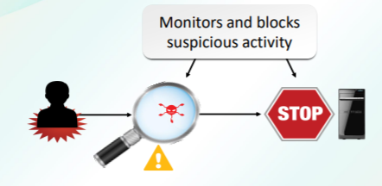

An intrusion prevention system (IPS) is very similar to an IDS, except that in addition to detecting and alerting, an IPS can also take action to prevent the breach from occurring.

**NIDS - Network-based Intrusion Detection System**

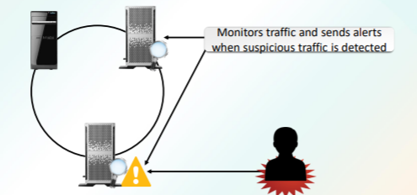

A network-based IDS (NIDS) monitors network traffic using sensors that are located at key locations within the network, often in the demilitarized zone (DMZ) or at network borders.

**Wireless IDS**

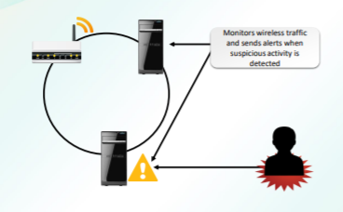

The WIDS is the software that detects an attack on a wireless network or wireless system.

**Network IPS**

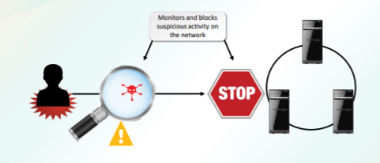

Intrusion Prevention System (IPS) is a network security/threat prevention technology that examines network traffic flows to detect and prevent vulnerability exploits.

**Wireless IPS**

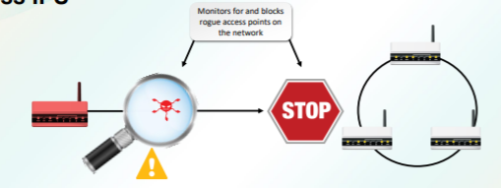

A wireless intrusion prevention system (WIPS) is a network device that monitors the radio spectrum for the presence of unauthorized access points (intrusion detection), and can automatically take countermeasures (intrusion prevention).

**Guidelines for Applying Network Security Administration Principles**

* Manage network devices so that they are configured according to security policies.
* Maintain documentation for all current server configurations.
* Establish and document baselines.
* Implement strong ACLs and implement implicit deny.
* Update antivirus software regularly.
* Configure only required network services.
* Disable unused interfaces and unused application service ports.
* Create and implement a DRP.
* Apply security updates and patches.
* Encrypt sensitive data.
* Check event logs for unusual activity.
* Monitor network activity.

**NETWORK DESIGN ELEMENTS, IMPLEMENT NETWORKING PROTOCOLS AND SERVICES**

**Network Monitoring Systems**

Network monitoring software is designed to monitor and manage the network traffic flow over a network.

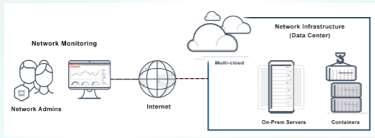

**Types of Network Monitoring Systems**

* Behavior-based
* Signature-based
* Anomaly-based
* Heuristic.

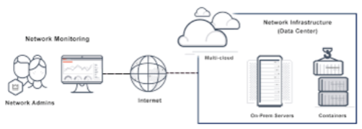

**Web Security Gateway**

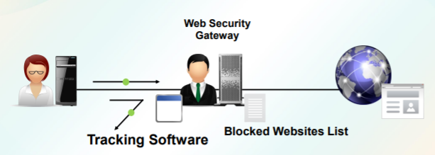

A Web security gateway is a type of security solution that prevents unsecured traffic from entering an internal network of an organization.

**DMZ - Demilitarized Zones**

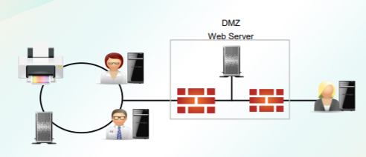

DMZs are designed to provide access to systems without jeopardizing the internal network.

**NAT - Network Address Translation**

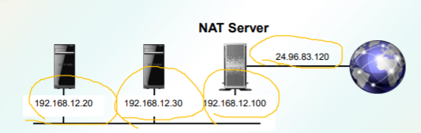

Network Address Translation (NAT) is a technique used to modify the network address information of a host while traffic is traversing a router or firewall.

There are two main types of NAT:

**Static NAT** is used when the translated device needs to be accessible from the public network.

**Dynamic NAT.** This is more commonly used when many hosts on the internal network need to access the internet and don’t have a requirement for a static address.

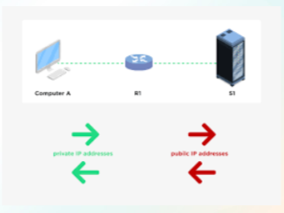

**VPN - Virtual Private Network**

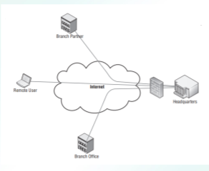

VPN (Virtual Private Network) is a technology that uses encrypted tunnels to create secure connections across public networks like the internet

**VPN Concentrator**

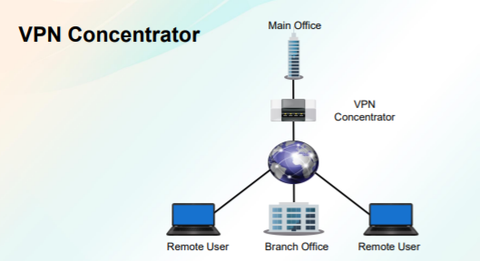

A VPN concentrator is a type of networking device that provides secure creation of VPN connections and delivery of messages between VPN nodes.

**Virtualization**



Virtualization is the process of running a virtual instance of a computer system in a layer abstracted from the actual hardware.

**Cloud Computing**

Cloud computing means storing and accessing data and programs over the Internet instead of your computer's hard drive.

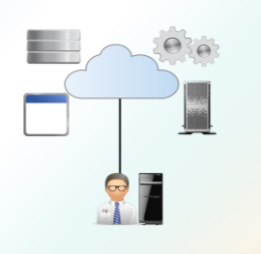

**Cloud Computing Deployment Models**

* Private
* Public
* Community
* Hybrid

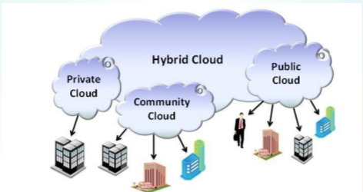

**Cloud Computing Service Types**

* SaaS - Software as a Service
* PaaS - Platform as a Service
* IaaS - Infrastructure as a Service

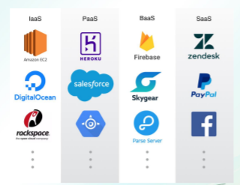

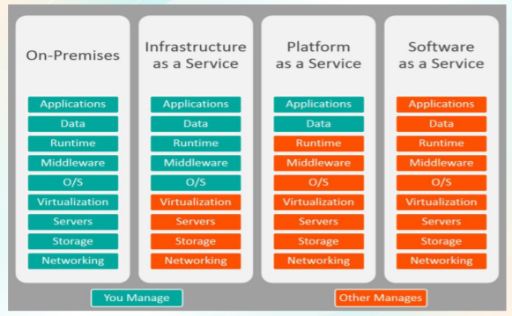

**DNS - Domain Name System (or Service or Server)**

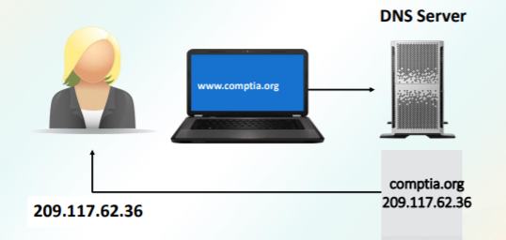

**HTTP - Hypertext Transfer Protocol.**

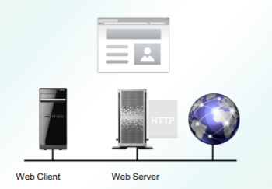

HTTP is the protocol used to transfer data over the web.

**HTTPS**

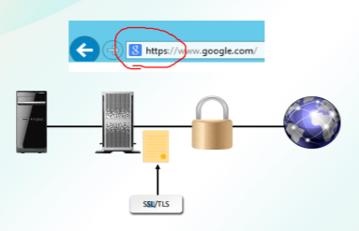

HTTPS, the secure version of HTTP web browsing, uses the SSL protocol.

**SSL/TLS**

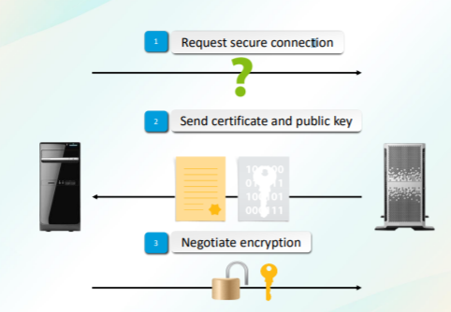

**SECURE SHELL (SSH)**

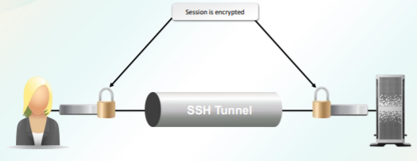

Secure Shell (SSH) is a cryptographic network protocol for operating network services securely over an unsecured network

**Telnet**

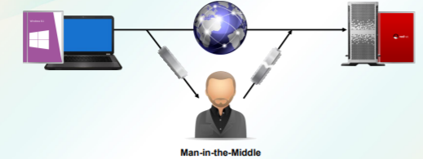

TELNET (TELecommunication NETwork) is a network protocol used on the Internet or local area network (LAN) connections.

Some of the applications supported with SSH include the following:

* Secure logon
* Secure remote command execution
* Secure file transfer
* Secure backup, copy, and mirroring of files
* Creation of VPN connections (when used in conjunction with the OpenSSH server and client)

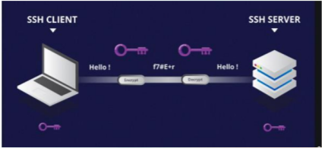

**SNMP - Simple Network Management Protocol**

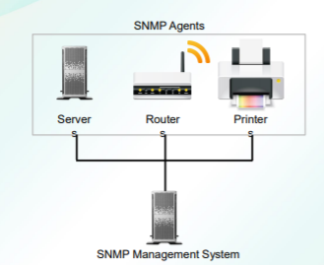

Simple Network Management Protocol (SNMP) is a set of protocols for network management and monitoring.

**ICMP**

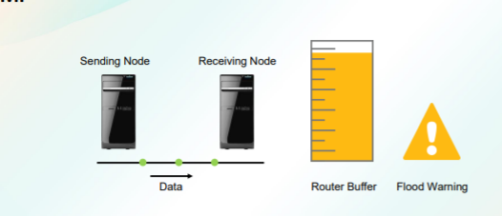

The Internet Control Message Protocol (ICMP) is a supporting protocol in the Internet protocol suite.

**IPSec**

* Data security in transit
* Data authenticity and integrity
* Anti-replay protection
* Non-repudiation
* Eavesdropping and sniffing protection

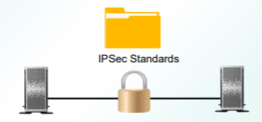

Internet Protocol Security (IPsec) is a secure network protocol suite that authenticates and encrypts the packets of data sent over an Internet Protocol network

**NetBIOS**

* Applications communicate across network
* Connection communication over sessions
* Connectionless datagram communication
* Name registration
* Vulnerable to analysis by malicious users
* Implement strong passwords
* Disallow root access
* Disable null sessions

The BIOS provides an interface between the computer's operating system and the hardware.

**File Transfer Protocols**

**FTP** is used to transfer files between computers on a network.

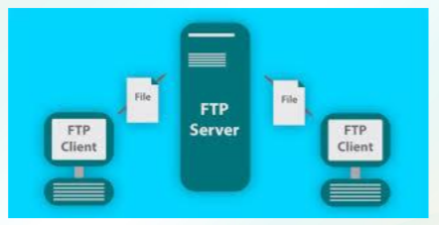

**SFTP (SSH File Transfer Protocol)** is a network protocol that provides file transfer and manipulation functionality over any reliable data stream.

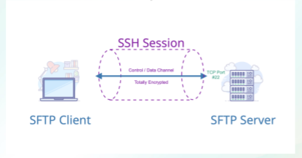

**FTPS (FTP/SSL)** is a name used to provide a number of ways that FTP software can perform secure file transfers.

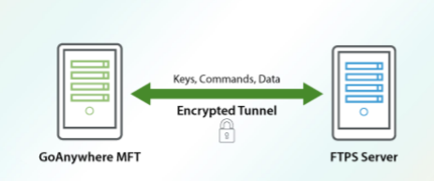

**TFTP - Trivial File Transfer Protocol** is a file transfer protocol similar to FTP, but is much more limited.

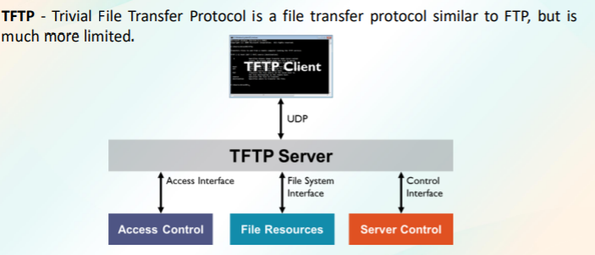

**Ports and Port Ranges**

A port is:

* Endpoint of logical connections
* Numbered from 0 to 65,535
* Split into three blocks:
* Well-known ports
* Registered ports
* Dynamic ports

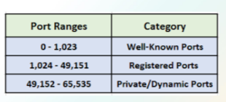

**APPLY SECURE NETWORK ADMINISTRATION PRINCIPLES / SECURE WIRELESS TRAFFIC**

**Network Administration Security Methods**

* Flood guards
* Loop protection
* Port security
* MAC limiting
* MAC filtering
* Network separation
* VLAN management
* Implicit deny
* Log analysis

**Network Administration Security Methods**

**Flood guards** serves as preventive control against denial-of-service (DoS) or distributed denial-of-service (DDoS) attacks.

**Loop protection** increases the efficiency of STP, RSTP, and MSTP by preventing ports from moving into a forwarding state that would result in a loop opening up in the network.

**Port Security** enables an administrator configure individual switch ports to allow only a specified number of source MAC addresses ingressing the port.

**MAC LIMITING** protects against flooding of the Ethernet switching table, and is enabled on Layer 2 interfaces (ports).

**MAC FILTERING** refers to a security access control method whereby the MAC address assigned to each network card is used to determine access to the network.

**NETWORK SEPARATION** is the tool used for dividing a network into smaller parts which are called subnetworks or network segments.

**VLAN MANAGEMENT** is a network switch that contains a mapping of device information to VLAN.

**IMPLICIT DENY** is a security stance treats everything not given specific and selective permission as suspicious.

**LOG ANALYSIS** is the term used for analysis of computer-generated records for helping organizations, businesses or networks in proactively and reactively mitigating different risks.

**Guidelines for Applying Network Security Administration Principles**

✓ Manage network devices so that they are configured according to security policies.

✓ Maintain documentation for all current server configurations.

✓ Establish and document baselines.

✓ Implement strong ACLs and implement implicit deny.

✓ Update antivirus software regularly.

✓ Configure only required network services.

✓ Disable unused interfaces and unused application service ports.

✓ Create and implement a DRP.

✓ Apply security updates and patches.

✓ Encrypt sensitive data.

✓ Check event logs for unusual activity.

✓ Monitor network activity

**Wireless Networks**

* Portable
* Inexpensive
* No obtrusive cabling
* Introduces new, significant security issues

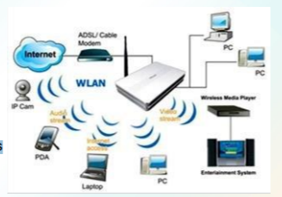

A wireless LAN (WLAN) allows users to connect to a network while allowing them to remain mobile.

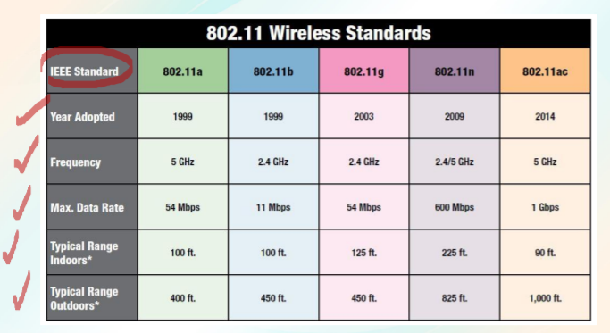

**WIRELESS STANDARDS**

Wireless standards are a set of services and protocols that dictate how your WiFi network (and other data transmission networks) acts.

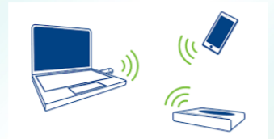

802.11: There were actually two variations on the initial 802.11 wireless standard. Both offered 1 or 2Mbps transmission speeds and the same RF of 2.4GHz.

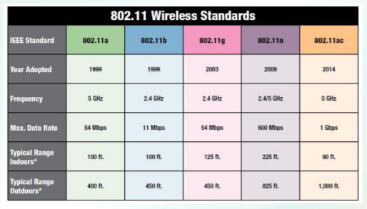

802.11a - The first “letter” following the June 1997 approval of the 802.11 standard, this one provided for operation in the 5GHz frequency, with data rates up to 54Mbps.

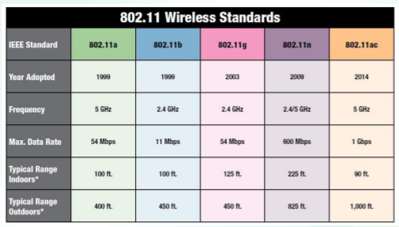

802.11b - Released in September 1999, it’s most likely that your first home router was 802.11b, which operates in the 2.4GHz frequency and provides a data rate up to 11 Mbps.

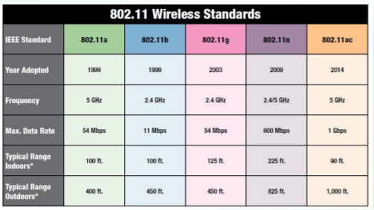

802.11g offers wireless transmission over distances of 150 feet and speeds up to 54Mbps compared with the 11Mbps of the 802.11b standard.

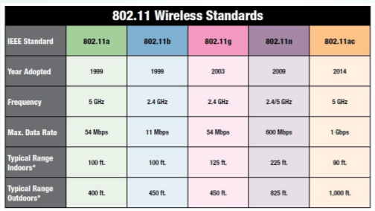

**802.11n (Wi-Fi 4)**

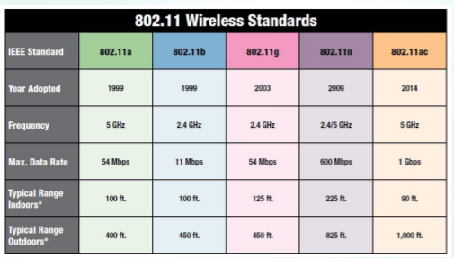

802.11ac (Wi-Fi 5) - Current home wireless routers are likely 802.1accompliant, and operate in the 5 GHz frequency space.

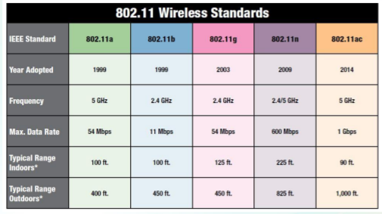

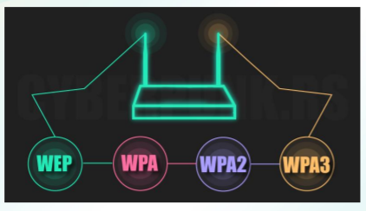

**Wireless security** is the anticipation of unauthorized access or breaks to computers or data by means of wireless networks.

**Wireless Security Protocols**

**WEP** was included as part of the original IEEE 802.11 standard and was intended to provide privacy

**WPA** was designed as the interim successor to WEP.

**WPA2** is the security method added to WPA for wireless networks that provides stronger data protection and network access control

**WPA3**, released in June 2018, is the successor to WPA2, which security experts describe as “broken.”

**Wireless Security Methods**

* Configure access point settings.
* Adjust SSID settings.
* Enable encryption.
* Configure network security settings.
* Adjust antenna and power source placement.
* Adjust client settings.

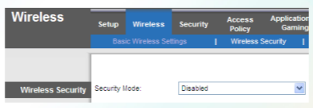

**Understanding Service Set IDentifier (SSID)**

The most basic component of the wireless network is the SSID

While there aren’t any specific security capabilities associated with the SSID, there are some security considerations that should be taken into account:

✓Choose your own SSID

✓Follow naming conventions

✓Turn off your SSID

**Captive Portals**

A captive portal is a web page accessed with a web browser that is displayed to newly connected users of a Wi-Fi or wired network before they are granted broader access to network resources.

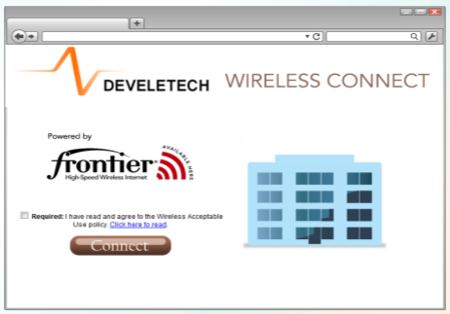

**Site Surveys**

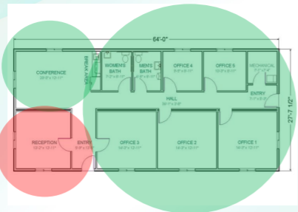

Site surveys are inspections of an area where work is proposed, to gather information for a design or an estimate to complete the initial tasks required for an outdoor activity.

**Guidelines for Securing Wireless Traffic**

* Keep sensitive data off of wireless devices.
* Install antivirus software on wireless devices.
* Harden wireless devices and routers.
* Use a VPN with IPSec.
* Conduct a site survey
* Implement security protocols.
* Implement authentication and access control.
* Implement an IDS.
* Avoid relying on MAC filtering and disabling SSID broadcasts
* Implement captive portals that require login credentials.
* Follow hardware and software vendors’ security recommendations.
* Document all changes.

**MODULE 4 Supplementary**

**Network Components**

There are several common components that make up a network:

* Device
* Media
* Network adapter
* Network operating system
* Protocol

**Device** - A device is a unit of physical hardware or equipment that provides one or more computing functions within a computer system. It can provide input to the computer, accept output or both. A device can be any electronic element with some computing ability that supports the installation of firmware or third-party software.

**Media -** refers to various means of communication. The term can also be used as a collective noun for the press or news reporting agencies. Is also used as a collective noun, but refers to different types of data storage options.

**Network adapter -** NIC - Network Interface Card. A NIC is a component that provides networking capabilities for a computer. It may enable a wired connection (such as Ethernet) or a wireless connection (such as Wi-Fi) to a local area network.

**Network operating system -** A network operating system provides services for computers connected to a network. A network operating system may also refer to a basic OS that runs on a network device, such as a router or firewall.

**Protocol -** A protocol is a standard set of rules that allow electronic devices to communicate with each other. These rules include what type of data may be transmitted, what commands are used to send and receive data, and how data transfers are confirmed.

**Network Devices**

A router is a hardware device which is used to connect a LAN with an internet connection. It is used to receive, analyze and forward the incoming packets to another network. A router works in a Layer 3 (Network layer) of the OSI Reference model. A router forwards the packet based on the information available in the routing table. It determines the best path from the available paths for the transmission of the packet.

**A switch** is a hardware device that connects multiple devices on a computer network. A Switch contains more advanced features than Hub. The Switch contains the updated table that decides where the data is transmitted or not. Switch delivers the message to the correct destination based on the physical address present in the incoming message. A Switch does not broadcast the message to the entire network like the Hub. It determines the device to whom the message is to be transmitted. Therefore, we can say that switch provides a direct connection between the source and destination. It increases the speed of the network.

**A firewall** is a network security device that monitors incoming and outgoing network traffic and permits or blocks data packets based on a set of security rules. Its purpose is to establish a barrier between your internal network and incoming traffic from external sources (such as the internet) in order to block malicious traffic like viruses and hackers.

**A load balancer** is a device that acts as a reverse proxy and distributes network or application traffic across a number of servers. Load balancers are used to increase capacity (concurrent users) and reliability of applications.

**An all-in-one security appliance** provides protection against a multitude of threats without adding to your device-management burden. Here's how to choose the right model for your organization.

**Using Dedicated Firewalls to Protect a Network**

A firewall is a system that is designed to protect a computer or a computer network from network-based attacks. A firewall does this by filtering the data packets traversing the network. Firewalls remain the foundation of network security technologies. There are a number of options, types, and technologies associated with selecting, implementing, and maintaining the firewalls in a network. There are also a number of factors that help determine the proper solution to meet business requirements. The OSI Model (Open Systems Interconnection Model) is a conceptual framework used to describe the functions of a networking system.

The OSI model characterizes computing functions into a universal set of rules and requirements in order to support interoperability between different products and software. In the OSI reference model, the communications between a computing system are split into seven different abstraction layers: Physical, Data Link, Network, Transport, Session, Presentation, and Application.

**Physical Layer**

The lowest layer of the OSI Model is concerned with electrically or optically transmitting raw unstructured data bits across the network from the physical layer of the sending device to the physical layer of the receiving device. It can include specifications such as voltages, pin layout, cabling, and radio frequencies. At the physical layer, one might find “physical” resources such as network hubs, cabling, repeaters, network adapters or modems.

**Data Link Layer**

At the data link layer, directly connected nodes are used to perform node-to-node data transfer where data is packaged into frames. The data link layer also corrects errors that may have occurred at the physical layer. The data link layer encompasses two sub-layers of its own. The first, media access control (MAC), provides flow control and multiplexing for device transmissions over a network. The second, the logical link control (LLC), provides flow and error control over the physical medium as well as identifies line protocols.

**Network Layer.**

The network layer is responsible for receiving frames from the data link layer, and delivering them to their intended destinations among based on the addresses contained inside the frame. The network layer finds the destination by using logical addresses, such as IP (internet protocol). At this layer, routers are a crucial component used to quite literally route information where it needs to go between networks.

**Transport Layer**

The transport layer manages the delivery and error checking of data packets. It regulates the size, sequencing, and ultimately the transfer of data between systems and hosts. One of the most common examples of the transport layer is TCP or the Transmission Control Protocol.

**Session Layer**

The session layer controls the conversations between different computers. A session or connection between machines is set up, managed, and termined at layer 5. Session layer services also include authentication and reconnections.

**Presentation Layer**

The presentation layer formats or translates data for the application layer based on the syntax or semantics that the application accepts. Because of this, it at times also called the syntax layer. This layer can also handle the encryption and decryption required by the application layer.

Application Layer

At this layer, both the end user and the application layer interact directly with the software application. This layer sees network services provided to end-user applications such as a web browser or Office 365. The application layer identifies communication partners, resource availability, and synchronizes communication.

**OSI Model and Security**

Identify threats and targets.

Identify how threats will impact your network.

Secure your network by layers.

Any discussion about network security requires a discussion and understanding of the Open Systems Interconnect (OSI) reference model. The OSI model is a conceptual model, created by the International Organization for Standardization (ISO) in 1978 and revised in 1984, to describe a network architecture that allows data to be passed between computer systems. While never fully utilized as the model for a protocol, the OSI model is the standard for discussing how networking works.

**When to Use a Hardware Firewall Instead of a Software Firewall There are two basic types of software firewall:**

* Host firewall
* Network firewall

**Host firewall:** One type of software firewall is a firewall application installed on a host, used to protect the host from network-based attacks. An example of this type of software firewall would be the Windows firewall included with recent versions of Microsoft operating systems. Host firewalls are also known as personal firewalls.

**Network firewall:** The other type of software firewall is a firewall application installed on a server used to protect network segments from other network segments. These types of firewalls offer similar functionality to a hardware firewall. The most popular network firewalls are those produced by Cisco.

With an understanding of the network infrastructure, the next step is to analyze the logs to see which traffic is allowed and which traffic is blocked.

**Ingress traffic** is traffic that originates from outside the network’s routers and proceeds toward a destination inside the network.

**Egress traffic** is network traffic that begins inside a network and proceeds through its routers to its destination somewhere outside of the network.

**VLAN - Virtual Local Area Network**

A virtual LAN (VLAN) is any broadcast domain that is partitioned and isolated in a computer network at the data link layer. Virtual LANs (VLANs) were developed as an alternate solution to deploying multiple routers. VLANs are logical network segments used to create separate broadcast domains, but still allow the devices on the VLANs to communicate at Layer 2, without requiring a router.

**Subnet**

It is any broadcast domain that is partitioned and isolated in a computer network at the data link layer A subnetwork or subnet is a logical subdivision of an IP network. The practice of dividing a network into two or more networks is called subnetting. Computers that belong to a subnet are addressed with an identical most-significant bit-group in their IP addresses.

**IDS - Intrusion Detection Systems**

Intrusion detection systems (IDS) are designed to detect unauthorized user activities, attacks, and network compromises. It is a device or software application that monitors a network or systems for malicious activity or policy violations.

**IPS - Intrusion Prevention System**

An intrusion prevention system (IPS) is very similar to an IDS, except that in addition to detecting and alerting, an IPS can also take action to prevent the breach from occurring. Intrusion prevention system (IPS) is a form of network security that works to detect and prevent identified threats. Intrusion prevention systems continuously monitor your network, looking for possible malicious incidents and capturing information about them.

**NIDS - Network-based Intrusion Detection System**

A network-based IDS (NIDS) monitors network traffic using sensors that are located at key locations within the network, often in the demilitarized zone (DMZ) or at network borders. Network-based intrusion detection system (NIDS) is used to monitor and analyze network traffic to protect a system from networkbased threats. A NIDS reads all inbound packets and searches for any suspicious patterns. When threats are discovered, based on its severity, the system can take action such as notifying administrators, or barring the source IP address from accessing the network.

**Wireless IDS**

The WIDS is the software that detects an attack on a wireless network or wireless system. WIDS is actually a broader concept than catching break-in attempts. It also includes verifying the access points that are on the network, identifying any that shouldn't be there or have security issues, and detecting attacks on APs/clients.

**Network IPS**

Intrusion Prevention System (IPS) is a network security/threat prevention technology that examines network traffic flows to detect and prevent vulnerability exploits. An intrusion prevention system (IPS) is a form of network security that works to detect and prevent identified threats. Intrusion prevention systems continuously monitor your network, looking for possible malicious incidents and capturing information about them.

**Wireless IPS**

A wireless intrusion prevention system (WIPS) is a network device that monitors the radio spectrum for the presence of unauthorized access points (intrusion detection), and can automatically take countermeasures (intrusion prevention).

Guidelines for Applying Network Security Administration Principles

• Manage network devices so that they are configured according to security policies.

• Maintain documentation for all current server configurations.

• Establish and document baselines.

• Implement strong ACLs and implement implicit deny.

• Update antivirus software regularly.

• Configure only required network services.

• Disable unused interfaces and unused application service ports.

• Create and implement a DRP.

• Apply security updates and patches.

• Encrypt sensitive data.

• Check event logs for unusual activity.

• Monitor network activity.

**Network Monitoring Systems**

Network monitoring software is designed to monitor and manage the network traffic flow over a network. It is mainly used by network administrators and security staff to monitor the operations of a network. It automates most of the network monitoring processes and workflow.

**Types of Network Monitoring Systems**

• Behavior-based

• Signature-based

• Anomaly-based

• Heuristic.

**Web Security Gateway**

A Web security gateway is a type of security solution that prevents unsecured traffic from entering an internal network of an organization. It is used by enterprises to protect their employees/users from accessing and being infected by malicious Web traffic, websites and virus/malware.

**DMZ - Demilitarized Zones**

DMZs are designed to provide access to systems without jeopardizing the internal network. Another common configuration is to have the firewall connected to an extranet, with connections to customers, vendors, or business partners. In computer networking, a DMZ is a firewall configuration used to secure hosts on a network segment. In most DMZs, the hosts on the DMZ are connected behind a firewall which is connected to a public network like the internet.

**NAT - Network Address Translation**

Network Address Translation (NAT) is a technique used to modify the network address information of a host while traffic is traversing a router or firewall. This technique is used to hide the network information of a private network while allowing traffic to be transferred across a public network like the internet.

**There are two main types of NAT:**

**Static NAT** is used when the translated device needs to be accessible from the public network. Static NAT is used when the translated device needs to be accessible from the public network. Static NAT: Static NAT maps an unregistered IP address on the private network to a registered IP address on the public network, using a one-to-one basis.

**Dynamic NAT.**

This is more commonly used when many hosts on the internal network need to access the internet and don’t have a requirement for a static address. Dynamic NAT. This is more commonly used when many hosts on the internal network need to access the internet and don’t have a requirement for a static address. The workstation’s address is translated to the next available registered address in the pool as soon as it initiates a connection to the public network. Dynamic NAT: Dynamic NAT maps an unregistered IP address on the private network to a registered IP address that is selected by the routing device providing the NAT service from a pool of registered IP addresses.

**VPN - Virtual Private Network**

VPN (Virtual Private Network) is a technology that uses encrypted tunnels to create secure connections across public networks like the internet. It allows you to create a secure connection to another network over the Internet. VPNs can be used to access region-restricted websites, shield your browsing activity from prying eyes on public Wi-Fi, and more.

**VPN Concentrator**

A VPN concentrator is a type of networking device that provides secure creation of VPN connections and delivery of messages between VPN nodes. It is a type of router device, built specifically for creating and managing VPN communication infrastructures

**Virtualization**

Virtualization is the process of running a virtual instance of a computer system in a layer abstracted from the actual hardware. Most commonly, it refers to running multiple operating systems on a computer system simultaneously. Virtualization refers to the act of creating a virtual (rather than actual) version of something, including virtual computer hardware platforms, storage devices, and computer network resources.

**Cloud Computing**

Cloud computing means storing and accessing data and programs over the Internet instead of your computer's hard drive. In the simplest terms, cloud computing means storing and accessing data and programs over the Internet instead of your computer's hard drive. Cloud computing is the use of various services, such as software development platforms, servers, storage and software, over the internet, often referred to as the "cloud."

**Cloud Computing Deployment Models**

* Private
* Public
* Community
* Hybrid

❑ Private referred to as internal cloud or corporate cloud.

❑ Public or external cloud is one base on the usual mainstream model, in which service provider makes resources, such as storage and application, obtainable to the general public over the Internet or via web applications/web services.

❑ Community can be recognized where a number of organizations have comparable necessities and very willing to share infrastructure so as to take in the benefits of cloud computing.

❑ Hybrid is the combination of public and private cloud where the infrastructure partially hosted inside the organization and externally in a public cloud

Private one provides wider opportunities for customizing the infrastructure to the company’s requirements. A private model is especially suitable for companies that seek to safeguard their missioncritical operations or for businesses with changing requirements.

The public cloud deployment model is the first choice for businesses that operate within the industries with low privacy concerns.

A community deployment model largely resembles a private one; the only difference is the set of users. While a private type implies that only one company owns the server, in the case of a community one, several organizations with similar backgrounds share the infrastructure and related resources.

A hybrid cloud encompasses the best features of the above-mentioned deployment models — public, private and community ones. It allows companies to mix and match the facets of all three types that best suit their requirements.

**Cloud Computing Service Types**

* SaaS - Software as a Service
* PaaS - Platform as a Service
* IaaS - Infrastructure as a Service

**SaaS** type of cloud computing model offers users the hardware infrastructure, the software product and interrelates with the users through a front-end gateway or portal.

The **IaaS** type of cloud computing distributes a full computer infrastructure via the web or Internet. Most popular IaaS providers like Amazon Web Services offer virtual server instances with unique IP addresses and block of storage on demand.

**PaaS** type of cloud computing offers a full or partial product development tools or environment that users can access and utilize online, even in collaboration with others and hosted on the provider's infrastructure.

**DNS** - Domain Name System (or Service or Server). The DNS is a service used on the internet for resolving fully qualified domain names (FQDN) to their actual Internet Protocol (IP) addresses, using a distributed network of name servers.

**HTTP** - Hypertext Transfer Protocol. It is part of the Internet protocol suite and defines commands and services used for transmitting webpage data. HTTP is the protocol used to transfer data over the web.

**HTTPS**, the secure version of HTTP web browsing, uses the SSL protocol. This protocol provides 128-bit encryption and is currently the leading security mechanism for protecting web traffic including banking, e-commerce, secure email, and essentially any other secure website that might be encountered.

**SSL/TLS**

**SSL** - Secure Sockets Layer. SSL (Secure Sockets Layer) is the standard security technology for establishing an encrypted link between a web server and a browser. Secure Sockets Layer is an encryption-based Internet security protocol. It was first developed by Netscape in 1995 for the purpose of ensuring privacy, authentication, and data integrity in Internet communications. SSL is the predecessor to the modern TLS encryption used today.

**TLS** - Transport Layer Security. TLS is a cryptographic protocol that provides end-to-end communications security over networks and is widely used for internet communications and online transactions. TLS is the up-to-date encryption protocol that is still being implemented online, even though many people still refer to it as ‘SSL encryption’.

**TLS** - Transport Layer Security. TLS is a cryptographic protocol that provides endto-end communications security over networks and is widely used for internet communications and online transactions. TLS is the up-to-date encryption protocol that is still being implemented online, even though many people still refer to it as ‘SSL encryption’.

**SECURE SHELL (SSH)**

Secure Shell (SSH) is a cryptographic network protocol for operating network services securely over an unsecured network. The Secure Shell (SSH) protocol is a protocol for secure remote logon and other secure network services over the network. SSH can be used for several applications across multiple platforms, including UNIX, Microsoft Windows, Apple Mac, and Linux.

**Telnet**

TELNET (TELecommunication NETwork) is a network protocol used on the Internet or local area network (LAN) connections. A Telnet program allows a user on one system to login to a remote system and issue commands in a command window of the remote system.

Some of the applications supported with SSH include the following:

1. Secure logon

2. Secure remote command execution

3. Secure file transfer

4. Secure backup, copy, and mirroring of files

5. Creation of VPN connections (when used in conjunction with the OpenSSH server and client)

**SNMP - Simple Network Management Protocol**

Simple Network Management Protocol (SNMP) is a set of protocols for network management and monitoring. These protocols are supported by many typical network devices such as routers, hubs, bridges, switches, servers, workstations, printers, modem racks and other network components and devices. Simple Network Management Protocol (SNMP) is an Internet Standard protocol for collecting and organizing information about managed devices on IP networks and for modifying that information to change device behavior.

**ICMP**

The Internet Control Message Protocol (ICMP) is a supporting protocol in the Internet protocol suite. It is used by network devices, including routers, to send error messages and operational information indicating, for example, that a requested service is not available or that a host or router could not be reached.

**IPSec**

* Data security in transit
* Data authenticity and integrity
* Anti-replay protection
* Non-repudiation
* Eavesdropping and sniffing protection

**Internet Protocol Security (IPsec)** is a secure network protocol suite that authenticates and encrypts the packets of data sent over an Internet Protocol network. Internet protocol security (IPsec) is a set of protocols that provides security for Internet Protocol. It can use cryptography to provide security. IPsec can be used for the setting up of virtual private networks (VPNs) in a secure manner.

**NetBIOS** - The BIOS provides an interface between the computer's operating system and the hardware. Network Basic Input/Output System." NetBIOS was introduced in 1983 by IBM as an improvement to the standard BIOS used by Windows-based computers.

* Applications communicate across network
* Connection communication over sessions
* Connectionless datagram communication
* Name registration
* Vulnerable to analysis by malicious users
* Implement strong passwords
* Disallow root access
* Disable null sessions

**File Transfer Protocols**

FTP is used to transfer files between computers on a network. You can use FTP to exchange files between computer accounts, transfer files between an account and a desktop computer, or access online software archives. Keep in mind, however, that many FTP sites are heavily used and require several attempts before connecting.

**SFTP (SSH File Transfer Protocol)** is a network protocol that provides file transfer and manipulation functionality over any reliable data stream. It is typically used with the SSH-2 protocol (TCP port 22) to provide secure file transfer but is intended to be usable with other protocols as well.

**FTPS (FTP/SSL)** is a name used to provide a number of ways that FTP software can perform secure file transfers. Each way involves the use of a SSL/TLS layer below the standard FTP protocol to encrypt the control and/or data channels.

**TFTP** - Trivial File Transfer Protocol is a file transfer protocol similar to FTP but is much more limited. Unlike FTP, TFTP does not support authentication and cannot change directories or list directory contents. Therefore, it is most often used to transfer individual files over a local network.

**Ports and Port Ranges**

A port is:

Endpoint of logical connections

Numbered from 0 to 65,535

**Split into three blocks:**

* Well-known ports
* Registered ports
* Dynamic ports

**Flood guards** serves as preventive control against denial-of-service (DoS) or distributed denial-of-service (DDoS) attacks. Flood guards are available either as standalone devices or as firewall components. It is capable of monitoring network traffic to identify DoS attacks in progress generated through packet flooding.

**Loop protection** increases the efficiency of STP, RSTP, and MSTP by preventing ports from moving into a forwarding state that would result in a loop opening up in the network. Loop protection performs a specified action when BPDUs are not received on a nondesignated port interface.

**Port Security** enables an administrator to configure individual switch ports to allow only a specified number of source MAC addresses ingressing the port. Port security is a layer two traffic control feature on Cisco Catalyst switches.

**MAC limiting** protects against flooding of the Ethernet switching table and is enabled on Layer 2 interfaces (ports). MAC move limiting detects MAC movement and MAC spoofing on access interfaces. It is enabled on VLANs. MAC limiting enhances port security by limiting the number of MAC addresses that can be learned within a VLAN.

**MAC Filtering** refers to a security access control method whereby the MAC address assigned to each network card is used to determine access to the network. MAC address filtering allows you to define a list of devices and only allow those devices on your Wi-Fi network.

**Network separation** is the tool used for dividing a network into smaller parts which are called subnetworks or network segments.

**VLAN Management** is a network switch that contains a mapping of device information to VLAN. VLAN Management can also be used for providing security through segregating clients with an unknown MAC address, or through further extension of the protocol to provide login for Cisco ACLs.

**Implicit deny** is a security stance treats everything not given specific and selective permission as suspicious. Network boundaries that follow an implicit deny concept only allows specific IP addresses and/or service ports while blocking all others.

**Log analysis** is the term used for analysis of computer-generated records for helping organizations, businesses or networks in proactively and reactively mitigating different risks. Most organizations and businesses are required to do data logging and log analysis as part of their security and compliance regulations. Log analysis helps in reducing problem diagnosis, resolution time and in effective management of applications and infrastructure.

Guidelines for Applying Network Security Administration Principles

• Manage network devices so that they are configured according to security policies.

• Maintain documentation for all current server configurations.

• Establish and document baselines.

• Implement strong ACLs and implement implicit deny.

• Update antivirus software regularly.

• Configure only required network services.

• Disable unused interfaces and unused application service ports.

• Create and implement a DRP.

• Apply security updates and patches.

• Encrypt sensitive data.

• Check event logs for unusual activity.

• Monitor network activity.

**Wireless Networks**

• Portable

• Inexpensive

• No obtrusive cabling

• Introduces new, significant security issues

**A wireless LAN (WLAN)** allows users to connect to a network while allowing them to remain mobile. Wireless Local Area Network." A WLAN, or wireless LAN, is a network that allows devices to connect and communicate wirelessly. Unlike a traditional wired LAN, in which devices communicate over Ethernet cables, devices on a WLAN communicate via Wi-Fi.

Wireless standards are a set of services and protocols that dictate how your Wi-Fi network (and other data transmission networks) acts.

**802.11:** There were two variations on the initial 802.11 wireless standard. Both offered 1 or 2Mbps transmission speeds and the same RF of 2.4GHz. The difference between the two was in how data traveled through the RF media. One used FHSS, and the other used DSSS. The original 802.11 standards are far too slow for modern networking needs and are now no longer deployed.

**802.11a** - The first “letter” following the June 1997 approval of the 802.11 standard, this one provided for operation in the 5GHz frequency, with data rates up to 54Mbps. Counterintuitively, 802.11a came out later than 802.11b, causing some confusion in the marketplace because people expected that the standard with the "b" at the end would be backward compatible with the one with the "a" at the end.

**802.11b** - Released in September 1999, it’s most likely that your first home router was 802.11b, which operates in the 2.4GHz frequency and provides a data rate up to 11 Mbps. However, devices are designed to be backward-compatible with previous 802.11 standards that provided for speeds of 1, 2, and 5.5Mbps. 802.11b uses a 2.4GHz RF range and is compatible with 802.11g. Interestingly, 802.11a products hit the market before 802.11a, which was approved at the same time but didn’t hit the market until later.

**802.11g** offers wireless transmission over distances of 150 feet and speeds up to 54Mbps compared with the 11Mbps of the 802.11b standard. 802.11g: 802.11g is a popular wireless standard today. Like 802.11b, 802.11g operates in the 2.4GHz range and therefore is compatible with it.

**802.11n** (Wi-Fi 4). 802.11n (Wi-Fi 4) - The first standard to specify MIMO, 802.11n was approved in October 2009 and allows for usage in two frequencies - 2.4GHz and 5GHz, with speeds up to 600Mbps. When you hear wireless LAN, vendors use the term “dual-band”, it refers to being able to deliver data across these two frequencies.

**802.11ac** (Wi-Fi 5) - Current home wireless routers are likely 802.1ac-compliant and operate in the 5 GHz frequency space. With Multiple Input, Multiple Output (MIMO) – multiple antennas on sending and receiving devices to reduce error and boost speed – this standard supports data rates up to 3.46Gbps. Some router vendors include technologies that support the 2.4GHz frequency via 802.11n, providing support for older client devices that may have 802.11b/g/n radios, but also providing additional bandwidth for improved data rates.

**Wireless security** is the anticipation of unauthorized access or breaks to computers or data by means of wireless networks.

**Wireless Security Protocols**

WEP was included as part of the original IEEE 802.11 standard and was intended to provide privacy. WEP Widely recommended in the early days of WLAN use, WEP rapidly fell out of favor when a flaw with the encryption mechanism was found.

**WPA** was designed as the interim successor to WEP. WPA2 is the security method added to WPA for wireless networks that provides stronger data protection and network access control. WPA3, released in June 2018, is the successor to WPA2, which security experts describe as “broken.” WPA included a new security protocol, Temporal Key Integrity Protocol (TKIP), which, while related to WEP to ensure backwards compatibility, adds new features to help address the issues associated with WEP.

**WPA/WPA2** is the best security method for both home and corporate WLAN security. WPA2 provides enterprise and consumer Wi-Fi users with a high level of assurance that only authorized users can access their wireless networks. The goal of developing WPA3 was to improve WPA in terms of simplicity of use and increased cryptographic strength.

**Wireless Security Methods**

• Configure access point settings.

• Adjust SSID settings.

• Enable encryption.

• Configure network security settings.

• Adjust antenna and power source placement.

• Adjust client settings.

**Understanding Service Set IDentifier (SSID)**

The most basic component of the wireless network is the SSID While there aren’t any specific security capabilities associated with the SSID, there are some security considerations that should be taken into account:

• Choose your own SSID

• Follow naming conventions

• Turn off your SSID

**Captive Portals**

A captive portal is a web page accessed with a web browser that is displayed to newly connected users of a Wi-Fi or wired network before they are granted broader access to network resources. Captive portals are commonly used to present a landing or log-in page which may require authentication, payment, acceptance of an end-user license agreement, acceptable use policy, survey completion, or other valid credentials that both the host and user agree to adhere by.

**Site Surveys**

Site surveys are inspections of an area where work is proposed, to gather information for a design or an estimate to complete the initial tasks required for an outdoor activity. It can determine a precise location, access, best orientation for the site and the location of obstacles.

Guidelines for Securing Wireless Traffic

• Keep sensitive data off of wireless devices.

• Install antivirus software on wireless devices.

• Harden wireless devices and routers.

• Use a VPN with IPSec.

• Conduct a site survey.

• Implement security protocols.

• Implement authentication and access control.

• Implement an IDS.

• Avoid relying on MAC filtering and disabling SSID broadcasts.

• Implement captive portals that require login credentials.

• Follow hardware and software vendors’ security recommendations.

• Document all changes.

**PERFECT**

What is not needed to be protected?a. Data**b. Intruder**c. Infrastructured. System

The characteristic of a resource—ensuring access is restricted to only permitted users, applications, or computer systems. a. Attack**b. Confidentiality** c. Availabilityd. Integrity

PJ is buying books from an online retail location, and she finds that she can alter the cost of a book from $19.99 to $1.99. Which portion of the CIA set of three has been broken?a. Confidentiality**b. Integrity**c. Availabilityd. None of the above

Lourwel is working on her college applications online, when the admissions site crashes. She is incapable to turn in her application on time.a. Confidentialityb. Integrity**c. Availability**d. None of the above

A company that purchased an HVAC system for the datacenter is MOST concerned with which of the following?**a. Availability**b. Integrityc. Confidentialityd. Fire suppression

It is the term used for a broad range of malicious activities accomplished through human interactions.**a. Social Engineering Attacks**b. Physical Security Attacksc. Software-Based Attacksd. Network-Based Attacks

The action or process of identifying someone or something or the fact of being identified.**a. Identification**b. Implementation c. Monitoringd. Running

This technique typically relies on the trusting nature of the person being attacked.a. Computer Engineering**b. Social Engineering**c. Cyber Engineeringd. Reverse Engineering

It is often a chain message telling recipients to forward the mail to all their contacts. a. Spoofing**b. Hoax**c. Phishingd. Vishing

It is a cyber-attack that uses disguised email as a weapon. a. Spoofingb. Hoax**c. Phishing**d. Vishing

It is type of phishing attacks that try to lure victims via voice calls.a. Spoofingb. Hoaxc. Phishing**d. Vishing**

It is a method used by cybercriminals to masquerade as a senior player at an organization and directly target senior or other important individuals at an organization**a. whaling**b. URL hijacking c. Spamd. Spim

It is unsolicited usually commercial messages sent to a large number of recipients or posted in a large number of placesa. whalingb. URL hijacking **c. Spam**d. Spim

It is perpetuated by bots that harvest IM screen names off of the Internet and simulate a human user by sending spam to the screen names via an instant message. a. whalingb. URL hijacking c. Spam**d. Spim**

It is a type of social engineering technique used to obtain information such as personal identification numbers (PINs), passwords and other confidential data by looking over the victim's shoulder**a. Shoulder surfing** b. Dumpster diving c. Tailgatingd. Spam

It is a technique used to retrieve information that could be used to carry out an attack on a computer network. a. Shoulder surfing **b. Dumpster diving** c. Tailgatingd. Spam

It is also known as piggybackinga. Shoulder surfing b. Dumpster diving **c. Tailgating**d. Spam

It is an attack that tricks a user into clicking a webpage element which is invisible or disguised as another element. **Clickjacking**

It could be a cyber-attack in which the culprit looks for to create a machine or arrange asset inaccessible to its planning clients by incidentally or inconclusively disturbing administrations of a have associated to the Web.**a. Denial-of-service attack**b. Distributed denial of service c. Session hijacking d. ARP poisoning

It is a software or hardware device designed to gain administrator-level control over a computer system without being detected. Rootkits can target the BIOS, hypervisor, boot loader, kernel or, less commonly, libraries or applications. a. keyloggerb. Trojan Horsec. **Rootkits**d. Backdoor Attacks

It is a type of malware that constantly changes its identifiable features in order to evade detection. **a. Polymorphic Malware**b. Logic Bombsc. Botnetsd. Ransomware

It is a piece of code intentionally inserted into a software system that will set off a malicious function when specified conditions are met. a. Polymorphic Malware**b. Logic Bombs**c. Botnetsd. Ransomware

It is a type of malware from cryptology that threatens to publish the victim's data or perpetually block access to it unless a ransom is paida. Polymorphic Malwareb. Logic Bombsc. Botnets**d. Ransomware**

A security administrator wants to deploy security controls to mitigate the threat of company employees' personal information being captured online. Which of the following would BEST serve this purpose?**a. Anti-spyware**b. Antivirusc. Host-based firewalld. Web content filter

Ann, a software developer, has installed some code to reactivate her account one week after her account has been disabled. Which of the following is this an example of? a. Rootkitb. Botnet**c. Backdoor**d. Spyware

What is not needed to be protected?a. Data**b. Intruder**c. Infrastructured. System

The characteristic of a resource—ensuring access is restricted to only permitted users, applications, or computer systems. a. Attack**b. Confidentiality** c. Availabilityd. Integrity

PJ is buying books from an online retail location, and she finds that she can alter the cost of a book from $19.99 to $1.99. Which portion of the CIA set of three has been broken?a. Confidentiality**b. Integrity**c. Availabilityd. None of the above

Lourwel is working on her college applications online, when the admissions site crashes. She is incapable to turn in her application on time.a. Confidentialityb. Integrity**c. Availability**d. None of the above

A company that purchased an HVAC system for the datacenter is MOST concerned with which of the following?**a. Availability**b. Integrityc. Confidentialityd. Fire suppression

It is the term used for a broad range of malicious activities accomplished through human interactions.**a. Social Engineering Attacks**b. Physical Security Attacksc. Software-Based Attacksd. Network-Based Attacks

The action or process of identifying someone or something or the fact of being identified.**a. Identification**b. Implementation c. Monitoringd. Running

This technique typically relies on the trusting nature of the person being attacked.a. Computer Engineering**b. Social Engineering**c. Cyber Engineeringd. Reverse Engineering

It is often a chain message telling recipients to forward the mail to all their contacts. a. Spoofing**b. Hoax**c. Phishingd. Vishing

It is a cyber-attack that uses disguised email as a weapon. a. Spoofingb. Hoax**c. Phishing**d. Vishing

It is type of phishing attacks that try to lure victims via voice calls.a. Spoofingb. Hoaxc. Phishing**d. Vishing**

It is a method used by cybercriminals to masquerade as a senior player at an organization and directly target senior or other important individuals at an organization**a. whaling**b. URL hijacking c. Spamd. Spim

It is unsolicited usually commercial messages sent to a large number of recipients or posted in a large number of placesa. whalingb. URL hijacking **c. Spam**d. Spim

It is perpetuated by bots that harvest IM screen names off of the Internet and simulate a human user by sending spam to the screen names via an instant message. a. whalingb. URL hijacking c. Spam**d. Spim**

It is a type of social engineering technique used to obtain information such as personal identification numbers (PINs), passwords and other confidential data by looking over the victim's shoulder**a. Shoulder surfing** b. Dumpster diving c. Tailgatingd. Spam

It is a technique used to retrieve information that could be used to carry out an attack on a computer network. a. Shoulder surfing **b. Dumpster diving** c. Tailgatingd. Spam

It is also known as piggybackinga. Shoulder surfing b. Dumpster diving **c. Tailgating**d. Spam

It is an attack that tricks a user into clicking a webpage element which is invisible or disguised as another element. **Clickjacking**

It could be a cyber-attack in which the culprit looks for to create a machine or arrange asset inaccessible to its planning clients by incidentally or inconclusively disturbing administrations of a have associated to the Web.**a. Denial-of-service attack**b. Distributed denial of service c. Session hijacking d. ARP poisoning

It is a software or hardware device designed to gain administrator-level control over a computer system without being detected. Rootkits can target the BIOS, hypervisor, boot loader, kernel or, less commonly, libraries or applications. a. keyloggerb. Trojan Horsec. **Rootkits**d. Backdoor Attacks

It is a type of malware that constantly changes its identifiable features in order to evade detection. **a. Polymorphic Malware**b. Logic Bombsc. Botnetsd. Ransomware

It is a piece of code intentionally inserted into a software system that will set off a malicious function when specified conditions are met. a. Polymorphic Malware**b. Logic Bombs**c. Botnetsd. Ransomware

It is a type of malware from cryptology that threatens to publish the victim's data or perpetually block access to it unless a ransom is paida. Polymorphic Malwareb. Logic Bombsc. Botnets**d. Ransomware**

A security administrator wants to deploy security controls to mitigate the threat of company employees' personal information being captured online. Which of the following would BEST serve this purpose?**a. Anti-spyware**b. Antivirusc. Host-based firewalld. Web content filter

Ann, a software developer, has installed some code to reactivate her account one week after her account has been disabled. Which of the following is this an example of? a. Rootkitb. Botnet**c. Backdoor**d. Spyware

**58/60**

What does confidentiality of data refer to? **Rules which restrict access only to those who need to know**

It is to set upon in a forceful, violent, hostile, or aggressive way, with or without a weapon **attack**

What does availability of data refer to? **The level of assurance that data will be available to people who need it, when they need it**

These are malicious pieces of computer code and applications that can damage your computer, as well as steal your personal or financial information. **Software-Based Attacks**

Franz is working on her university applications online, when the admissions website crashes. She is unable to turn in her application on time. **Availability**

It is necessary for a responsible individual or organization to secure confidential information. **Information Security**

In cybersecurity, what does CIA stand for? Confidentiality, Integrity, **Availability**

What isn't objective of security? **Intrusion**

It is the term used for a broad range of malicious activities accomplished through human interactions. **Social Engineering Attacks**

Sara, a security administrator, manually hashes all network device configuration files daily and compares them to the previous days' hashes. Which of the following security concept is Sara using? **Integrity**

It is a method in cryptography by which cryptographic keys are exchanged between two parties, allowing use of a cryptographic algorithm. **Key exchange**

It helps to reduce fraud and discover malicious activities by employees. **Biometrics** **(Security token)**

Which of the following is best practice to put at the end of an ACL? **Implicit deny**

A security technique that regulates who or what can view or use resources in a computing environment **Access** **control**

It is the assurance that someone cannot deny the validity of something. **Non-repudiation**

It is one way to enable security during the process of message transmission when the message is intended for a recipient only. **Hashing**

Users require access to a certain server depending on their job function. Which of the following would be the MOST appropriate strategy for securing the server? **Role based access control**

It is an authentication method that identifies and recognizes people based on voice recognition or physical traits such as a fingerprint, face recognition, iris recognition, and retina scan. **Biometrics**

It is a concept that has employees rotate through different jobs to learn the procedures and processes in each. **Job** **rotation**

It is the practice of converting a password to a longer and more random key for cryptographic purposes such as encryption. **Key** **Stretching**

It talks about what in the event that any Network Security Intrusion Detection or Prevention Framework is utilized and how it is executed. **Intrusion** **Detection**

It ought to clearly recognize how the arrangement will be implemented and how security breaches and/or wrongdoing will be dealt with. **Enforcement**

It distinguishes all the ways that the system can be remotely accessed and what is in put to guarantee that get to be from as it were authorized people. **Remote** **Access**

It could be a set of rules connected by the proprietor, maker or director of a network, site, or service. **Acceptable User Policy**

Expired credit cards, visas, passports, and IDs. **Shred**

It may be an explanation that uncovers a few or all of the ways a party assembles, employments, discloses, and oversees a client or client's information **Privacy Policy**

It lists the retention period and disposal method for each type of record. **Retention Schedules**

It requires understanding how people experience change and what they need to change successfully. **Individual change management**

Every paper or electronic record has a specific amount of time that it needs to be kept. **Retention**

It is a living document that provides guidelines for your organization’s social media use. **Social media policy**

Isn't restricted to looking through the junk for self-evident treasures like get to codes or passwords composed down on sticky notes. **Dumpster diving**

It particularly targets senior administration that hold control in companies, such as the CEO, CFO, or other administrators **whaling**

It is a type of social engineering technique used to obtain information such as personal identification numbers (PINs), passwords and other confidential data by looking over the victim's shoulder **Shoulder surfing**

It is the act of stealing information stored on computers, servers, or other devices from an unknowing victim with the intent to compromise privacy or obtain confidential information. **Data theft**

He uses the same tools and techniques as a hacker but does so in order to disrupt services and bring attention to a political or social cause. **Hacktivists**

It is generally assumed that most of them are juveniles who lack the ability to write sophisticated programs or exploits on their own and that their objective is to try to impress their friends or gain credit in computer-enthusiast communities. **Script** **kiddie**

At the outside break area, an employee, Ann, asked another employee to let her into the building because her badge is missing. Which of the following does this describe? **Tailgating**

It is the act of taking data put away on computers, servers, or other gadgets from an unconscious casualty with the expectation to compromise protection or get secret data **Data theft**

Which of the following might a security administrator actualize to relieve the hazard of tailgating for a huge organization? **Train employees on risks associated with social engineering attacks and enforce policies.**

It can lead to a tremendous drop in guests of websites. **URL** **hijacking**

During a server audit, a security administrator does not notice abnormal activity. However, a network security analyst notices connection to unauthorized ports from outside the corporate network. Using specialized tools, the network security analyst also notices hidden processes running. Which of the following has MOST likely been installed on the server? **Rootkit**

A type of virus that has been designed to thwart attempts by analysts from examining its code by using various methods to make tracing, disassembling and reverse engineering more difficult. **Armored Virus**

A security administrator wants to deploy security controls to mitigate the threat of company employees' personal information being captured online. Which of the following would BEST serve this purpose? **Anti-spyware**

It is a type of malware that constantly changes its identifiable features in order to evade detection. **Polymorphic Malware**

The string: ` or 1=1-- -    Represents which of the following? **SQL Injection**

It is a self-replicating program that copies itself to other computers over the network without the need for any user intervention. **Worms**

A security administrator is concerned about the strength of user's passwords. The company does not want to implement a password complexity policy. Which of the following can the security Administrator implement to mitigate the risk of an online password attack against users with weak passwords? **Shorten the password expiration period**

It does not corrupt or modify files on a target computer. **Worms**

It is a software that automatically displays or downloads advertising material (often unwanted) when a user is online. **Adware**

These are attacks against an opening left in a functional piece of software that allows access into a system or software application without the owner’s knowledge. Backdoor **Attacks**

It is a hacking method that allows an individual to send anonymous messages to Bluetooth-enabled devices within a certain radius. **Bluejacking**

It could be a program that collects chunks of information that are likely to be account names and their related passwords so that an aggressor can utilize those qualifications to posture as the individual they were stolen from. **Password stealer**

It is a device hack performed when a wireless, Bluetooth-enabled device is in discoverable mode. **Bluesnarfing**

Joe, a user, in a coffee shop is checking his email over a wireless network. An attacker records the temporary credentials being passed to Joe's browser. The attacker later uses the credentials to impersonate Joe and creates SPAM messages. Which of the following attacks allows for this impersonation? **Session hijacking**

It is an attack whereby the attacker renders a machine or network resource unavailable. **Denial-of-service attack**

It is a cyber-attack in which the perpetrator seeks to make a machine or network resource unavailable to its intended users by temporarily or indefinitely disrupting services of a host connected to the Internet. **Denial-of-service attack**

All the following are Environmental Threats except **Assessment**

It is an attack on the protocol used to determine a device’s hardware address (MAC address) on the network when the IP address is known. **ARP poisoning**

It is relatively straightforward using an open source tool called Reaver **WPS attack**

It is also known as bluehacking. **Bluejacking**

**F1. 55/60**

1. These are attacks designed to compromise network security by either eavesdropping on or intercepting and manipulating network traffic.

* Physical Security Attacks
* **Network-Based Attacks**
* Social Engineering Attacks
* Software-Based Attacks

1. The characteristic of a resource—ensuring access is restricted to only permitted users, applications, or computer systems.

* Availability
* **Confidentiality**
* Attack
* Integrity

1. It is to set upon in a powerful, rough, antagonistic, or forceful way, with or without a weapon

* CIA Triad
* Integrity
* Control
* **Attack**

1. Franz is working on her university applications online, when the admissions website crashes. She is unable to turn in her application on time.

* Confidentiality
* Integrity
* **Availability**
* None of the above

1. What does confidentiality of data refer to?

* Rules which prevent data from being changed
* Rules which allow access only to all parties
* **Rules which restrict access only to those who need to know**
* Rules which hide data

1. It is protection of available information or information resources.

* Information Confidentiality
* Information Integrity
* Information Privacy
* **Information Security**

1. It is important to staff who use email messaging to provide PII to others on a regular basis to have confidence that their messages are not intercepted or altered during transmission. They are concerned about which of the following types of security control?

* Safety
* Availability
* **Integrity**
* Confidentiality

1. Elastic cloud computing environments often reuse the same physical hardware for multiple customers over time as virtual machines are instantiated and deleted. This has important implications for which of the following data security concerns?

* Integrity of data
* Hardware integrity
* Availability of servers
* **Data confidentiality**

1. It is the third core security principle, and it is defined as a characteristic of a resource being accessible to a user, application, or computer system when required.

* Attack
* Confidentiality
* Integrity
* **Availability**

1. A weakness which can be exploited by a threat actor, such as an attacker, to perform unauthorized actions within a computer system.

* Threat
* Intrusion
* **Vulnerability**
* Prevention

1. It is the affirmation that somebody cannot deny the legitimacy of something.

* Authorization
* Authentication
* Identification
* **Non-repudiation**

1. Users require access to a certain server depending on their job function. Which of the following would be the MOST appropriate strategy for securing the server?

* Mandatory access control
* Discretionary access control
* Common access card
* **Role based access control**

1. During a routine audit a web server is flagged for allowing the use of weak ciphers. Which of the following should be disabled to mitigate this risk? (Select TWO).

* **SSL 1.0**
* AES
* RC4
* SSL 3.0

1. Which of the following access controls enforces permissions based on data labeling at specific levels?

* Discretionary access control
* **Mandatory access control**
* Separation of duties access control
* Role based access control

1. It is a random string of bits created explicitly for scrambling and unscrambling data.

* **encryption key**
* Hashing
* Asymmetric encryption
* Symmetric encryption

1. Which of the following can hide confidential or malicious data in the whitespace of other files (e.g. JPEGs)?

* Digital signatures
* **Steganography**
* Transport encryption
* Hashing

1. Which of the following concepts describes the use of a one-way transformation in order to validate the integrity of a program?

* **Hashing**
* Non-repudiation
* Steganography
* Key escrow

1. While rarely enforced, mandatory vacation policies are effective at uncovering:

* Collusion between two employees who perform the same business function.
* Help desk technicians with oversight by multiple supervisors and detailed quality control systems.
* Acts of incompetence by a systems engineer designing complex architectures as a member of a team.
* **Acts of gross negligence on the part of system administrators with unfettered access to system and no oversight.**

1. It is the process of verifying the identity of a person or device.

* **Authentication**
* Authorization
* Non-repudiation
* Identification

1. It is an authentication method that identifies and recognizes people based on voice recognition or physical traits such as a fingerprint, face recognition, iris recognition, and retina scan.

* **Biometrics**
* Time of day restrictions
* Security token
* Mandatory vacations

1. It is a built up or official way of doing something.

* User Access to Computer Resources
* **Procedures**
* Security policies
* Enforcement

1. It is the teach that guides how we plan, prepare and back people to effectively embrace alter in arrange to drive organizational victory and results.

* Change management
* Individual change management
* Enterprise change management
* **Organizational change management**

1. It lists the retention period and disposal method for each type of record.

* **Retention Schedules**
* Paper documents
* Classification
* Official information

1. It is the discipline that guides how we prepare, equip and support individuals to successfully adopt change in order to drive organizational success and outcomes.

* Organizational change management
* Enterprise change management
* **Change management**
* Individual change management

1. These are typically stored in folders, which are kept in filing cabinets.

* Classification
* Retention Schedules
* **Paper documents**
* Official information

1. It is how are all the security programs looked into and how as often as possible

* Acceptable User Policy
* Information Security Training
* Remote Access
* **Information Security Auditing**

1. It gives the IT department a method to review the changes before they are implemented.

* **Change management**
* Organizational change management
* Enterprise change management
* Individual change management

1. It could be a set of rules outlined to upgrade computer security by empowering clients to utilize solid passwords and utilize them appropriately.

* Privacy policy
* Extranet policy
* **Password policy**
* Audit policy

1. It provides guidelines regarding wireless access points and the management by ITS of 802.11X and related wireless standards access.

* Extranet policy
* **Wireless standards policy**
* Social media policy
* Password policy

1. It is the conceptual model that defines the structure, behavior, and more views of a system

* Change documentation
* **System architecture**
* Log
* Group Policy

1. It could be an individual who picks up unauthorized get to to computer records or systems in arrange to encourage social or political closes.

* **Malicious insiders**
* Hacktivists
* Script kiddie
* Data theft

1. It is a cyber-attack that uses disguised email as a weapon.

* **Phishing**
* Vishing
* Spoofing
* Hoax

1. It is the act of masking a communication from an obscure source as being from a known, trusted source

* Phishing
* Vishing
* Hoax
* **Spoofing**

1. Which of the following might a security administrator actualize to relieve the hazard of tailgating for a huge organization?

* **Train employees on risks associated with social engineering attacks and enforce policies.**
* Train employees on correct data disposal techniques and enforce policies.
* Only allow employees to go on break one at a time and post security guards 24/7 at each entrance.
* Only allow employees to enter or leave through one door at specified times of the day.

1. At the outside break area, an employee, Ann, asked another employee to let her into the building because her badge is missing. Which of the following does this describe?

* Shoulder surfing
* Whaling
* **Tailgating**
* Impersonation

1. It happens both exterior and interior companies and decreasing the hazard of insider information burglary at the corporate level is anything but simple

* **Malicious insiders**
* Hacktivists
* Data theft
* Script kiddie

1. It is type of phishing attacks that try to lure victims via voice calls.

* Phishing
* Spoofing
* **Vishing**
* Hoax

1. It can lead to a tremendous drop in guests of websites.

* Spim
* **URL hijacking**
* whaling
* Spam

1. It is sort of phishing assaults that attempt to bait casualties by means of voice calls

* Hoax
* **Vishing**
* Phishing
* Spoofing

1. It is the false hone of making phone calls or clearing out voice messages implying to be from legitimate companies in arrange to initiate people to uncover individual data, such as bank subtle elements and credit card numbers.

* Hoax
* Phishing
* **Vishing**
* Spoofing

1. It can be used to perform Distributed Denial-of-Service (DDoS) attacks, steal data, send spam, and allows the attacker to access the device and its connection.

* Ransomware
* **Botnets**
* Logic Bombs
* Polymorphic Malware

1. It will continue to spread and infect devices even if its signature changes to avoid detection

* Logic Bombs
* **Polymorphic Malware**
* Botnets
* Ransomware

1. A security administrator examines a network session to a compromised database server with a packet analyzer. Within the session there is a repeated series of the hex character 90 (x90).  Which of the following attack types has occurred?

* SQL injection
* **Buffer overflow**
* XML injection
* Cross-site scripting

1. A security administrator wants to deploy security controls to mitigate the threat of company employees' personal information being captured online. Which of the following would BEST serve this purpose?

* Host-based firewall
* Web content filter
* Antivirus
* **Anti-spyware**

1. Joe, a user, in a coffee shop is checking his email over a wireless network. An attacker records the temporary credentials being passed to Joe's browser. The attacker later uses the credentials to impersonate Joe and creates SPAM messages. Which of the following attacks allows for this impersonation?

* Directory traversal
* **Session hijacking**
* XML injection
* Header manipulation

1. It may be a program that can duplicate itself and infect a computer without the user’s consent or information. Early viruses were usually a few forms of executable code that was hidden within the boot sector of a disk or as an executable file.

* Spyware
* Adware
* Viruses
* **Worms**

1. It is any software package that automatically plays, displays, or downloads advertisements to a computer after the software is installed on it or while the application is being used.

* **Adware**
* Viruses
* Spyware
* Worms

1. A user casually browsing the Internet is redirected to a warez site where a number of pop-ups appear. After clicking on a pop-up to complete a survey, a drive-by download occurs. Which of the following is MOST likely to be contained in the download?

* Backdoor
* Smurf
* **Spyware**
* Logic bomb
* DDoS

1. Sara, a hacker, is completing a website form to request a free coupon. The site has a field that limits the request to 3 or fewer coupons. While submitting the form, Sara runs an application on her machine to intercept the HTTP POST command and change the field from 3 coupons to 30.  Which of the following was used to perform this attack?

* Packet sniffer
* SQL injection
* Proxy
* **XML injection**

1. It means attack by Viruses, Worms, Trojan Horses etc. Many users believe that malware, virus, worms, bots are all same things.

* Polymorphic Malware
* keylogger
* **Software attacks**
* Botnets

1. It is an invasion where somebody tries to take data that computers, smartphones, or other gadgets transmit over a organize.

* Evil twin attack
* Replay Attacks
* Man-in-the-Middle Attacks
* **Eavesdropping Attacks**

1. A user commuting to work via public transport received an offensive image on their smart phone from another commuter. Which of the following attacks MOST likely took place?

* War driving
* Bluesnarfing
* **Bluejacking**
* War chalking

1. It could be a false Wi-Fi access point that shows up to be genuine but is set up to spy on remote communications

* Man-in-the-Middle Attacks
* **Evil twin attack**
* Replay Attacks
* Eavesdropping Attacks

1. Its marks were conceived by a group of friends in June 2002 and publicized by Matt Jones who designed the set of icons and produced a downloadable document containing them.

* War driving
* Sinkhole Attacks
* **War Chalking**
* Wireless Replay Attacks

1. It is an attack on the protocol used to determine a device’s hardware address (MAC address) on the network when the IP address is known.

* Distributed denial of service
* **ARP poisoning**
* Session hijacking
* Denial-of-service attack

1. It may be a Trojan that's planned to accumulate data from a system.

* Account phishing
* Spamming
* **Password stealer**
* Clickjacking

1. It takes advantage of the specific capacity limits that apply to any network resources – such as the infrastructure that enables a company’s website.

* **Distributed denial of service**
* Session hijacking
* ARP poisoning
* Denial-of-service attack

1. It is an attack that tricks a user into clicking a webpage element which is invisible or disguised as another element.

* Account phishing
* Password stealer
* Spamming
* **Clickjacking**

1. It is the action of sending promotions by e-mail to individuals who don't need to get them

* Clickjacking
* **Spamming**
* Password stealer
* Account phishing

1. It is a cyber-attack in which the perpetrator seeks to make a machine or network resource unavailable to its intended users by temporarily or indefinitely disrupting services of a host connected to the Internet.

* Distributed denial of service
* Session hijacking
* **Denial-of-service attack**
* ARP poisoning

What is not needed to be protected?

a. Data

**b. Intruder**

c. Infrastructure

d. System

The characteristic of a resource—ensuring access is restricted to only permitted users, applications, or computer systems.

a. Attack

**b. Confidentiality**

c. Availability

d. Integrity

PJ is buying books from an online retail location, and she finds that she can alter the cost of a book from $19.99 to $1.99. Which portion of the CIA set of three has been broken?

a. Confidentiality

**b. Integrity**

c. Availability

d. None of the above

Lourwel is working on her college applications online, when the admissions site crashes. She is incapable to turn in her application on time.

a. Confidentiality

b. Integrity

**c. Availability**

d. None of the above

26. Franz is working on her college applications online, when the admissions site crashes. She is incapable to turn in her application on time.

a. Confidentiality

b. Integrity

**c. Availability**

d. None of the above

A company that purchased an HVAC system for the datacenter is MOST concerned with which of the following?

**a. Availability**

b. Integrity

c. Confidentiality

d. Fire suppression

It is the term used for a broad range of malicious activities accomplished through human interactions.

**a. Social Engineering Attacks**

b. Physical Security Attacks

c. Software-Based Attacks

d. Network-Based Attacks

The action or process of identifying someone or something or the fact of being identified.

a. **Identification**

b. Implementation

c. Monitoring

d. Running

This technique typically relies on the trusting nature of the person being attacked.

a. Computer Engineering

**b. Social Engineering**

c. Cyber Engineering

d. Reverse Engineering

This technique typically relies on the trusting nature of the person being attacked.

a. Computer Engineering

**b. Social Engineering**

c. Cyber Engineering

d. Reverse Engineering

It is a cyber-attack that uses disguised email as a weapon.

a. Spoofing

b. Hoax

**c. Phishing**

d. Vishing

It is type of phishing attacks that try to lure victims via voice calls.

a. Spoofing

b. Hoax

c. Phishing

**d. Vishing**

It is a method used by cybercriminals to masquerade as a senior player at an organization and directly target senior or other important individuals at an organization

**a. whaling**

b. URL hijacking

c. Spam

d. Spim

It is unsolicited usually commercial messages sent to a large number of recipients or posted in a large number of places

a. whaling

b. URL hijacking

**c. Spam**

d. Spim

It is perpetuated by bots that harvest IM screen names off of the Internet and simulate a human user by sending spam to the screen names via an instant message.

a. whaling

b. URL hijacking

c. Spam

**d. Spim**

It is a type of social engineering technique used to obtain information such as personal identification numbers (PINs), passwords and other confidential data by looking over the victim's shoulder

**a. Shoulder surfing**

b. Dumpster diving

c. Tailgating

d. Spam

It is a technique used to retrieve information that could be used to carry out an attack on a computer network.

a. Shoulder surfing

**b. Dumpster diving**

c. Tailgating

d. Spam

It is also known as piggybacking

a. Shoulder surfing

b. Dumpster diving

**c. Tailgating**

d. Spam

50. It could be a cyber-attack in which the culprit looks for to create a machine or arrange asset inaccessible to its planning clients by incidentally or inconclusively disturbing administrations of a have associated to the Web.

**a. Denial-of-service attack**

b. Distributed denial of service

c. Session hijacking

d. ARP poisoning

It is a software or hardware device designed to gain administrator-level control over a computer system without being detected. Rootkits can target the BIOS, hypervisor, boot loader, kernel or, less commonly, libraries or applications.

a. keylogger

b. Trojan Horse

**c. Rootkits**

d. Backdoor Attacks

It is a type of malware that constantly changes its identifiable features in order to evade detection.

**a. Polymorphic Malware**

b. Logic Bombs

c. Botnets

d. Ransomware

It is a piece of code intentionally inserted into a software system that will set off a malicious function when specified conditions are met.

a. Polymorphic Malware

**b. Logic Bombs**

c. Botnets

d. Ransomware

It is a type of malware from cryptology that threatens to publish the victim's data or perpetually block access to it unless a ransom is paid

a. Polymorphic Malware

b. Logic Bombs

c. Botnets

**d. Ransomware**

A security administrator wants to deploy security controls to mitigate the threat of company employees' personal information being captured online. Which of the following would BEST serve this purpose?

**a. Anti-spyware**

b. Antivirus

c. Host-based firewall

d. Web content filter

Ann, a software developer, has installed some code to reactivate her account one week after her account has been disabled. Which of the following is this an example of?

**a. Rootkit**

b. Botnet

**c. Backdoor**

d. Spyware

Which of the following is a security benefit of providing additional HVAC capacity or increased tonnage in a datacenter?

-Increased availability of network services due to **higher throughput**

Elastic cloud computing environments often reuse the same physical hardware for multiple customers over time as virtual machines are instantiated and deleted.  This has important implications for which of the following data security concerns?

**-Data confidentiality**

Matt, a security administrator, wants to ensure that the message he is sending does not get intercepted or modified in transit. This concern relates to which of the following concepts?

**-Integrity**

It is the state of being protected against the unauthorized use of information, especially electronic data, or the measures taken to achieve this.

**-Information Security**

Franz is working on her university applications online, when the admissions website crashes. She is unable to turn in her application on **time.**

What is not goal of security?

**-Threats**

A company with a US-based sales force has requested that the VPN system be configured to authenticate the sales team based on their username, password and a client-side certificate.  Additionally, the security administrator has restricted the VPN to only allow authentication from the US territory. How many authentication factors are in use by the VPN system?

**-3**

**Explanation:**

Three different types of authentication factors have been used in this question:

Something you know – username and password.

Something you have – client side certificate.

Somewhere you are – authentication to the VPN is only allowed from the U.S. territory.

Incorrect Answers:

A: This option refers to single factor authentication, which only makes use of one authentication factor.

B: This option refers to two-factor authentication, which makes use of two different authentication factors.

D: This option refers to four-factor authentication, which makes use of four different authentication factors.

It is an encryption and decryption key that is randomly generated to ensure the security of a communications session between a user and another computer or between two computers.

Group of answer choices

**-Session keys**

Ann, a newly hired human resource employee, sent out confidential emails with digital signatures, to an unintended group. Which of the following would prevent her from denying accountability?

**-Non repudiation**

A security technique that regulates who or what can view or use resources in a computing environment

**-access control**

It is a security mechanism to determine access levels or user/client privileges related to system resources including files, services, computer programs, data and application features.

**-Authorization**

It is how are all the security programs looked into and how as often as possible

**-Acceptable User Policy**

It could be a set of rules outlined to upgrade computer security by empowering clients to utilize solid passwords and utilize them appropriately.

-password policy

**ATTEMPT 54/60**

It is the quality or state of being uncovered to the plausibility of being assaulted or hurt, either physically or candidly.

**-vulnerability**

It is important to staff who use email messaging to provide PII to others on a regular basis to have confidence that their messages are not intercepted or altered during transmission. They are concerned about which of the following types of security control?

**-Integrity**

Facts and statistics collected together for reference or analysis.

**-Data**

These are malicious pieces of computer code and applications that can damage your computer, as well as steal your personal or financial information.

**-Software Based Attacks**

A security administrator wants to ensure that the message the administrator sends out to their Chief Financial Officer (CFO) does not get changed in route. Which of the following is the administrator MOST concerned with?

**-Data Integrity**

It is an illegal act of entering, seizing, or taking possession of another's property

**-Intrusion**

It is the state of being protected against the unauthorized use of information, especially electronic data, or the measures taken to achieve this.

**-Information Security**

To ensure compatibility with their flagship product, the security engineer is tasked to recommend an encryption cipher that will be compatible with the majority of third-party software and hardware vendors. Which of the following should be recommended?

**-AES**

Users require access to a certain server depending on their job function. Which of the following would be the MOST appropriate strategy for securing the server?

**-Role based access control**

It also known as public key cryptography

**-Asymmetric encryption**

During a routine audit a web server is flagged for allowing the use of weak ciphers. Which of the following should be disabled to mitigate this risk? (Select TWO).

-SSL 1.0

It helps to reduce fraud and discover malicious activities by employees.

-Security Token

Which of the following security concepts can prevent a user from logging on from home during the weekends?

* Time of day restrictions

It is one way to enable security during the process of message transmission when the message is intended for a recipient only.

-Hashing

It is the act or method of storing something for future use.

-Storage

It is a built up or official way of doing something.

-procedures

It is the conceptual show that characterizes the structure, behavior, and more sees of a system

-System Architecture

It is the conceptual model that defines the structure, behavior, and more views of a system

-System Architecture

It is the teach that guides how we plan, prepare and back people to effectively embrace alter in arrange to drive organizational victory and results.

**-Organizational change management**

It gives centralized administration and setup of operating systems, applications, and users' settings in an Active Directory environment.

**-Group Policy**

Expired credit cards, visas, passports, and IDs

-**Shred**

It gives rules with respect to remote access points and the administration by ITS of 802.11X and related remote guidelines get to

**-wireless standards policy**

It talks about what in the event that any Network Security Intrusion Detection or Prevention Framework is utilized and how it is executed.

**-Intrusion Detection**

It ought to incorporate data that recognizes how security profiles will be connected consistently over common gadgets

-Security Profile

It can be defined as defacing the digital assets of a company or individual to cause nuisance or permanent damage

**-Electronic vandalism**

It can be current or previous representatives, temporary workers or trade accomplices that picks up get to an organization arrange, system or information and discharge this data without authorization by the organization.

-**Malicious insiders**

It is the act of masking a communication from an obscure source as being from a known, trusted source

-**Spoofing**

It may be an amusing or pernicious misdirection.

-**Hoax**

It is frequently a chain message telling beneficiaries to forward the mail to all their contacts.

**-Phishing**

It is a technique used to retrieve information that could be used to carry out an attack on a computer network.

**-Dumpster diving**

It is also known as piggybacking

**-Tailgating**

Ann, a software developer, has installed some code to reactivate her account one week after her account has been disabled. Which of the following is this an example of?

**-Backdoor (kase authorized user naman pag di authorized, rootkit)**

Account lockout is a mitigation strategy used by Jane, the administrator, to combat which of the following attacks?

**-Brute Force**

It is a piece of code intentionally inserted into a software system that will set off a malicious function when specified conditions are met

**-Logic Bombs**

These were usually some form of executable code that was hidden in the boot sector of a disk or as an executable file

**-Viruses**

These are attacks against an opening left in a functional piece of software that allows access into a system or software application without the owner’s knowledge.

-**Backdoor Attacks**

It may also protect itself from antivirus programs, making it more difficult to trace.

**-armored virus**

These are considered one of the most serious types of malware since they may be used to gain unauthorized access to remote systems and perform malicious operations.

**-trojan Horse**

These are a critical segment of a pentest in which preparation can make a major impact on the success of a pentest.

**-Password attacks**

Highly sensitive data is stored in a database and is accessed by an application on a DMZ server. The disk drives on all servers are fully encrypted. Communication between the application server and end-users is also encrypted. Network ACLs prevent any connections to the database server except from the application server.  Which of the following can still result in exposure of the sensitive data in the database server?

**-Sql injection**

Joe, a user, in a coffee shop is checking his email over a wireless network. An attacker records the temporary credentials being passed to Joe's browser. The attacker later uses the credentials to impersonate Joe and creates SPAM messages. Which of the following attacks allows for this impersonation?

**-Session Hijacking**

Which of the following describes how an attacker can send unwanted advertisements to a mobile device?

**-Bluejacking**

It could be a program that collects chunks of information that are likely to be account names and their related passwords so that an aggressor can utilize those qualifications to posture as the individual they were stolen from.

**-Password stealer**

A network analyst received several reports that impersonation was taking place on the network. Session tokens were deployed to mitigate this issue and defend against which of the following attacks?

**-Replay**

It is also known as black hole DNS

**-Sinkhole attacks**

It could be a cyber-attack in which the culprit looks for to create a machine or arrange asset inaccessible to its planning clients by incidentally or inconclusively disturbing administrations of a have associated to the Web.

**-Denial Of Service attack**

It takes advantage of the specific capacity limits that apply to any network resources – such as the infrastructure that enables a company’s website.

**-DDOS**

**M1-M2 FORMATIVE 50/60 (50 lang to bahala kayo jan XD)**

1. Digital Signatures provide which of the following?

* Authentication

2. Facts and statistics collected together for reference or analysis.

* Data

3. What isn't objective of security?

* Intrusion?

4. It is the state of being whole and unified.

**Attack**

Confidentiality

Integrity

Availability

5. Observe and check the progress or quality of (something) over a period

Implementation

Identification

Running

**Monitoring**

6. What does confidentiality of data refer to?

Rules which allow access only to all parties

Rules which hide data

Rules which prevent data from being changed

**Rules which restrict access only to those who need to know**

7. It is the term used for a broad range of malicious activities accomplished through human interactions.

**Social Engineering Attacks**

Network-Based Attacks

Software-Based Attacks

Physical Security Attacks

8. It is to set upon in a forceful, violent, hostile, or aggressive way, with or without a weapon

Integrity

Control

**Attack**

CIA Triad

9. What does confidentiality of data imply to

Rules which prevent data from being changed

**Rules which restrict access only to those who need to know**

Rules which hide data

Rules which allow access only to all parties

10. What does confidentiality of information allude to?

Rules which restrict access only to those who need to know

Rules which hide data

**Rules which prevent data from being changed**

Rules which allow access only to all parties

11. A policy requires employees to take time away from their job.

Time of day restrictions

Security token

Biometrics

**Mandatory vacations**

12. It is the process of verifying the identity of a person or device.

**Authentication**

Non-repudiation

Authorization

Identification

13. It is a concept that has employees rotate through different jobs to learn the procedures and processes in each.

**Job rotation**

Separation of duties

Implicit deny

Access control

14. It is a physical device that an authorized user of computer services is given to ease authentication.

Biometrics

**Security token**

Time of day restrictions

Mandatory vacations

15. During a routine audit a web server is flagged for allowing the use of weak ciphers. Which of the following should be disabled to mitigate this risk? (Select TWO).

RC4

**AES**

SSL 3.0

SSL 1.0

16. Which of the following can hide confidential or malicious data in the whitespace of other files (e.g. JPEGs)?

Transport encryption

Digital signatures

**Steganography**

Hashing

17. It is an encryption and decryption key that is randomly generated to ensure the security of a communications session between a user and another computer or between two computers.

**Session Keys**

Key exchange

Digital Signature

Cipher Suites

18. Which of the following should be used when a business needs a block cipher with minimal key size for internal encryption?

**Blowfish**

RC5

AES

3DES

19. It can only encrypt data; that data cannot be decrypted

Steganography

**Hash function**

Stream ciphers

Block cipher

20. A company hired Joe, an accountant. The IT administrator will need to create a new account for Joe. The company uses groups for ease of management and administration of user accounts. Joe will need network access to all directories, folders and files within the accounting department.  
Which of the following configurations will meet the requirements?

Create two accounts: a user account and an account with full network administration rights.

Create a user account with password reset and notify Joe of the account creation.

**Create an account with role-based access control for accounting.**

Create a user account and assign the user account to the accounting group.

21. It is a built up or official way of doing something.

**Procedures**

Enforcement

Security policies

User Access to Computer Resources

22. Paper and electronic records to the University Archives if they have permanent legal, fiscal, administrative, or historical value.

Delete

Shred

Recycle

**Transfer**

23. It provides guidelines regarding wireless access points and the management by ITS of 802.11X and related wireless standards access.

Extranet policy

Social media policy

Password policy

**Wireless standards policy**

24. These are typically stored in folders, which are kept in filing cabinets.

Classification

Retention Schedules

Official information

**Paper documents**

25. It talks about what in the event that any Network Security Intrusion Detection or Prevention Framework is utilized and how it is executed.

**Intrusion Detection**

Internet

Anti-Virus

Back-up and Recovery

26. Expired credit cards, visas, passports, and IDs.

Recycle

**Shred**

Transfer

Delete

27. It incorporates how to handle connections, through sifting, individual utilize of the mail framework, dialect confinements, and authentic necessities

Sensitive data

E-Mail

Passwords

**Security Profiles**

28. It lists the retention period and disposal method for each type of record.

Paper documents

**Retention Schedules**

Official information

Classification

29. Electronic records that are not archival. Click here for tips on identifying and deleting electronic records that have met retention.

Shred

Transfer

Recycle

**Delete**

30. It may be isolated from the arrangement as a entirety and included in a comprehensive Business Continuity Plan Format for your organization

Internet

**Back-up and Recovery**

Anti-Virus

Intrusion Detection

31. It is spontaneous as a rule commercial messages sent to a huge number of beneficiaries or posted in an expansive number of places

Whaling

URL hijacking

Spim

**Spam**

32. It is the use of the Internet to conduct violent acts that result in, or threaten, loss of life or significant bodily harm, in order to achieve political or ideological gains through threat or intimidation.

Script kiddie

Electronic vandalism

**Cyberterrorism**

Data theft

33. Which of the following might a security administrator actualize to relieve the hazard of tailgating for a huge organization?

**Train employees on risks associated with social engineering attacks and enforce policies.**

Only allow employees to enter or leave through one door at specified times of the day.

Only allow employees to go on break one at a time and post security guards 24/7 at each entrance.

Train employees on correct data disposal techniques and enforce policies.

34. It is additionally known as piggybacking.

**Tailgating**

Spam

Shoulder surfing

Dumpster diving

35. It is the act of stealing information stored on computers, servers, or other devices from an unknowing victim with the intent to compromise privacy or obtain confidential information.

Malicious insiders

**Data theft**

Hacktivists

Script kiddie

36. All executive officers have changed their monitor location so it cannot be easily viewed when passing by their offices. Which of the following attacks does this action remediate?

**Shoulder Surfing**

Impersonation

Whaling

Dumpster Diving

37. It could be an individual who picks up unauthorized get to to computer records or systems in arrange to encourage social or political closes.

Data theft

Script kiddie

**Malicious insider**

Hacktivists

38. An investigator recently discovered that an attacker placed a remotely accessible CCTV camera in a public area overlooking several Automatic Teller Machines (ATMs). It is also believed that user accounts belonging to ATM operators may have been compromised. Which of the following attacks has MOST likely taken place?

Dumpster diving

**Shoulder surfing**

Vishing attack

Whaling attack

39. He uses the same tools and techniques as a hacker but does so in order to disrupt services and bring attention to a political or social cause.

**Hacktivists**

Script kiddie

Malicious insiders

Data theft

40. It is the process by which a URL is wrongly removed from the search engine index and replaced by another URL.

Spim

Whaling

**URL hijacking**

Spam

41. It is a piece of code intentionally inserted into a software system that will set off a malicious function when specified conditions are met.

Botnets

**Logic Bombs**

Ransomware

Polymorphic Malware

42. It is a software that automatically displays or downloads advertising material (often unwanted) when a user is online.

Worms

**Adware**

Spyware

Viruses

43. Two programmers write a new secure application for the human resources department to store personal identifiable information. The programmers make the application available to themselves using an uncommon port along with an ID and password only they know. This is an example of which of the following?

Logic Bomb

Root Kit

Spyware

**Backdoor**

44. During a server audit, a security administrator does not notice abnormal activity. However, a network security analyst notices connection to unauthorized ports from outside the corporate network. Using specialized tools, the network security analyst also notices hidden processes running. Which of the following has MOST likely been installed on the server?

Logic bomb

SPIM

**Rootkit**

Backdoor

45. A security administrator examines a network session to a compromised database server with a packet analyzer. Within the session there is a repeated series of the hex character 90 (x90).  Which of the following attack types has occurred?

**Buffer overflow**

XML injection

SQL injection

Cross-site scripting

46. Account lockout is a mitigation strategy used by Jane, the administrator, to combat which of the following attacks?

Spoofing

**Brute force**

Man-in-the-middle

Privilege escalation

47. It means attack by Viruses, Worms, Trojan Horses etc. Many users believe that malware, virus, worms, bots are all same things.

Polymorphic Malware

Keylogger

**Software attacks**

Botnets

48. It is a program that records the keystrokes on a computer.

**keylogger**

Trojan Horse

Rootkits

Backdoor Attacks

49. It may also protect itself from antivirus programs, making it more difficult to trace.

**armored virus**

Polymorphic Malware

Botnets

Ransomware

50. It is several Internet-connected devices, each of which is running one or more bots.

Logic Bombs

Ransomware

**Botnets**

Polymorphic Malware

51. It will send multiple requests to the attacked web resource – with the aim of exceeding the website’s capacity to handle multiple requests and prevent the website from functioning correctly.

Denial-of-service attack

**Distributed denial of service**

Session hijacking

ARP poisoning

52. It could be a cyber-attack in which the culprit looks for to create a machine or arrange asset inaccessible to its planning clients by incidentally or inconclusively disturbing administrations of a have associated to the Web.

**Distributed denial of service**

Session hijacking

**Denial-of-service attack**

ARP poisoning

53. Which of the following describes how an attacker can send unwanted advertisements to a mobile device?

Man-in-the-middle

**Bluejacking**

Bluesnarfing

Packet sniffing

54. It is the use of messaging systems to send an unsolicited message (spam), especially advertising, as well as sending messages repeatedly on the same website.

**Spamming**

Password stealer

Clickjacking

Account phishing

55. It is an attack that tricks a user into clicking a webpage element which is invisible or disguised as another element.

Password stealer

**Clickjacking**

Spamming

Account phishing

56. It happens when a cybercriminal listens stealthily on a secure network communication, intervention it, and after that falsely delays or resends it to mislead the collector into doing what the programmer needs

Replay Attacks

Man-in-the-Middle Attacks

Evil twin attack

**Eavesdropping Attacks**

57. It is also known as bluehacking.

**Bluejacking**

Evil Twins

Jamming

Bluesnarfing

58. Which of the following describes how an attacker can send unwanted advertisements to a mobile device?

Bluesnarfing

**Bluejacking**

Packet sniffing

Man-in-the-middle

59. It is relatively straightforward using an open source tool called Reaver

AES

WPA

**WPS attack**

WEP

60. It usually does not conform to wireless LAN (WLAN) security policies, and additionally can allow anyone with a Wi-Fi device to connect to your network.

Transitive access

**Wireless security**

Rogue Access Points

Evil Twins

**M3 AND M4 FORMATIVE**

43/50

It allows an attacker to circumvent the same origin policy, which is designed to segregate different websites from each other. **Cross-site scripting**

It is a model of computer data storage in which the digital data is stored in logical pools**. Cloud storage**

It is the proper development, deployment, and maintenance of applications. **Patch management**

An attack that tricks the victim into submitting a malicious request. **Cross-Site Request Forgery**

The process of making apps more secure by finding, fixing, and enhancing the security of apps. **Application security**

It is computer storage that is connected to one computer and not accessible to other computers. **Direct-attached storage**

It is the simplest variety of cross-site scripting. **Cross-site scripting**

It should happen as early as possible in the data flow, preferably as soon as the data is received from the external party. **Input Validation**

It is a concept in which multiple layers of security are used to defend assets. **Defense in depth**

It is the correct improvement, arrangement, and support of applications **Application security**

It could be a collection of apparatuses, strategies, and best hones to decrease vulnerability in innovation applications, systems, infrastructure, firmware, and other ranges **hardening**

It is used for access control, all entities are allowed access, except those listed in the blacklist **Blacklisting**

It describes a password that is difficult to detect by both humans and computer programs, effectively protecting data from unauthorized access. s**trong password**

These may be introduced either beneath modified control or by a human software engineer utilizing an altering device or a debugger **patch**

A company would like to prevent the use of a known set of applications from being used on company computers.  Which of the following should the security administrator implement? **Blacklisting**

It characterizes a set of fundamental security goals which must be met by any given benefit or system **security baseline**

An audit found that an organization needs to implement job rotation to be compliant with regulatory requirements. To prevent unauthorized access to systems after an individual changes roles or departments, which of the following should the organization implement? **Permission auditing and review**

It could be a comprehensive overhaul with modern highlights. **service pack**

It prevents identified programs from running. **Blacklisting**

These are frequently composed to progress the usefulness, convenience, or execution of a program. (Bobong choices naman to ) security baseline trusted computing base hardening **patch**

It determines the device to whom the message is to be transmitted. **Router**

It characterizes computing functions into a universal set of rules and requirements in order to support interoperability between different products and software. **OSI Model**

It is a component that provides networking capabilities for a computer. **Network adapter**

It forwards the packet based on the information available in the routing table**. Router**

The term can moreover be utilized as a collective thing for the press or news detailing organizations. **Media**

It is any broadcast space that's apportioned and separated in a computer organize at the data link layer. **virtual LAN (VLAN)**

It is a logical subdivision of an IP network. **A subnetwork or subnet**

It refers to a basic OS that runs on a network device, such as a router or firewall. **Network operating system**

It is a hardware device which is used to connect a LAN with an internet connection. **Router**

It delivers the message to the correct destination based on the physical address present in the incoming message. **Switch**

It implies putting away and getting to information and programs over the Web rather than your computer's difficult drive. **Cloud Computing**

A server administrator needs to administer a server remotely using RDP, but the specified port is closed on the outbound firewall on the network.  The access the server using RDP on a port other than the typical registered port for the RDP protocol. **SSH**

It is a set of protocols that provides security for Internet Protocol **Internet protocol security**

It alludes to the location of assaults by searching for particular designs, such as byte groupings in network activity, or known noxious instruction groupings utilized by malware. **Heuristic**

It implies empowering a individual to find or learn something for themselves **Behavior-based**

It is mainly used by network administrators and security staff to monitor the operations of a network. **Network Monitoring Systems**

It is utilized by ventures to ensure their employees/users from getting to and being contaminated by pernicious Web traffic, websites and virus/malware. **Web Security Gateway**

It was first developed by Netscape in 1995 for the purpose of ensuring privacy, authentication, and data integrity in Internet communications. **SSL**

It is the first choice for businesses that operate within the industries with low privacy concerns. **Public**

It may be a sort of security arrangement that avoids unsecured activity from entering an inside network of an organization **Web Security Gateway**

It is the anticipation of unauthorized access or break to computers or data by means of wireless networks. **Wired Security**

This is a specification for a set of communication protocols to standardize the way that wireless devices can be used for Internet access. **WAP**

Which among the following is the least strong security encryption standard? **WEP**

Maximum speed of 802.11n **600 Mbps**

Maximum speed of 802.11g **54 Mbps**

Frequency of 802.11b **2.4GHz**

It alludes to a security get to control strategy whereby the MAC address alloted to each network card is utilized to decide to get to the network **MAC Filtering**

it performs a specified action when BPDUs are not received on a non-designated port interface **Loop protection**

it is a security protocol designed to provide a wireless LAN with a level of security and privacy comparable to what is usually expected of a wired LAN. **WEP**

802.11a Maximum distance **100 ft**

**42/50**

It involves inputting massive amounts of random data, called fuzz, to the test subject to make it crash.

* **Fuzzing**

It should not be used as the primary method of preventing XSS, SQL Injection and other attacks which are covered in respective cheat sheets but can significantly contribute to reducing their impact if implemented properly.

* **Input validation vulnerability**

These are also known by several other names, including XSRF, “Sea Surf”, Session Riding, Cross-Site Reference Forgery, and Hostile Linking.

* **Cross-Site Request Forgery**

It is computer storage that is connected to one computer and not accessible to other computers.

* **Direct-attached storage**

It could be a settled reference within the advancement cycle or an agreed-upon detail of a item at a point in time.

* **Application security**

A web security vulnerability that allows an attacker to compromise the interactions that users have with a vulnerable application.

* **Cross-site scripting**

It is a file-level (as opposed to block-level) computer data storage server connected to a computer network providing data access to a heterogeneous group of clients

* **Network-Attached Storage**

It is an area of systems management that involves acquiring, testing and installing multiple patches, or code changes, to an administered computer system

* **Patch management**

It is a specialized chip on an endpoint device that stores RSA encryption keys specific to the host system for hardware authentication

* **Trusted Platform Module**

An attack that forces an end user to execute unwanted actions on a web application in which they’re currently authenticated.

* **Cross-Site Request Forgery**

These apparatuses too serve for the reason of observing any person action, the device consequently picks the information from the connected PC that's being utilized by another worker who are ordinarily the bookkeepers and the investigators.

* **Logging**

It is used for access control, all entities are allowed access, except those listed in the blacklist

* **Blacklisting**

It refers to any software or application that disables any pop-up, pop-over or pop-under advertisement window that you would see while using a Web browser.

* **pop-up blocker**

It is list of items, such as usernames or IP addresses, that are denied access to a certain system or protocol.

* **White listing**

It may be permanent (until patched again) or temporary.

* **Patch**

It is comprehensive updates with new features

* **Service** **pack**

These are frequently composed to progress the usefulness, convenience, or execution of a program.

* **Patch**

It ought to incorporate Microsoft’s proposals for arranging those settings

* **trusted computing base**

It is a list of items that are granted access to a certain system or protocol.

* **Dfq naskip ko potangena**

Which passwords below would be considered strong?

* **W@lk+hed0g**

Is also used as a collective noun but refers to different types of data storage options.

* **Media**

It refers to a basic OS that runs on a network device, such as a router or firewall.

* **Network operating system**

These rules include what type of data may be transmitted, what commands are used to send and receive data, and how data transfers are confirmed.

* **Protocol**

It refers to a basic OS that runs on a network device, such as a router or firewall.

* **Network operating system**

It does not broadcast the message to the entire network like the Hub.

* **Switch**

A standard set of rules that allow electronic devices to communicate with each other.

* **Protocol**

It is traffic that originates from outside the network’s routers and proceeds toward a destination inside the network.

* **Ingress traffic**

It works in a Layer 3 (Network layer) of the OSI Reference model.

* **Router**

It refers to various means of communication.

* **Media**

It characterizes computing functions into a universal set of rules and requirements in order to support interoperability between different products and software.

* **OSI Model**

It implies putting away and getting to information and programs over the Web rather than your computer's difficult drive.

* **Cloud Computing**

Which of the following is the appropriate network structure used to protect servers and services that must be provided to external clients without eliminating access for internal users?

* **DMZ**

It is outlined to screen and oversee the network activity stream over a network.

* **Network Monitoring Systems**

It is mainly used by network administrators and security staff to monitor the operations of a network.

* **Network Monitoring Systems**

It is a technology that uses encrypted tunnels to create secure connections across public networks like the internet

* **Virtual Private Network**

It is the first choice for businesses that operate within the industries with low privacy concerns.

* **Public**

It is a protocol for secure remote logon and other secure network services over the network.

* **Secure Shell (SSH)**

It allows you to create a secure connection to another network over the Internet.

* **Virtual Private Network**

It refers to running multiple operating systems on a computer system simultaneously.

* **Virtualization**

It is the process of running a virtual instance of a computer system in a layer abstracted from the actual hardware.

* **Virtualization**

Maximum speed of 802.11g

* **54 Mbps**

It came out later than 802.11b.

* **Naskip nnmn potaena ☺**

It empowers a director to design person switch ports to permit as it were a indicated number of source MAC addresses entrance the port

* **Port Security**

It increments the effectiveness of STP, RSTP, and MSTP by avoiding ports from moving into a sending state that would result in a circle opening within the network

* **Loop protection**

It helps in reducing problem diagnosis, resolution time and in effective management of applications and infrastructure.

* **Log analysis**

It is a layer two traffic control feature on Cisco Catalyst switches.

* **Port Security**

It may be a network switch that contains a mapping of gadget data to VLAN.

* **VLAN Management**

It alludes to a security get to control strategy whereby the MAC address alloted to each network card is utilized to decide to get to the network

* **MAC Filtering**

Maximum speed of 802.11n

* **600 Mbps**

It can also be used for providing security through segregating clients with an unknown MAC address, or through further extension of the protocol to provide login for Cisco ACLs.

* **VLAN Management**